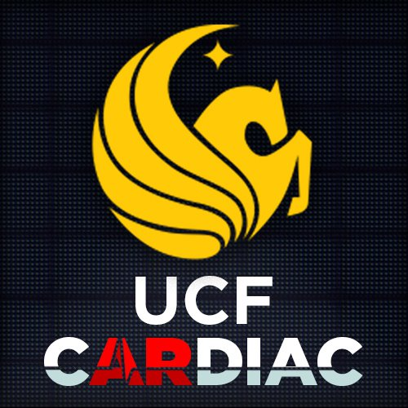

cARdiac AR

Group 12

Alexander Melendez

Alexandra Krivonos

Andrew Rodriguez

Anthony Tran

Chris Mathew

Emmanuel Pineda

Team Sponsor

Melissa Cowan - Melissa.Cowan@ucf.edu

Presentation date

April 17th, 2023

# Table of Contents

**Table of Contents 2**

1. Executive summary 9

2. Introduction 10

2.1 Project Function 10

2.2 Significance 11

2.3 Project Motivation 11

2.4 Individual Motivations 12

2.4.1 Andrew Rodriguez 12

2.4.2 Emmanuel Pineda 13

2.4.3 Alexandra Krivonos 14

2.4.4 Anthony Tran 15

2.4.5 Chris Mathew 16

2.4.6 Alexander Melendez 17

2.5 Broader impacts 18

2.6 Trends in AR 18

2.7 AR and The Medical Field 20

2.8 Legal, Ethical, and Privacy Issues 21

3. Project Characterization 22

3.1 Objectives and Goals 22

3.1.1 Goals 22

3.1.2 Objectives 22

3.1.2.1 Identifying Students 23

3.1.2.1.1 SSO 23

3.1.2.1.2 Outside Sign On 23

3.1.2.1.3 QR Code 24

3.1.2.1.4 Student List 24

3.1.2.1.5 Sign On Through Headset 25

3.1.2.2 Adding Cases to M1 26

3.1.2.3 Flashcards Confidence Level 26

3.1.2.4 Ability to Switch out Quiz Questions 26

3.1.3 Stretch Goals 26

3.1.3.1 Teacher Portal 27

3.1.3.2 Account for Students to View Progress 27

3.1.3.3 Including Heartbeat Audio 27

3.1.3.4 QR/Account Code to Login 28

3.1.3.5 Update the animation for blood flow 28

3.2 Specifications and Requirements 28

3.2.1 Tools and Technology 28

3.2.1.1 Headset Changes 28

3.2.2 Augmented Reality 33

3.2.2.1 Holograms 34

3.2.2.2 Mixed reality toolkit features 36

3.2.2.2.1 Spatial anchoring 36

3.2.2.2.2 Eye tracking 37

3.2.2.2.3 Object manipulator 37

3.2.2.2.4 Spatial Awareness 38

3.2.2.2.5 Boundary System 39

3.2.2.2.6 Follow 39

3.2.3 Version Control Options 39

3.2.3.1 Perforce 40

3.2.3.2 Plastic SCM 40

3.2.3.3 GitHub 42

3.2.3.4 (GitHub) 44

3.3 Concept of operation 46

4. Design of the Application 46

4.1 Research and Investigation process 46

4.1.1 Original state of the project 46

4.1.2 Overview 47

4.1.3 Data gathering 49

4.1.4 Updating content of flashcards and cases 49

4.1.5 Unity Requirements for development 50

Upgrading from 2017 to 2018 50

Upgrading from 2018 to 2019 50

4.2 HoloLens Toolkit Vs. Mixed Reality Toolkit 50

4.2.1 HoloLens Toolkit 51

4.2.1.1 Input Module 51

4.2.1.2 Sharing Module 51

4.2.1.3 Spatial Mapping 51

4.2.1.4 Spatial Sound 52

4.2.1.5 Utilities 52

4.2.1.6 Build 52

4.2.2 Mixed Reality Toolkit 52

4.2.2.1 MRTK Services 52

4.2.2.2 Systems 52

4.2.2.3 Input System 53

4.2.2.4 Input Overview 53

4.2.2.5 Input Actions 53

4.2.2.6 Input Controllers and Pointers 53

4.2.2.7 Boundary System 53

4.2.2.8 Data Providers 54

4.2.2.9 Extensions 54

4.2.2.10 MRTK Packages 54

4.2.2.11 Assets Package 54

4.2.2.12 Unity Package Manager 54

4.2.2.13 Other Packages 54

4.2.2.14 Modularization of MRTK 55

4.2.2.15 Profiles 55

4.3. Design summary 55

4.3.1 Frontend 55

4.3.1.1 Color scheme 55

4.3.1.2 Updating the Application 58

4.3.1.3 Application Follows Eye Movement 58

4.3.1.4 Flashcards 59

4.3.1.5 Cases 60

4.3.1.6 Menu Option 62

4.3.1.7 Heart model 62

5. Prototype plan 64

5.1 cARdiac-AR application prototype with Figma 64

5.1.1 Login page 64

5.1.2 Introduction Prompt 65

5.1.3 Tutorial 66

5.1.4 Selection Menu 67

5.1.5 Heart Scene 68

15.1.5.1 Anatomy heart control 70

15.1.5.2 Open heart control 72

5.1.6 Flashcards 73

5.1. 7 Case Study 75

5.2 Faculty dashboard prototype 79

5.2.1 Faculty dashboard 79

5.2.2 Student Portal 80

5.3 Backend prototype 81

5.3.1 Canvas API 81

5.3.1.1 Webcourses Canvas Access Tokens 81

16.1.2 Shibboleth Server Provider 82

16.1.3 EFI Sign-On Service 82

16.1.4 OAuth2 82

16.1.5 Learning Tools Interoperability (LTI) 84

5.3.1. QR Code Functionality 86

5.3.1.3 Connecting Database to Unity 87

5.3.1.3.1 Unity and MongoDB 88

5.4 Unity and mySQL 90

5.4.1 Connecting to mySQL: 90

5.5 API Testing 98

5.6 Collaboration 98

5.7 Group Member Ideas 99

5.7.1 Emmanuel Pineda 99

5.7.2 Anthony Tran 99

5.7.3 Alexandra Krivonos 100

5.7.4 Andrew Rodriguez 100

5.7.5 Chris Mathew 101

5.7.6 Alexander Melendez 101

5.8 Database selection 102

5.8.1 Firebase 102

5.8.2 MongoDB 102

5.8.3 MySQL 103

5.8.4 Azure Cosmos DB 104

5.8.5 Our Choice (MySQL) 104

5.9 Database structure (version 1): 105

5.9.1 User table 105

5.9.2 Flashcards table 106

5.9.3 Cases table 107

5.10 Database structure (version 2) 108

5.10.1 Students 109

5.10.2 CaseAttempt and Cases 109

5.10.3 Flashcards and Flashcard Attempt 110

5.10.4 Dr Hemo schemas 110

5.10.5 MySQL Workbench 111

5.10.6 Exporting the Database tables as .csv file 111

5.10.7 Database connection 111

5.10.8 Azure App Services 112

6. Build design 113

6.1 Unity app 113

6.1.1 Login 113

6.1.2 Welcome scene 113

6.1.3 Tutorial 114

6.1.4 Class Selection 114

6.1.5 M1 Students 115

6.1.6 Flashcards 116

6.1.7 M2 Students 118

6.1.7.1 Main Scene 118

6.1.8 Cases 119

6.2 PHP app 122

6.1 General information 122

6.2 Functionality 123

6.2.1 Login 123

6.2.2 Cases and Flashcards 123

6.2.3 Case and Flashcards attempts 123

6.3 MySQL and Unity connection 124

6.4 Final Database Structure 124

7. Images and Diagrams 126

7.1 Use Case Diagrams 126

7.1.1 cARdiac App Use 126

7.2 Permissions Diagram 126

7.3.1 User software/AR interaction 128

7.3.2 Development Lifecycle 128

7.4 Gantt Charts 129

7.4.1 Gantt Chart for Senior Design 1 129

7.4.2 Gantt Chart for Senior Design 2 130

8. Setup/Deployment of AR Project 130

8.1 General AR Setup 130

8.2 Deployment of the app to HoloLens2 for debugging 134

8.3 Deploy final application 136

8.4 Sideloading app onto Hololens 2 138

8.5 Windows Device Portal 140

9. Testing 143

9.1 Different types of Testing 143

9.2 Perception simulation 146

9.3 Plans for user testing 146

9.3.1 User testing metrics 147

9.4 Testing Environments 148

9.4.1 HoloLens Emulator 148

9.4..2 HoloLens 2.0 150

9.4..3 Unity 150

3.3.4 Visual Studio 151

3.3.4.1 Modular Installation 153

3.3.4.2 Connect to Database 153

3.3.4.3 Debugging and Deploying 154

3.3.4.4 Squiggles and Quick Actions 154

3.3.4.5 Refactoring 154

3.3.4.6 IntelliSense 155

3.3.4.7 Call Hierarchy 155

3.3.5 Canvas 155

9.4.6 Outside Testing 155

9.4.7 Hyper-V 156

9.4.8 .NET Framework 157

9.4.8.1 .NET Architecture 157

9.4.9 Universal Windows Platform (UWP) 158

9.4.9.1 Secure 159

9.4.9.2 SDK Extensions for Unique Aspects of Specific Devices 159

9.4.9.3 Adaptive Inputs and Controls 159

9.5 Testing results 159

10. Conclusions 161

10.1 Characterization of results 161

10.2 Future improvements 162

10.3 Summary of the project 162

10.4 Limitations and future updates 162

10.5 UCF Wi-Fi connection to the HoloLens2 162

10.5.1 Connecting to Corporate Wi-Fi 163

10.5.1.1 Enrollment Validation 163

10.5.1.2 Wi-Fi Certificate Validation 164

10.5.1.3 Validate Line-of-business App Install 166

10.5.2 Solution 166

10.6 PHP app limitations 167

10.7 Usage Constraints 167

11. Administration 168

11.1 Budget and financing 168

11.2 Project management 169

11.2.1 Agile 169

11.2.1.1 Agile Principles 170

11.2.1.2 Agile Scrum 170

11.2.2 Jira 172

11.2.3 Sprints 172

11.2.4 Backlog 173

11.3 Communication 174

11.3.1 Group Meetings 175

11.4 Documentation and Source Code 178

11.4.1 Source Code 178

11.4.2 Documentation 178

11.5 Milestones 179

11.6 Division of labor 182

11.6.1 Alexandra Krivonos 182

11.6.2 Alexander Melendez 182

11.6.3 Andrew Rodriguez 183

11.6.4 Anthony Tran 183

11.6.5 Chris Mathew 183

11.6.6 Emmanuel Pineda 183

12. Acknowledgments 184

13. References **185**

# Executive summary

This project is focused on updating the cARdiac-AR project. CARdiac-AR is an augmented reality application on cardiac disorders. The goal of this application is to produce an interactive, educational mixed reality system that would display a high-quality 3D model of the human heart, conceptualizing the anatomy of sinus rhythm and cardiac arrhythmias and other heart disorders using 3D models and animations. This application will serve as a learning tool for medical students that would not overload students’ cognitive capacity while providing a visual tool as an addition to their learning for a better understanding of the material. This app would provide educational resources on heart anatomy for two levels of students (M1 and M2) and differentiate the information for each level based on the course they students are currently taking. Each student level can view realistic variations of various heart rhythms and how they change when different disorders are present. The app also provides flashcard mode so that students can learn the concept at their own pace. The flashcard question is created by professionals(professors) and correlates with the materials that are being covered in class. Another mode in this project is the case mode, where students can review case-based questions to test their knowledge. In this mode, the professor can create case scenarios with questions for them. The students can view the model for the selected case and answer the question regarding the case selected. The students can also get feedback based on their selection.

There already exists the first version of cARdiac-AR, was created for the 1st generation of HoloLens. For this project, our main objective is to upgrade the application for the 2nd generation of HoloLens. Additionally, our project aims to improve the functionality of the existing application. Our team would like to add the functionality of student engagement metrics and quiz performance so that the teachers can view students’ progress and quiz results. With the help of quiz performance metrics, the students will also gain more information on how well they understand the material. We would also like to fix a few bugs on the front end and make the front end more uniform throughout the application. Another improvement that our team would like to implement is the functionality of changing the cases and flashcards material. As of right now, there exists no database to store the information for the app. We would like to create a database so that the professors would be able to easily update the question to match the materials they want the students to master. This would also provide better functionality of the up because it would not require the app to be reopened every time the changes were made to the question in comparison with the first version where it was necessary. As a stretched-out goal, we would like to try to work with UCF IT Security on using the WebCourses API for this project so that the grades for the quizzes could be easily moved to WebCourses automatically without the need for the professor to put the grades in manually.

# 2. Introduction

## 2.1 Project Function

The main function of the cARdiac AR 2.0 project is to port and refine the existing cARdiac application from the HoloLens 1 to the HoloLens 2. The new app will be very much the same as the existing cARdiac app on the HoloLens 1; in which it will have medical students view and use the 3D heart and be quizzed in the app with randomly selected, but instructor-curated questions. The app will keep track of the main metrics needed by the instructor: the student engagement and quiz performance. During use, those metrics will be reported back to the instructor through Webcourse API or a separate website that can only be accessed through SSO. If the website idea is deemed more feasible for usage than going directly from the Webcourse API, then hosting a dashboard for instructors to receive and review student metrics will be another function to the project. The refinement from the current cARdiac app’s user interface will be required, as the current interface is deemed unappealing. Overall, the project should be able to be usable in the new Hololens 2, be able to securely return student metrics to instructors, and update the existing application’s user experience.

A secondary function from the cARdiac AR 2.0 project is to, along with the cARdiac VR team and the Dr. Hemo's Lesser Escape Room team, develop a central data gathering base where all the apps can send their data to, and where in which instructors can pull the student metrics such as quiz grades and student activity (confidence ratings) for grading purposes.

## 2.2 Significance

The AR application on cardiac disorders for HoloLens2 is a significant educational tool for students because it provides a unique and interactive learning experience. Through the use of AR technology, students can visualize and explore the anatomy and physiology of the heart in a way that is not possible with traditional learning methods. This application allows students to observe and interact with 3D models of the heart and its various components, which deepens their understanding of complex cardiac disorders. Overall, the AR application on cardiac disorders for HoloLens2 is a valuable addition to medical education that can help students develop a deeper understanding of the human heart and its functions. Being able to interact with the heart and see how various diseases affect physiology of the heart is a very important concept for the students to understand. AR technology is a great tool to provide a hands-on experience for the students when learning the concepts that require visualization. This technology can become a great tool in the future and while the current application only covers cardiac disorders, it would be a great addition in other various studies and applications.

This application also serves as a great tool for reporting to the faculty to gather the reports and feedback from the students and gain better ideas on their understanding. This application allows the UCF faculty to design the components Flashcards and cases based on their own educational style and match them best with the material that they teach. Students using the application can report their confidence levels and general understanding, for faculty to review and tailor the material taught. This way the studying methods can be altered to make sure that the students are understanding the material properly.

## 2.3 Project Motivation

As a team, we were all drawn to this project because it offers a great amount of industry-like experience while still having guidance from Dr. Gerber and Dr. Leinecker. This experience is priceless and makes us more valuable candidates when we first try to get into the industry. This project also allows us to grow both professionally and individually allowing us to learn and improve upon key skills that we can carry forth such as communication, teamwork, new technologies, problem-solving and more. Lastly, we would be able to give back to our school by providing a more updated version of their Cardiac AR service that will be used to help the students in the College of Medicine learn in a more interactive and engaging way. For all the school has done for us, this is the least we can do.

## 2.4 Individual Motivations

### 2.4.1 Andrew Rodriguez

There were several main reasons for choosing this project, the first of which is I wanted to get more real-world experience so that I can learn firsthand what it is like to be a software engineer. This project allows me to not only write code but also to go through the different stages that occur before the first lines of code are written, researching, writing the design document, and collaborating with the team and sponsor. Another way this project simulates real world experiences is by taking code that a previous team worked on understanding that code and then updating the code to work with and or incorporate new functionality that the newer version of the service provides. This allows us to also build the skill of familiarizing ourselves with others’ code and research solutions and or services that are new and might be useful to implement. These skills are used every day in the industry and are crucial to develop them early. With this project my team and I will have to communicate and or work with the Cardiac VR team and UCF Canvas IT which is something that can happen in industry. Getting this experience before I go into the industry is something that can set me apart from other candidates and allows me to grow professionally.

The second reason for choosing this project is that it provides me the opportunity to learn new technologies that I would not have learned otherwise. This allows me to broaden my knowledge base of technologies and or better my understanding of or skills of certain technologies, which can be carried forward through my future career. I have experience in making a basic website and working on the backend of a service, but this project allows me to do something completely new. Hopefully my prior experiences can help me and my team complete this project to a level that the sponsor is beyond happy with.

### 2.4.2 Emmanuel Pineda

My main motivation for choosing this project is that I get to help build software that can help other UCF students progress in their studies with an interactive application. I’ve always had a passion for creating meaningful useful software for others to use and this project allows me to do just that. The other main reason is that I can get real world experience on what its like to be a software engineer. It allows me to work closely with a sponsor who is very responsive and knows what requirements they desire for the project. It helps me learn to communicate with a “customer” and learn to close the gap between technical and non-technical topics, what is achievable and what isn’t etc.. It allows me to go through the entire process of creating an application from scratch and look closely at code from previous versions that could be useful to help implement the new one or update it to work better and add more useful features. Being able to look at other people’s code, understand it, use it, and update it is something that is often done in industry, and I think this would be good practice for a very large scale project. Learning to work with a group of people you’re not familiar with is also a large part of this project that is good to learn because it teaches you to communicate properly with others to get the job done rather than causing push backs for any possible conflicts.

My other main motivation for choosing this project is that I get to learn to use technology that I’m not familiar with. I’m excited and eager to research and learn all the new technology that we need to have a good understanding of to execute the program. The main software that I’ll be learning is Unity which is used for creating 2D and 3D platforms which I have no experience in but would love the opportunity to learn and C# programming language. The project also allows me to work closely with the HoloLens 2.0 equipment and creating a functional game that can operate on it and use its technology and features to make the most out of the application. Learning new technology can help hone my skills as a software engineer that I can use to open more job opportunities for me later down the line.

### 2.4.3 Alexandra Krivonos

There are many reasons why I am excited to work on this project. Some of them are technical and some are not. One of my main motivations is to learn the process of software development. This class is a good source to get an idea of what software development looks like in a real working environment. I strongly believe that during this class I will learn valuable lessons about development that would be extremely useful for me in my future profession. Working and communicating with a team, and collaborating with the sponsor to match their expectations seem like crucial steps to learning how to become a better engineer.

My other motivation for working on this project is the fact I can get hands-on experience in AR development and other technologies. So far, my experience consists of mostly basic front-end, API, working with analyzing big data and different databases. I do not have much experience with AR, but that was always something I wanted to learn about. And this project will give me a lot of insight into AR development. The number of companies that are trying to incorporate AR technology into their apps is rising. After seeing and hearing more about the AR technologies that those companies create, I got inspired to try it out myself. Additionally, HoloLens2 is such an interesting tool to work with. There are very limited possibilities to actually try and use it, and this project is perfect to get a hands-on experience with such a unique device like HoloLens.

Another motivation of mine is to be able to create something for UCF. I am glad that there is an opportunity to collaborate with UCF students to build an application that will be used by other UCF students. I am minoring in Bioinformatics and Genomics, and after taking some classes in the biological field I am interested in the ways Computer Science can be used in the medical field and the ways it can improve the work of scientists. Since I had to take several biology-related classes for the minor I’ve noticed that good visualization can make a huge difference in how well the material covered in class can be absorbed. However, modern textbooks still provide relatively primitive and not detailed enough visualizations for the concepts, there are videos at best. This app has the potential to become very useful for anatomy students as they will get a physical model of the heart. I wish some similar interactable tool existed for my courses to provide a greater understanding of the topics and it means a lot to become part of the project that might bring a lot of clarity to the students.

### 2.4.4 Anthony Tran

My motivation for choosing this project is to gain experience programming for augmented reality as well as make a positive difference for future students attending UCF College of Medicine. While I don’t have any prior experience with Microsoft HoloLens or augmented reality, I do have experience building projects in Unity. I also have experience in front end development which will help with one of our client’s goals of updating the UI and UX design of the application. The idea of working with augmented reality is exciting considering how it’s a relatively new and emerging technology with wide reaching possibilities that could benefit society. I look forward to researching and creating with AR.

I believe the project will have a positive impact for future medical students attending UCF College of Medicine by providing them with an updated version of a three-dimensional model of a heart in augmented reality. The model allows students to manipulate parts of the heart as well as test their knowledge with expert level questions. This “hands-on” approach of learning with augmented reality seems like something out of a sci-fi movie and I can’t wait to see the progress my team and I can make with it by the end of Senior Design 2. By updating the model from Microsoft HoloLens 1 to HoloLens 2, the model will become more detailed and have a better user experience.

By the end of Senior Design 2 I hope to have a better understanding of how to create and build upon augmented reality applications. I’m eager to start researching and going through the documentation left to us from the previous cARdiac team to learn more about the project. The scope of this project is the largest assignment that I’ve ever done. I believe that the skills gained throughout Senior Design and the challenges that come with it will make me a better developer for my future job after I graduate.

### 2.4.5 Chris Mathew

My motivation for this project is to gain programming experience in API and Front-End development for augmented reality, while also making a useful tool for the use by medical students at the University of Central Florida College of Medicine. With no prior knowledge of programming for AR or the Microsoft HoloLens, I believe this project will let me learn more about the emerging technology and how to incorporate Unity elements in an AR environment. I have some experience working with API development in previous classes and plan to use that knowledge and apply it to this project, with additional learning needed in finding a way to complete a client goal of fixing API problems from the project’s previous implementation.

I was interested in this project by the opportunity to work with AR headsets and to develop with hands-on access to the Microsoft HoloLens. Since its inception, I’ve always been intrigued and curious about augmented reality technology and its use in real world scenarios. This project presents an opportunity to work with the University’s College of Medicine and help develop a more hands-on and interactive learning experience for medical students on the heart, especially compared to the traditional textbook and quiz environment. The project having a previous implementation (on an older generation of the HoloLens), also directed me to picked this as my Senior Design project, as having base documentation to work and improve upon from the cARdiac AR 1.0 project can lead us to better direction in how the development of this project should go.

By the end of Senior Design 2, I hope to have gained a lot more programming knowledge in Unity and the Mixed Reality toolkit, as well as a refined knowledge in API development to make the application more usable for instructors and grading their students. I also hope to refine my interpersonal skills while working with my team to create a product that will satisfy the needs of the client, while also creating a product that will leave an impact for the future use of AR in learning environments.

### 2.4.6 Alexander Melendez

My motivation for choosing this project is to learn and utilize AR while also being able to make an impact for the UCF College of Medicine. I have no prior knowledge in creating an AR application nor have I specifically worked with the Microsoft HoloLens; however, I believe that I will be able to learn a lot from learning more about these technologies through this project. I do have some prior experience in utilizing Unity for game projects, so I hope that that experience will help in this project. I also have some prior experience working with API as well as a bit of frontend just in case this project also calls for some assistance in those areas as well.

I am looking forward to this project having a positive impact for the UCF College of Medicine. Utilizing AR for a teaching environment is quite an interesting concept, especially if it’s not for the sole purpose of teaching AR. Thus, having such a different experience should end up being more fun and engaging to everyone. This could be the start of something even bigger which is quite intriguing. Seeing how we can transform and improve upon the initial version to create something more usable is great.

In the end, I am hoping to have gained some valuable experience in AR technology while also gaining more knowledge in Unity. I also want to ensure that I can work within a team for a project of this scope. I do hope that this project is successful and ends up having that positive impact that I mentioned earlier.

## 2.5 Broader impacts

Our project has the potential to have a far-reaching impact on the educational and medical fields. The application provides medical students with a way to visualize, interact, and learn about the heart and the possible effects of conditions affecting it. Students can manipulate the model and test themselves against expert-level questions from anywhere around the world as long as they have a computer and a pair of Microsoft HoloLens. This can open the door for countless students or individuals wanting to learn about cardiology. But why stop at cardiology?

With further development, the application could eventually be expanded to other parts of the body such as the lungs, stomach, or brain. Medical students would no longer have to rely on textbook passages and images. They could learn from and interact with life-size replicas of any body part under any condition. Studies have shown that hands-on learning is one of the most successful types of education among students. It’s more engaging for students to participate than to listen and watch. It’s also probable that from a medical student’s point of view where most of their training is hands-on, it would make more sense to learn this way.

There are also some environmental benefits if the medical field gravitated toward this style of education. As the use of augmented reality increases it would mean less of a need to manufacture plastic models, thus there would be less waste in the world. Overall, this project has the potential to influence the way medical students are taught in the future, or at the very least it will give them options.

## 2.6 Trends in AR

Augmented reality (AR) is not foreign territory as it used to be. With much advancement in technology, augmented reality is seen more often whether users are aware of it or not, examples of this would be the popular app Pokémon Go, Snapchat, or Facebook filters, new technology such as HoloLens, etc. Virtual reality (VR) has been its biggest competitor, but AR is projected to surpass virtual reality in the upcoming years as technology advances and companies find greater use for AR. In 2017, an estimated 37.6 million Americans actually used AR however in 2022 it was projected that the users of AR will reach up to 95.1 million, the current number is 83.1 million users. However, AR has become more common to the point that an estimated 46% of Americans are not aware that they’re using AR.

Augmented reality can be used for more than just a fancy feature, though, it can be utilized for educational purposes as well. AR can be a fun way to help students learn, be more interactive, and stay interested in what they’re being taught. This becomes especially useful when it comes to teaching complex topics and it is estimated that around 95% of teenage students own smartphones making AR more accessible to use in a classroom setting. AR can be especially useful to help teach students that have learning disabilities. It's estimated that about 6.1 million kids in the U.S. are diagnosed with ADD and ADHD, and using AR for kids with these conditions can help keep them concentrated on learning and help block out as many distractions.

The benefit that comes with using augmented reality as an educational tool is that it’s an effective way to keep students engaged in immersive visuals partnered with speech and audio. This introduces a new concept of learning by appealing to the human senses for gathering information. AR can help reduce the number of physical forms of education and lower the cost of educational materials since a vast majority of all Americans in general own a smartphone of some sort. AR can help make learning more fun and interesting, making students want to interact more and making learning feel more effortless. [27]

## 2.7 AR and The Medical Field

AR headsets being used in the medical field is somewhat new and has shown to have several benefits and the HoloLens 2 is no different. The biggest, and most obvious, benefit that the Hololens 2 provides when being used in the medical field is enhancing patient treatments. This is done by reducing the time-to-care of patients, reducing training by thirty percent (allowing them to interact with and manipulate different scenarios they might encounter), and improving ward-round efficiency by thirty percent.

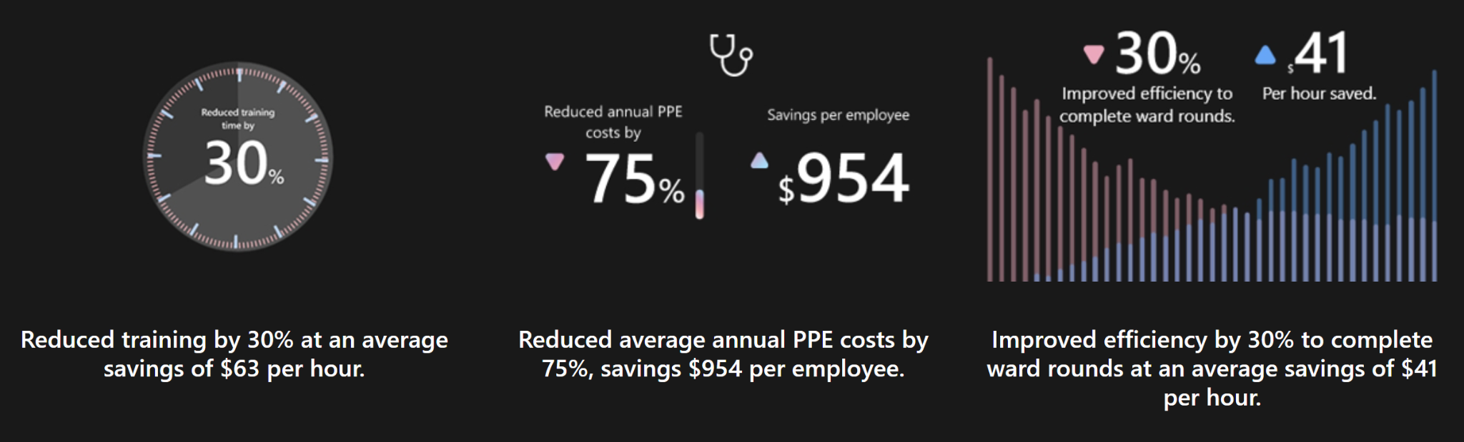

*Figure 2.1 Statistics on patient treatment improvements [53]*

Another major benefit provided by the inclusion of the HoloLens 2 headset in the medical field is that it provides the capability for healthcare workers and professionals to remotely connect with experts. This capability can now allow for second opinions from an expert that otherwise be across the country, or world, which further emphasizes the improvement of patient treatment. Another capability that the HoloLens 2 brings is that healthcare professionals can pull up patient data and go beyond the two-dimensional restriction of X-rays and MRI scans by allowing them to traverse them in a three-dimensional way through the headset. The healthcare professional can now better show the patient what they might be talking about and or what the procedure may look like. This can provide a better patient understanding and in turn, better patient comfort that may have been difficult to achieve without the headset. Some healthcare institutions have already started incorporating the Hololens 2 headset MediView, Medlab, GE Healthcare, and CAE just to name a few.

## 2.8 Legal, Ethical, and Privacy Issues

The first version of the product didn’t have any legal or privacy issues, because no personal data of students, or faculty was necessary to use the app. In the second version, however, the students and faculty will have to login into the application, because we want the faculty meeting to see the students’ progress and grades. With the addition of storing users' personal information, the team faces some potential security risks. Since the students and faculty will log in with their UCF credentials, it poses a serious FERPA issue. One way to work around any issues would be to use the SSO so that the password won’t be stored in the database. The best option would be to use the OAuth2 API and integrated Canvas tools, in order to completely avoid accessing and storing credentials in the app. Instead, the authentication tokens would be used. In case this option will not work out, we would need to make sure that the credentials stored would be encrypted securely. In case SSO would be difficult to implement, other ways of identifying students also pose security risks. The sponsor suggested that the students log in with UCF email, which is also sensitive information that we need to consider. While encoding this information is a good idea, the team needs to come up with a way for faculty to have a way to identify which student is which. For this project, we ended up using the access code and password provided by the sponsor. Access code and password will be generated outside the application, so there would be no connection to the actual students' data.

Another possible FERPA issue is connected to the grades for the cases module for the students. We need to make sure that only faculty can have access to the grade of all students and that the students have access to only their grades in order not to violate FERPA. We need to make sure that no information on the grades is available to the users who are not supposed to see it.

# 3. Project Characterization

## 3.1 Objectives and Goals

### 3.1.1 Goals

* Update the application to work on HoloLens 2
* Update the scaling, moving, and rotating of the heart model to the HoloLens 2 standard
* Creating the logic for storing user data
* Fixing and updating the UI/UX for the application
* Incorporating confidence level for Flashcards component
* Storing information on Cases and Flashcards, such as completion, time spent, and confidence for each user
* Modality of Flashcards and Cases
* Enlarging the working window for the users
* Adding cases to M1 students
* Update the tutorial for HoloLens 2 users

### 3.1.2 Objectives

* Update the codebase from Unity 2017 to a more recent version
* Update the current User Interface to be more user-friendly.
* Fix Current Bugs and issues
* Set up a proper version control
* Move on from HoloToolKit to MixedRealityToolkit (used in HoloLens 2)
* Hold a database to store information from professors and students
* Implement Quiz Question Modularity in order to change out quiz questions at any time

#### 3.1.2.1 Identifying Students

One of the project goals is to have a way to identify each student when they are using the headset so that we can collect data and allow the instructors to see it. There are several possible approaches that were discussed during the development, the most appropriate was selected that works in collaboration with the cARdiac-VR application and Dr. Hemo-Escape Room.

##### 3.1.2.1.1 SSO

The first way the team came up with was to use a University of Central Florida single sign-on (SSO). The University of Central Florida (UCF) uses SSO as one of its main sign-on options, being supported on almost, if not all, school-related websites. That being said, it would make sense for the cARdiac AR app to also utilize SSO since it is being used by UCF students in the College of Medicine. A benefit of this would be that students are familiar with how it works and know their sign-in credentials; on the other hand, it would not be as easy to sign on while wearing the headset because it does require typing a username and password which may not be the easiest with an AR keyboard. To use the SSO there would be an annual fee of $50. Our team would also have to work with the UCF IT team to see if it is possible and what would need to be done.

##### 3.1.2.1.2 Outside Sign On

Another possible option is that we have the students sign in beforehand on a laptop or phone and then be able to link it to the headset. This option could work similarly to a log of who is using the device, where at a certain time we see the user sign on to use the device and we can see how long they are on it. That being said, this method could add to the requested data collection that the sponsor requested in addition to how many cases they got correct or incorrect and how many flashcards were viewed. This would make the sign-in process easier for the user because they can use whatever device they have readily available, some of which might have their login saved. The sign-on in a different device method does have a downside, that being the instructor would have to look at the log and then collect the data she wants for the corresponding student. If there is a way to automate the process so that signing on in a different device would send the data to the website would be a better implementation.

##### 3.1.2.1.3 QR Code

We had an idea to utilize the outward-facing cameras on the headset to do a QR code scan to sign in or just identify students. With this approach, there can be two ways that it can be done. The first way is to have students sign in on a mobile device, like the previous method that was talked about, and then have it present a unique QR for that session instead of acting like a log. That QR code could then be scanned by the headset to sign the user in on the HoloLens 2 headset. This method would require the user to always sign in on their mobile device so they can get the QR code.

The second way this method can be taken is by having the student sign in on a mobile device at the start of their course and then present them with an unique QR code for that specific student. This QR code would work just like the other option but would be permanently attached to the student. This option would allow the student to simply screenshot the QR code and then present it to the headset whenever they wanna use it instead of always having to sign in on another device. The functionality of the QR code would stay the same, identifying the student who is currently using the headset. The method does lose the possible time spent on data collection from the previous method that was discussed. The QR code would keep the student signed on either until a new QR code is scanned or until it hits a predetermined sign out time. This would make time spent on the cARdiac app inaccurate because the student might not have been using it the entire time.

##### 3.1.2.1.4 Student List

The final method that can be done for student identification is having a list of the students loaded onto the headset. This would allow the students to simply scroll to their name and click it to identify it. With the HoloLens 2 capability of eye tracking the scrolling could be made easy for the user, all they would have to look at the bottom of the page to scroll down or at the top of the page to scroll up, then they simply just click on their name. This method could allow the students to be separated by their class, M1 students being shown when M1 is clicked or M2 students being shown when M2 is clicked.

Another feature that could be added to this method would be the capability of searching. The list can then be filtered down to only show what the student is searching, showing both results for first and last name since there would be no way to know what the student is searching for. A downside of this method is that if there are a lot of students in each class then the list of names would be very long and could be somewhat of an inconvenience for the student to scroll through it all and or search for their name and then scroll. Also, the students would change each year and new students would be added and the old ones removed and or moved to M2, this would require the list of names to be updated. If there is a way to have the list of names update automatically, maybe utilizing the students enrolled in the class through a website like webcourses which is what UCF uses for students to see their classes, then this wouldn’t be a problem other it would be tedious for to manually update the students each year.

##### 3.1.2.1.5 Sign On Through Headset

The final method that we thought could be used to identify students is signing in through the headset itself. One way this can be done is using the new capabilities of the HoloLens 2 headset and have the student sign in through biometric factors like their eye. For this approach to work the headset would have to be able to hold multiple user’s biometric data so that each student can just sign in when they put the headset on. More research needs to be done on this particular approach to see if there are any limitations that we are unaware of.

The other approach would not be as effective but it would work; it would require the student to sign in through email. We know that some students have long emails and it would be tedious to enter the entire email, especially while dealing with a holographic keyboard, every time they put on the headset. To minimize the typing required we would want to create an autofill button or feature that auto fills the end of UCF’s email (@knights.ucf.edu). This feature would greatly benefit the user.

The last way that we can have the student sign on directly through the headset is by requiring them to enter their access code and a password, which is a unique numerical code assigned to anatomy students by the faculty. This approach is preferred because that would require users spent less time typing a long knights email of use any other devices for login. This not only would guarantee little type but also keep the user on that keyboard rather than swapping between the letters and number holographic keyboard.

#### 3.1.2.2 Adding Cases to M1

The cases component for M1 students has been our goal, and the functionality for it was implemented. However, in the middle of the development the faculty decided not to include the cases component for M1.

#### 3.1.2.3 Flashcards Confidence Level

Our sponsor has asked our team to include confidence level features in the flashcards to collect more data from the students. The idea is that there is a scale on the flashcard that has three choices: “No clue”, “Guesstimate”, and “Certain”. Before the student flips the card to reveal the answer, they fix the scale to what their confidence level on that card is. After the student flips the card, they would answer whether they got the answer correct or not.

#### 3.1.2.4 Ability to Switch out Quiz Questions

In the application, for M2 students, there is a section called “Cases” which quizzes students over the material. Our sponsor requested that if it were possible to include a feature that allows these case questions to be switched out easily for other questions when desired.

### 3.1.3 Stretch Goals

CARdiac AR is an augmented reality application for cardiac disorders that is shown through a 3D model of a human heart. This application currently exists on HoloLens 1, our main goal is to port this application to HoloLens 2 and upgrade the application to have better functionality, a cleaner user interface, and to report a student’s engagement metrics and performances for a professor to view. However, our sponsor did have some additional goals that would be nice to implement if there was extra time in the end that was included in the original PowerPoint presentation but was also discussed in person during a sponsor meeting. The following are stretch goals that were completed by our group:

* Updating the visualization of blood flow and electrical flow
* Incorporating the second heart model

There were some additional stretch goals that were discussed, but due to the limitation of time, they had to be left out of the development. The more detailed description of those stretch goals is described below.

#### 3.1.3.1 Teacher Portal

Our team has implemented the PHP application that is handling the input, output from the database and Unity app. Using the same environment on the Microsoft server, the portal for the teachers and faculty can be created. There they would be able to sign in to see their classes, their students, and their corresponding grades or completion progress. Microsoft PowerApps can be used to create the teacher portal alternatively. PowerApps is a low-code app development tool that allows people with little to no experience to create a professional-level app.

This solution would incorporate nicely with the rest of the environment that was set up on Microsoft infrastructure. There are mainly three different types of apps created: canvas apps, model-driven apps, and portals. Canvas apps are used to get data from various sources all into one location, model-driven apps are used for adding components to an application without any code, and portals are used to allow people to sign in, view data, and browse content. We would want to use the portal app to build our hub for the teachers to view this information because it is closest to what we need.

#### 3.1.3.2 Account for Students to View Progress

The sponsor would like for us to implement a way for professors to view students’ progress through flashcards (possibly their confidence level on each card if that additional goal were to be implemented) and in the M2 version of the application for the case questions to be recorded as well. After this an additional goal that would like to be implemented is allowing students to view their own progress. If this was added it would be included on the dashboard website for professors as its own section for students to login.

#### 3.1.3.3 Including Heartbeat Audio

The current version of cARdiac AR displays a simulation of how a heart reacts with different cardiac disorders or if you were to speed or slow down a human’s heart rate which includes a heart monitor that displays the rhythm of the heart that is implemented by displaying an mp3 file of a heart monitor for the appropriate setting. However, it does not include audio. We would like to try to include heartbeat audio in the application to make it more life-like and as accurate as possible. A challenge that we face implementing this is finding the correct heartbeat sound to display in respect to each disorder. At the very least we would like to at least add audio to when you speed up or slow down the heart rate as a starting point to help progress the application. Since the heart is a single game object, we would attach several audio pieces to that one object and then add code to signal when to play each audio.

#### 3.1.3.4 QR/Account Code to Login

Since there has to be a feature for a student to login through the cARdiac AR application in order for professors and possibly students, to view a student’s progress. Our team wants to make this process as user friendly and convenient as possible through an AR application. The first thing that comes to mind when logging into a user’s account is typing in a username or email and a password and although this is possible while using HoloLens 2 this is not the most efficient or user friendly way of logging in through an AR application. Our team considered incorporating two features in the application login page, an area to enter an account code to login that would be supplied to the user through Webcourses. Also, to include the ability to scan a QR code that will login the user in. Both of these methods are more user friendly allowing the user to login in more easily and quickly rather than typing in a long email and password.

#### 3.1.3.5 Update the animation for blood flow

The first version of the app contains the animation of the blood flow for the heart model. However, the blood flow animation looks unrealistic, rather schematic. Upon the request of the sponsor, we are looking into a way to make the animation look more realistic for the second version of the app.

## 3.2 Specifications and Requirements

### 3.2.1 Tools and Technology

### 3.2.1.1 Headset Changes

HoloLens 2 is a more up to date version of HoloLens 1 with some new capabilities and improvements to existing functionality, hardware, and capabilities. Starting with the hardware, Hololens 2 has Microsoft’s own second generation Holographic Processing Unit (HPU). The HPU is custom built for spatial and location processing for the new HoloLens 2. The headset also has Bluetooth 5.0, a more modern version, instead of the previous 4.1, and now uses USB type-C ports. A newer version of storage is used, a different type of WiFi, as well as a more powerful Random Access Memory (RAM). The RAM used in HoloLens 1 was capable of only 2GB while HoloLens 2’s RAM jumps to 8GB, an increase of 400%. Two IR cameras were added to the headset allowing for eye tracking capabilities.

One of the bigger things that was focused on improving for the second generation was the field of view. The first generation headset had a very limited field of view forcing the user to try and avoid even the smallest of head movements because then the hologram might not be fully seen. This does not make for the best user experience. Now with the new second generation the field of view is nearly doubled making head movements less troublesome and making it more natural for the user.

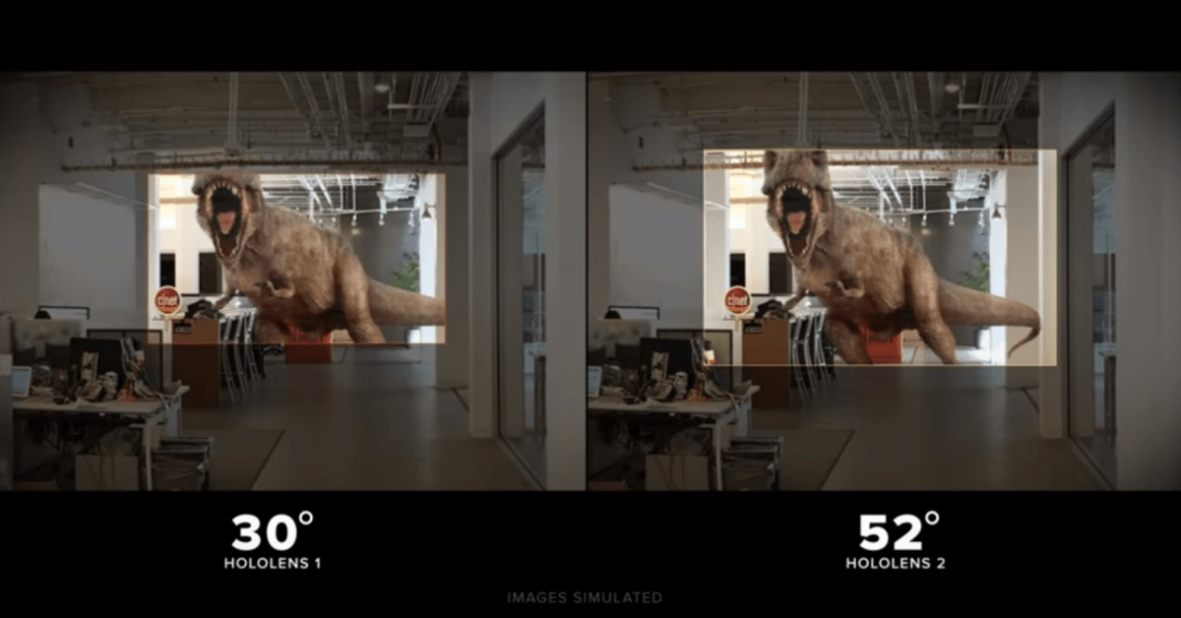

Figure 3.1 Field of View Comparison [77]

Another big improvement that HoloLens 2 brings is that it has more gestures that one can use to control and manipulate the environment that they see. HoloLens 1 was very limited to its gestures, mainly sticking with a pinch gesture to scale, click, rotate, etc. but now with the second generation the user can utilize more natural feeling gestures to accomplish the same task as before. These more natural feeling gestures include grabbing, clicking, a bloom motion, and holding. Both HoloLens 1 and 2 are able to use two hands. Along with these new gestures, the headset now adjusts to the user. The headset can now recognize the users' hands, so if one person is very tall and another is very short the headset will be able to adapt to their different arm lengths and recognize their hands and perform as if there is no difference in height. This new generation headset also tracks the user's eyes and has a voice assistant.

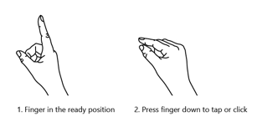

Figure 3.2 HoloLens 1 Gestures [46]

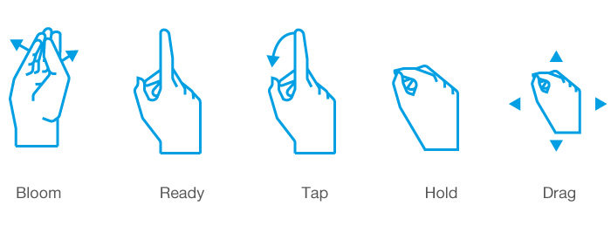

Figure 3.3 HoloLens 2 Gestures [52]

HoloLens 1 and HoloLens 2 both run on a platform utilizing the Windows Mixed Reality operating system. That being said, there is a way to port apps developed for HoloLens 1 to HoloLens 2. All that has to be done is to download the newest versions of the tools, update the unity project, compile, and update to the second version of the mixed reality tool kit. The cARdiac AR project was last worked on in a 2017 version of Unity and the porting guide recommends porting to a 2020 version. This could potentially make updating the app a lot easier and give us more time to focus on the extras that we would like to add and or fix.

To operate and test for HoloLens applications one of the following is required. Either a pair of Microsoft HoloLens 2 or a HoloLens emulator.

HoloLens 2

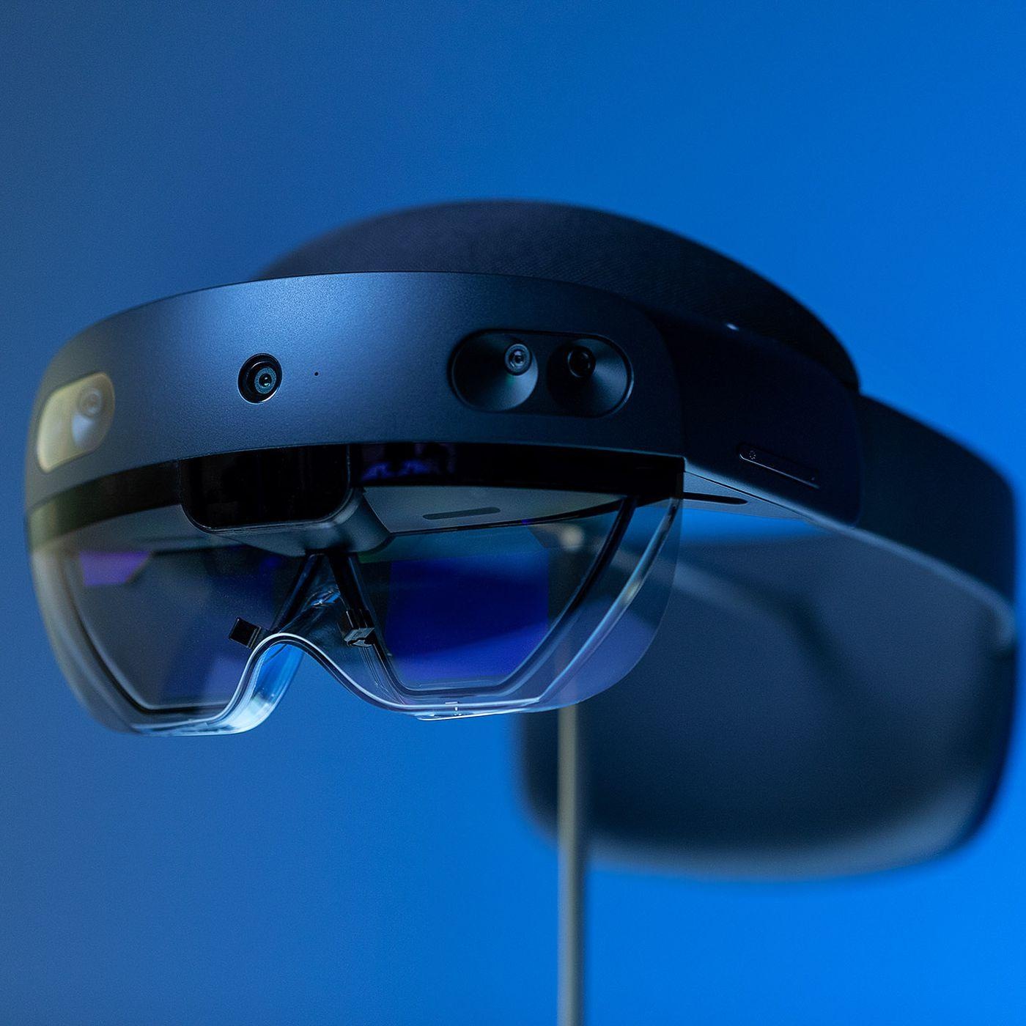

*Figure 3.4 HoloLens 2 headset*

HoloLens 2 is an augmented reality (AR) headset and is the successor to HoloLens 1. The HoloLens headsets are made by Microsoft and MicroVision. The headsets use a combination of a waveguide, laser-based stereoscopic, and full-color mixed reality smart glasses. The waveguide display on the HoloLens 2 has a fixed focus of 2 meters [38].

Features for HoloLens 2 include [37]:

* Hand tracking
* Built-in voice commands
* Eye tracking
* Spatial mapping
* Large field of view (54-degrees diagonally)

HoloLens Emulator

The main purpose of using the HoloLens emulator is to allow users to test HoloLens applications on a PC without a physical HoloLens. HoloLens Emulator uses a Hyper-V virtual machine to emulate human and environmental inputs that would be read by HoloLens sensors. Users can simulate inputs by using keyboards, mouses, or Xbox controllers. No modifications are required as HoloLens applications cannot distinguish between the emulator and a real HoloLens headset [34].

* Microsoft HoloLens 2
  + Platform for Development
* cARdiac App
  + For HoloLens 2
  + Based on cARdiac 1.0; will display a high-quality 3D model of the human heart in augmented reality for use by medical students that can be viewed and manipulated.
  + Will interrogate students with expert-level questions that vary by academic year.
  + Will be able to report student engagement metrics and quiz performance through the Canvas Webcourse API or Gradebook Website.
  + Will have better UX/UI front-end design from cARdiac 1.0
  + Ability for content creators to change quiz questions
  + Requires:
    - Mixed Reality Toolkit in Visual Studio for building applications in HoloLens
    - Unity
* Webcourse API/Gradebook Database
  + Tool used to return student metrics back to instructors through Webcourse API or through a separate database that will be viewable to only the instructor.
    - Website would display engagement and quiz performances to instructors through a dashboard interface.
  + Will need to secure student information from public access.

### 3.2.2 Augmented Reality

Augmented reality or Mixed reality is a blend of the physical and digital world. It comprises of 3D human, computer, and environmental interactions all made possible by advancements made in computer vision, graphical processing, display technologies, input systems, and cloud computing. The applications of mixed reality include:

* Environmental understanding: spatial mapping and anchors.
* Human understanding: hand-tracking, eye-tracking, and speech input.
* Spatial sound.
* Locations and positioning in both physical and virtual spaces.
* Collaboration on 3D assets in mixed reality spaces.

As users move through the physical world, their movement is mapped in a digital reality. Using environmental input and perception APIs, it is able to capture:

* A user's body position within the physical world through head tracking.
* Physical objects, surfaces, and boundaries through spatial mapping.
* Ambient lighting and sounds.

As a result, the physical and digital reality experience begins to blend [65].

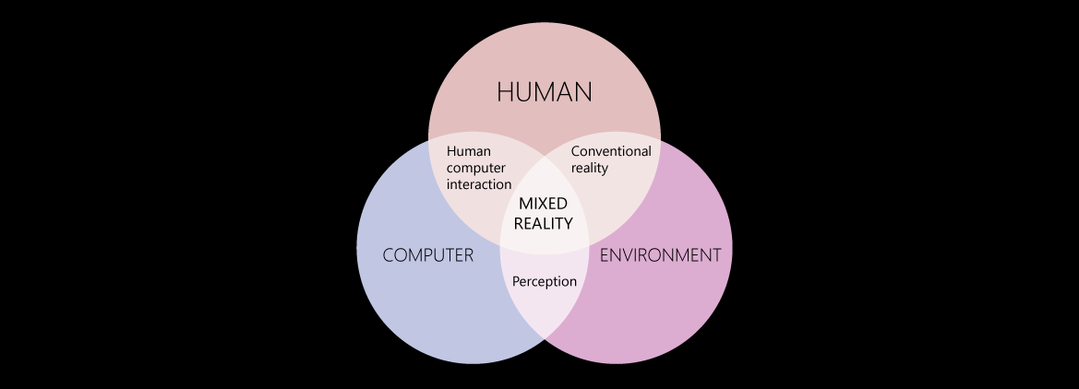

*Figure 3.5 The interactions between computers, humans, and environments.* [65]

#### 3.2.2.1 Holograms

Holograms are objects that are made up of light and sound that appear in the physical world and can resemble real or imaginative objects. Holograms can be interacted with by user inputs such as gestures, voice commands, and gaze. They have different appearances and behaviors based on the intended use. Holograms can be used for highlighting features of an environment or objects, elements of an application's UI, or entertainment. Depending on the use, holograms can also have a fixed location within the physical world or an ever changing one by following the user.

With Microsoft HoloLens, holograms appear in the display frames directly in front of the user's eyes. The sounds produced by HoloLens come from two speakers located above the user's ears. HoloLens has an additive display that adds light when rendering holograms. Any black color will be rendered transparent [64].

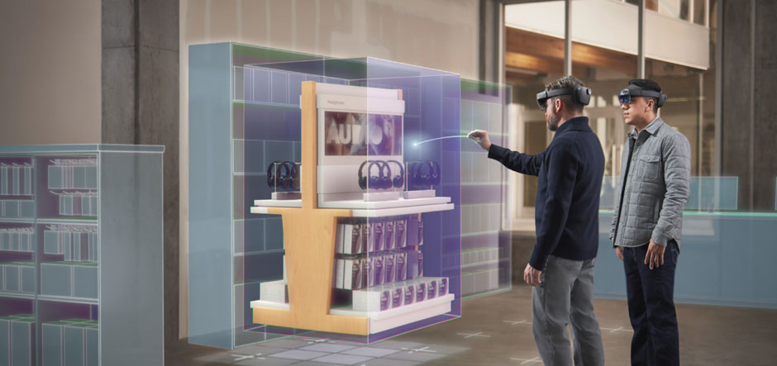

*Figure 3.6 Example of hologram use with HoloLens* [64]

Some best practices to keep in mind when creating holograms:

* A comfortable viewing distance for holograms is around 1-2 meters away from the user's head.
* For content that will be constantly on the HoloLens display, consider allowing elements to drift or move to one side of the frames when the user shifts their vision.
* Consider the following based on the use of the application:
  + Display-locked: If you need the content to be consistently on the screen. Lock it in place.
  + Body-locked: If you want the content to follow the user's gaze or body. Tether the content to the user within the 3D space.
* The optimal zone for holograms to be placed is between 1.25 and 5 meters from the user.

[64]

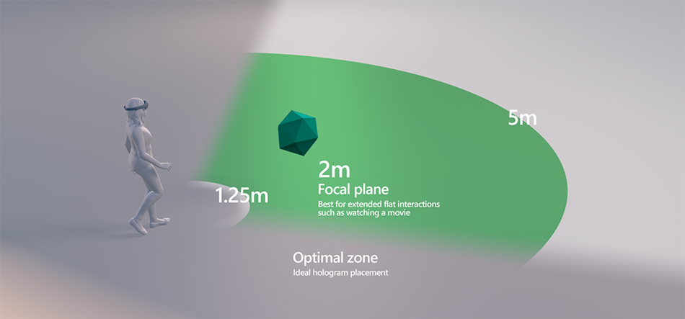

Figure 3.7 Illustration showing ideal hologram placement [64]

#### 3.2.2.2 Mixed reality toolkit features

##### 3.2.2.2.1 Spatial anchoring

With spatial anchoring we can pin a hologram in place to an important point in the world. Each anchor has its own coordinates that are saved and can be accessed and loaded up later. The coordinates can also be shared through the cloud by making an Azure Spatial Anchor. This way the point can be shared across multiple devices in real time.

Best practices to consider when using spatial anchoring:

* Let users place the spatial anchors: Generally users are the one's interacting with the anchored object. So it is recommended for users to place objects where they're comfortable with it.
* Render anchored holograms within three meters of their origin. This is due to proportional issues users may face from positional mistakes. For example if a hologram is placed far away from the user, they might mistake it for being smaller than the actual size and vice versa if the object is placed closer.
* Multiple holograms should maintain a fixed relationship with one another.
* Any dynamic hologram should use a stationary frame of reference instead of a local spatial anchor. If the hologram being placed has any movement or animation, it's probably best to avoid spatial anchoring because it can mess with the anchored coordinate system.
* Be mindful of where you put spatial anchors. Try to avoid a grid of anchored objects as it can get complicated managing without deep sensor data. Especially if the objects are dynamic.
* Release any anchors no longer in use.

[85]

##### 3.2.2.2.2 Eye tracking

Using eye tracking, we can use the user's eye gaze to complete or enhance tasks that weren't possible in the previous version of the application. With the eye gaze feature, we can see what the user has their attention set on and spotlight it. For instance if the user was looking at a specific part of the heart, the application could highlight it and display the description and name of the heart section in view on the prompt slate. Another use would be if the user was looking at an option on the navbar we can highlight it for a possible selection and the user can gesture to select it. This would reduce overall movement from users having to reach across the display to select the option.

##### 3.2.2.2.3 Object manipulator

The object manipulator is a recent component from the mixed reality toolkit 2 or MRTK2. The script allows for objects to be movable, scalable, and rotatable using the user's hands. There are options for one handed and two handed operations. Using the object manipulator we can simplify the UI of the application as well as the code base by removing the need to include movement, scaling, and rotating in the heart controls. Rather than having users select one by one the options to manipulate the heart and using three different changing scripts on the object, we can instead just attach one script, the object manipulator, on the heart and interact with it. [79]

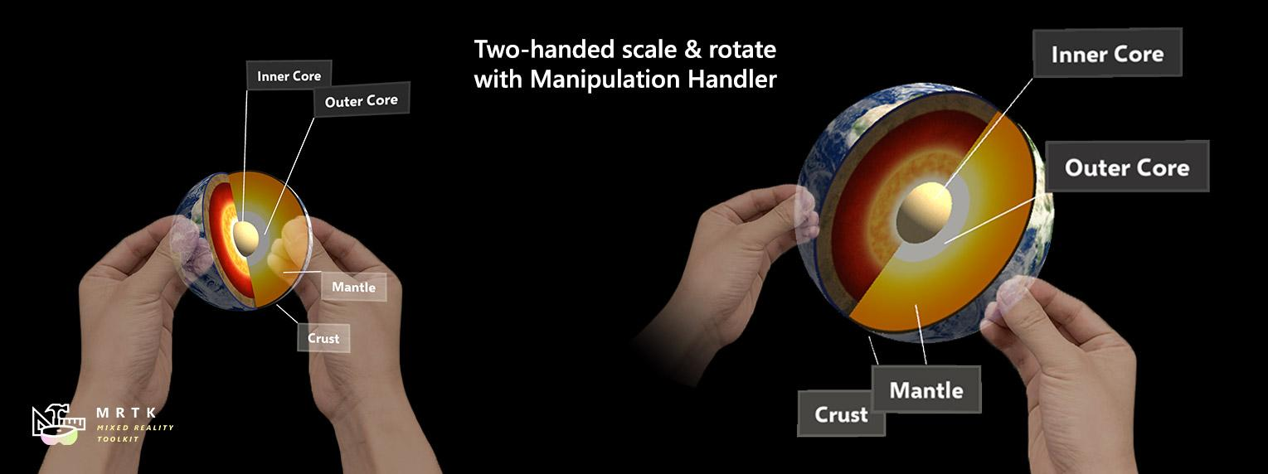

Figure 3.8 Example of object manipulator [79]

##### 3.2.2.2.4 Spatial Awareness

The mixed reality toolkit comes with spatial awareness, which creates a collection of meshes for the environment that's within view of a pair of Microsoft HoloLens. This allows for more accurate interaction between the holograms, real world objects, and the user. When developing for spatial awareness it's best to keep in mind that it takes time for HoloLens to render the meshes for the 3D environment, so any rendered objects with applied real world physics such as components attached with rigid body in Unity would need buffer time before they could interact with the newly meshed surroundings. [20]

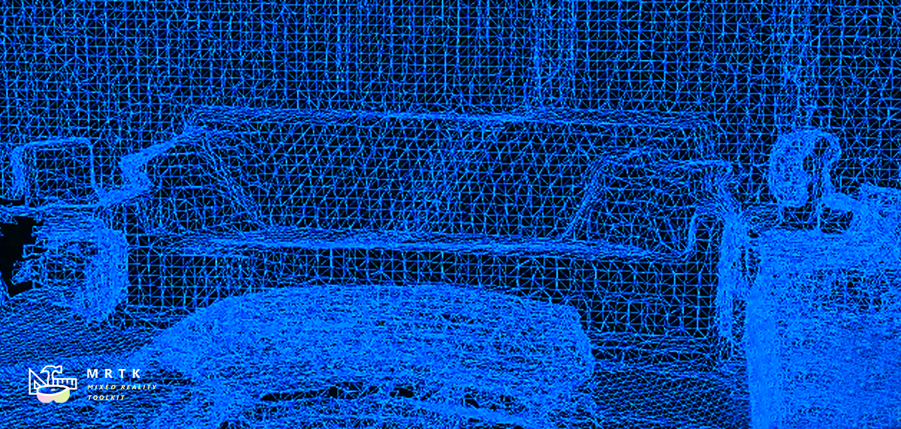

Figure 3.9 Visual representation of spatial awareness mesh collections [20]

##### 3.2.2.2.5 Boundary System

Within the Mixed Reality Toolkit there is a boundary system which provides a defined area for objects within view while wearing a Microsoft HoloLens headset. Boundaries are a vital element of mixed reality by helping users avoid unseen obstacles while wearing the headset. Mixed Reality Toolkit's boundary system creates a white outline for the user as they near boundaries. [19]

##### 3.2.2.2.6 Follow

The follow component within the Mixed Reality Toolkit positions and ties content in front of the user. By tracking the user, the element can be loosely constrained to them so that it moves along with the user after they move beyond a defined boundary. [25]

With this component, we plan on implementing it with the objects and menus of the application so that users can freely move while in use of it. This was not present in the current version of the app. When users moved the menu would remain stationary to a fixed location. Additionally if users were not facing the right direction when opening the app they would have to turn around to find the menu.

### 3.2.3 Version Control Options

With all projects, especially those that are worked on by a team,comes the need to use some sort of version control. There are several reasons why a team should use version control. Version control allows for improved collaboration, if we are both working on the different files then we can merge them both into one centralized location rather than having to keep sending each member of the team the file that was modified. Since all the files are stored in a centralized location it also acts as a backup. If someone's computer and or files got wiped all the progress would not be lost, this can help prevent major setbacks.

Another major benefit of version control systems is that it allows you to go back to the previous version, before certain changes were made. This capability can be very useful when bad code is pushed into the centralized location because it allows you to easily revert the change and allows for one to fix the problem before they commit the change again. Our team knew we needed to use a version control system for our project, and knew we needed to choose the right one for our needs.

#### 3.2.3.1 Perforce

Unity has the capability to integrate with two different version control systems, Plastic SCM and Perforce. This does not mean that we cannot use other version control systems, all it means it would not be supported and we would have to manually set it up and maintain it. Perforce is a good choice for a large team dealing with projects that incorporate a number of digital assets. Perforce utilizes a helix core which has a centralized model instead of a distributed model. A centralized model ensures all developers have the latest version by storing everything in one centralized server. This helps improve communication and collaboration because it allows for developers to see all work in progress that is being done. In version control systems that utilize distributed models any work in progress is stored in a local repository, therefore other team members are unable to see what one is working on. Perforce also has good performance, being able to handle billions of files, petabytes of storage, and millions of transactions a day. It allows developers to quickly and efficiently check if they are working on the latest file version. However, Perforce is not as efficient as a distributed model system when it comes to local commits, mergers, and diffs. Ideally Perforce would be a good choice when you have larger codebases, non-code assets like digital assets, code dependencies across components, and when a lot of code is being reused.

#### 3.2.3.2 Plastic SCM

The other version control system that Unity supports integration with is Plastic SCM. Plastic SCM was developed by Codice Software but is now owned by Unity, which is why it is capable of unity integration. Plastic SCM has the capability of being using both centralized and distributed version control models, allowing for the developers to pick whichever will fit their needs best. Unlike Perforce, Plastic SCM requires the entire workspace to be updated before a commit can be executed, while Perforce just needs the file to be committed to be the most up to date. This file commit restriction can cause some delays. This version control system does not allow for a user to see the entirety of how the code changed and developed over time, but does still allow to see recent history. Another major drawback of Plastic SCM when compared to Perforce is that it can not handle very large repositories and or large binary files well. Plastic SCM can store large binary files but then the performance is severely impacted, and can hold up to 8GB for a repository which is very small especially when you have a lot of digital assets. Plastic SCM and Perforce do have some similarities, those being that they both support task branches, have systems in place to avoid merge conflicts, both can show history (Perforce can show the entire history while Plastic SCM cannot). Overall, Plastic SCM could be considered for smaller projects with repositories smaller than 8GB but should not be considered for larger projects. Plastic SCM might be a better choice because it is faster than Perforce in the core functionalities of version control systems (add, checkin, and update) when handling smaller repositories, no more than 8GB.

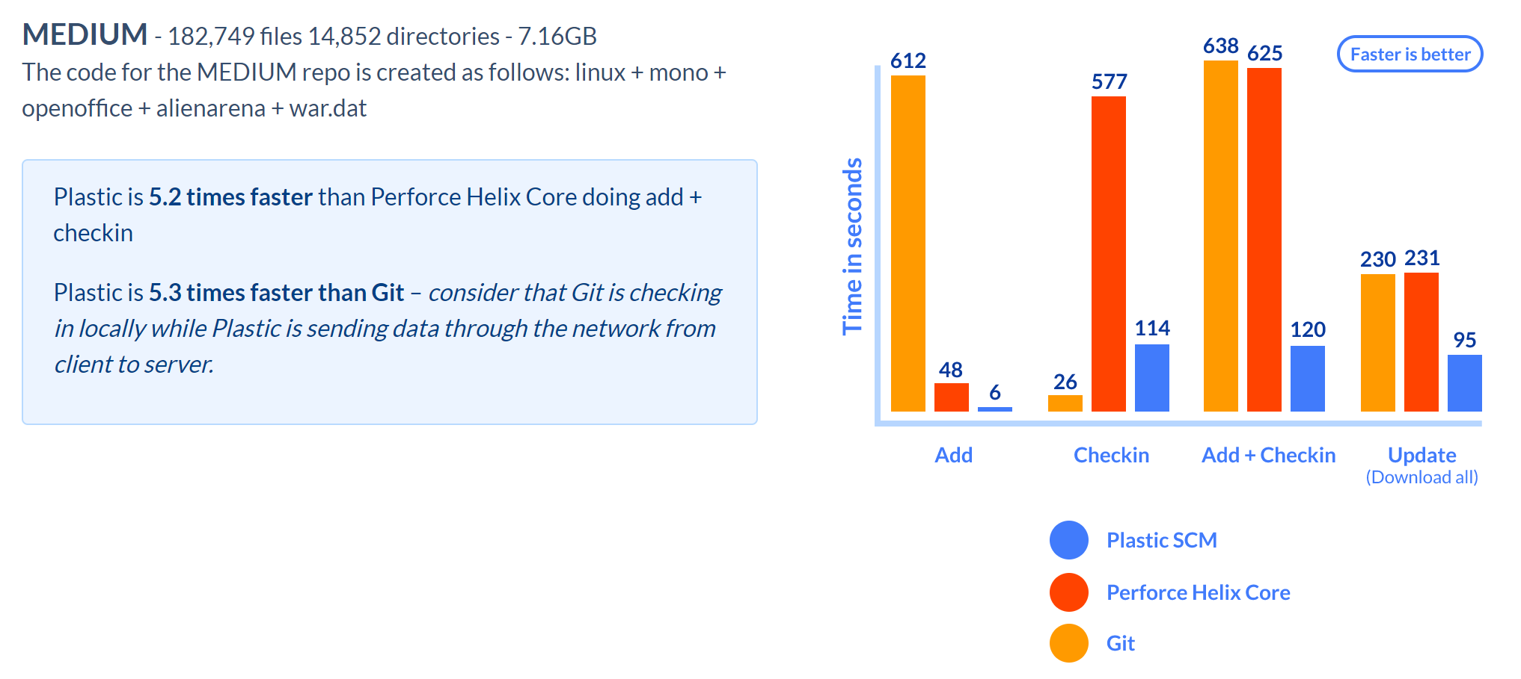

Figure 3.10 Speed Comparison [59]

The figure shows the speed comparison of the three version control systems that were considered for our project. As mentioned, Plastic SCM is significantly faster than Perforce and Git. Note that these results are for a repository of 7.16GB.

#### 3.2.3.3 GitHub

Another version control system that our team considered was GitHub. Although it is not capable of integration with unity we still wanted to consider it because it is a system that we are all familiar with and have used before. Like any other version control GitHub provides the team with a backup of the project. GitHub allows for markdown, like most other version control systems, which allows for users to leave comments, track issues, and create wikis. GitHub also has a system in place that makes the markdowns more useful when it comes to documentation. Having good documentation is key to familiarizing oneself with a new tool and or technology, thankfully GitHub is well documented for all things pertaining to Git. GitHub has documentation for generating secure shell (SSH) keys, a guide for the best workflow for Git, and samples of gitignore just to name a few. Having all this in one location is very beneficial because it cuts down time to look for documentation elsewhere, allowing oneself to use their time efficiently. GitHub, like most other version control systems, promotes collaborative coding, through easily allowing for branching and merging. This capability is essential when one’s team is not all in one physical location, especially since you do not need the company’s VPN to connect to GitHub all you have to do is store it in a private repository. GitHub also allows for projects to be made open source, if one’s team would like to do so, allowing for other contributors outside of the team to work on it.

GitHub has three main drawbacks: security, pricing, and difficulty for new users. The security risk comes from the fact that you are storing your repository, even if private, on a cloud. GitHub like any other website can be targeted to get user info allowing people to then be able to access your repo when they shouldn’t be able to. GitHub has taken actions to minimize this and provides information on what one can do to minimize it on their end too but it will always be a factor to keep in mind. Pricing can be a drawback if you have a large team. Some of GitHubs features, especially the enterprise ones, are locked behind a paywall because it is software as a service. The last drawback is that it isn’t the easiest tool to get familiar with, if you are new to it. The main causes of this are the various ways that one thing can be done, many commands, and inconsistencies between commands and arguments all of which can make the user overwhelmed and confused.

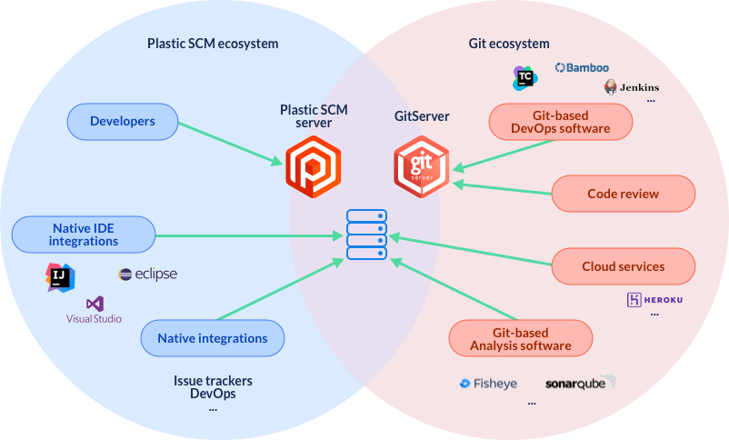

Figure 3.11 Git vs Plastic SCM [1]

The figure shows similarities and differences between the two version systems. The figure also shows some programs that the corresponding server can be integrated with.

#### 3.2.3.4 (GitHub)

With our team having familiarity with GitHub in previous projects and the scope of the overall project, the drawbacks of this version control do not seem as glaring. While not officially supported by Unity, it can work well with it as long as our team communicates either directly, or by ensuring that their pushes to the system have adequate information. The security of the project being stored on the cloud is not too worrying as GitHub having a breach in the near future seems unlikely due to recent security updates. The pricing of GitHub is not a concern because the features locked behind the enterprise version are not really necessary for our project. Finally, as mentioned before there are many guides on GitHub and its repository system in order to get familiar with it. Some team members also have experience in utilizing GitHub for previous projects as well and have found an easy way of using GitHub.

GitHub Desktop is an application for Github that allows for simple pushing and pulling with a click of a button. When pushing, it opens up a prompt to add in the details of the pushed changes. It also will not allow a push unless the most recent version of the project has been pulled and there are no conflicting adjustments. With the nature of version control, there is also the option to roll back to previous versions in the case of an unfixable, but avoidable error popping up within the latest versions All in all, it is a rather straightforward process in using GitHub and GitHub Desktop and will assist the team in delivering this project successfully.

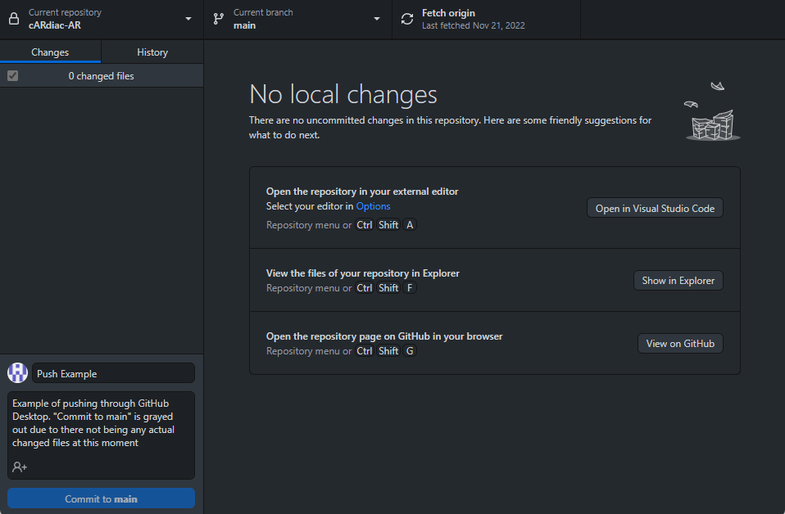

Figure 3.12 GitHub Desktop Example

## 3.3 Concept of operation

The cARdiac-AR application would allow the students to use the modern HoloLens 2 device for augmented reality experience. The AR application aims to provide an interactive and immersive experience to users by combining the physical world with digital information. The application uses the camera and sensors of a to track the user's hand position and gestures.

The first part of the application is the user application that will be used by the students. It was developed in Unity. There, students would be able to use the hand- and eye-tracking technologies used in the device developed by Microsoft to interact with various objects within the application. The application would allow the users to view objects and animations in 3D space while still being present in the class environment.

The application offers a range of educational resources, including 3D models and animations, to help users understand the functioning of the heart and different types of cardiac disorders. It includes several additional modules: anatomy, flashcard and cases. Students will be able to interact with all of the modules and learn and review various concepts.

A second part of the project is the database and the PHP applications that are connected to the Unity application. Their main purpose is to allow the faculty to review the engagement of the students. PHP app communicates with Unity and Database and serves as an additional layer of security.

# 4. Design of the Application

## 4.1 Research and Investigation process

### 4.1.1 Original state of the project

First version of the app was created for HoloLens 1. Our main goal was to update the app to work on the next generation HoloLens and fix the bugs to make the user experience smoother. However due to the state of the project of the previous developers and the incompatibility with the modules and interactions with HoloLens 2, it was decided to build the application from scratch. Building the app from scratch allowed us to easily integrate the objectives we planned out. It is important to know the state of the app when our team received this project to know what we changed, improved upon, and or added and why we might have done what we did.

### 4.1.2 Overview

The app can be broken down to two main sections M1 and M2 students (year ones and year twos respectively), both of which have some overlap. When you first open the app the student gets to choose their respective section to go into. Both sections have an AR heart at the center with an electrocardiogram graph (EKG) to the left which matches the heart's beat. The remaining similarities are a flashcards tab that students can click on for review and basic manipulation options of scale, move, and rotate. The flash cards tab allows students to review material but requires you to switch pages back and forth, we plan on making this experience easier for the user.

M1 students have tabs more focused on learning about the heart. The tabs that can be found in the M1 section are Anatomy, Contractility, Preload, and Afterload all of which have a textbox with information the student can read pertaining to that specific tab to help them learn about the heart, with an exception to the anatomy tab which does not have a textbox but rather adds labels to different sections of the heart.

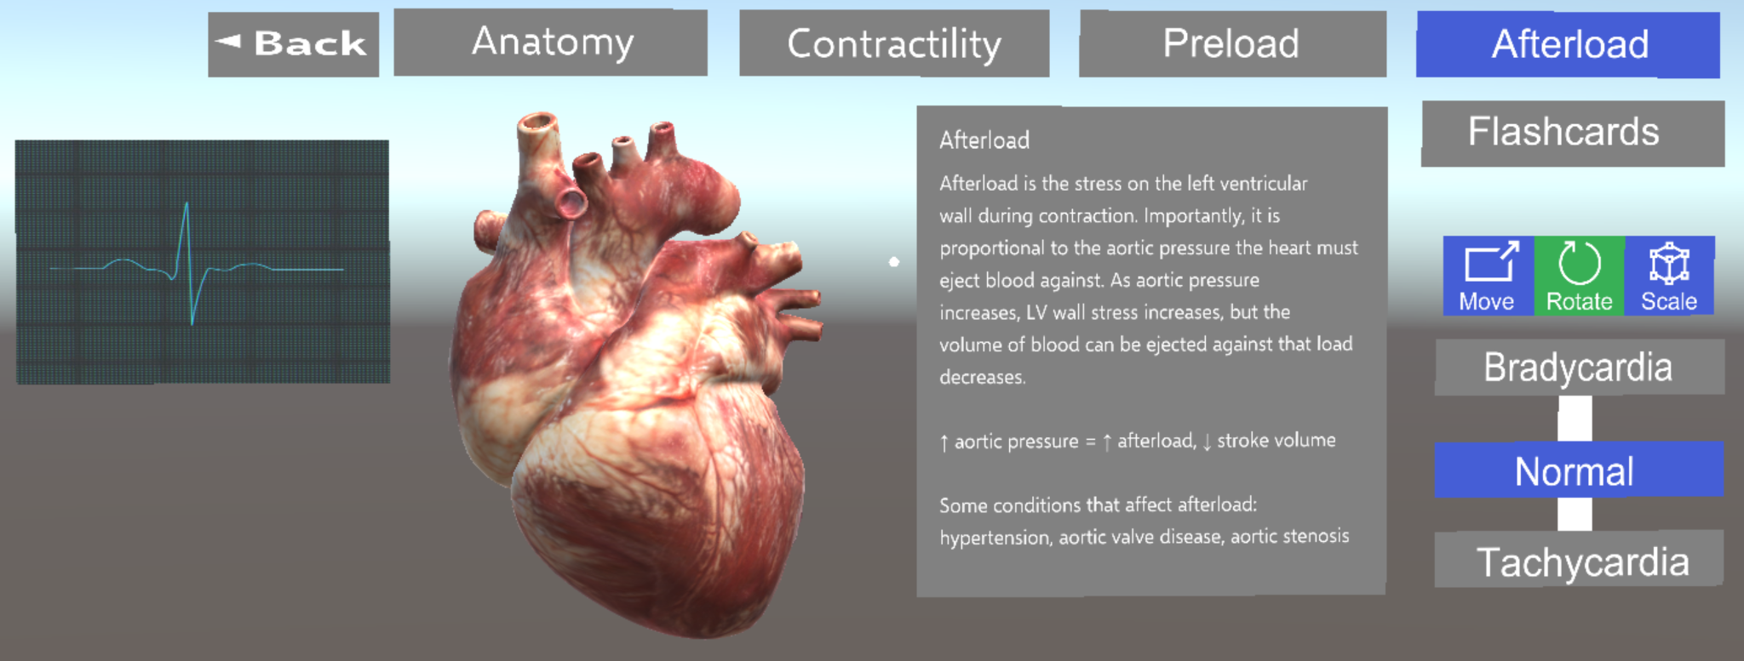

Figure 4.1 M1 Main Screen

M2 students have tabs more focused on review which are Cases and the above mentioned Flashcards. Cases can be compared to quizzes and the goal is to collect data from these just like a quiz. When you go into the cases tab there are different multiple choice questions that the student would go through and answer; after each inputted answer the student gets to see if they inputted the correct or incorrect answer and gets to try again. This behavior is similar to the flashcards where after each inputted answer it takes you to a different page and then you need to go back to the other questions. We plan on improving this to make it a more user friendly experience and minimize the amount of page switches needed. The last tab that can be found in the M2 section is the rhythms tab which allows students to see the heart and EKG of a heart with certain diseases, they also have the option to slow it down or speed up the heartbeat and or see the blood path or electrical path of the heart.

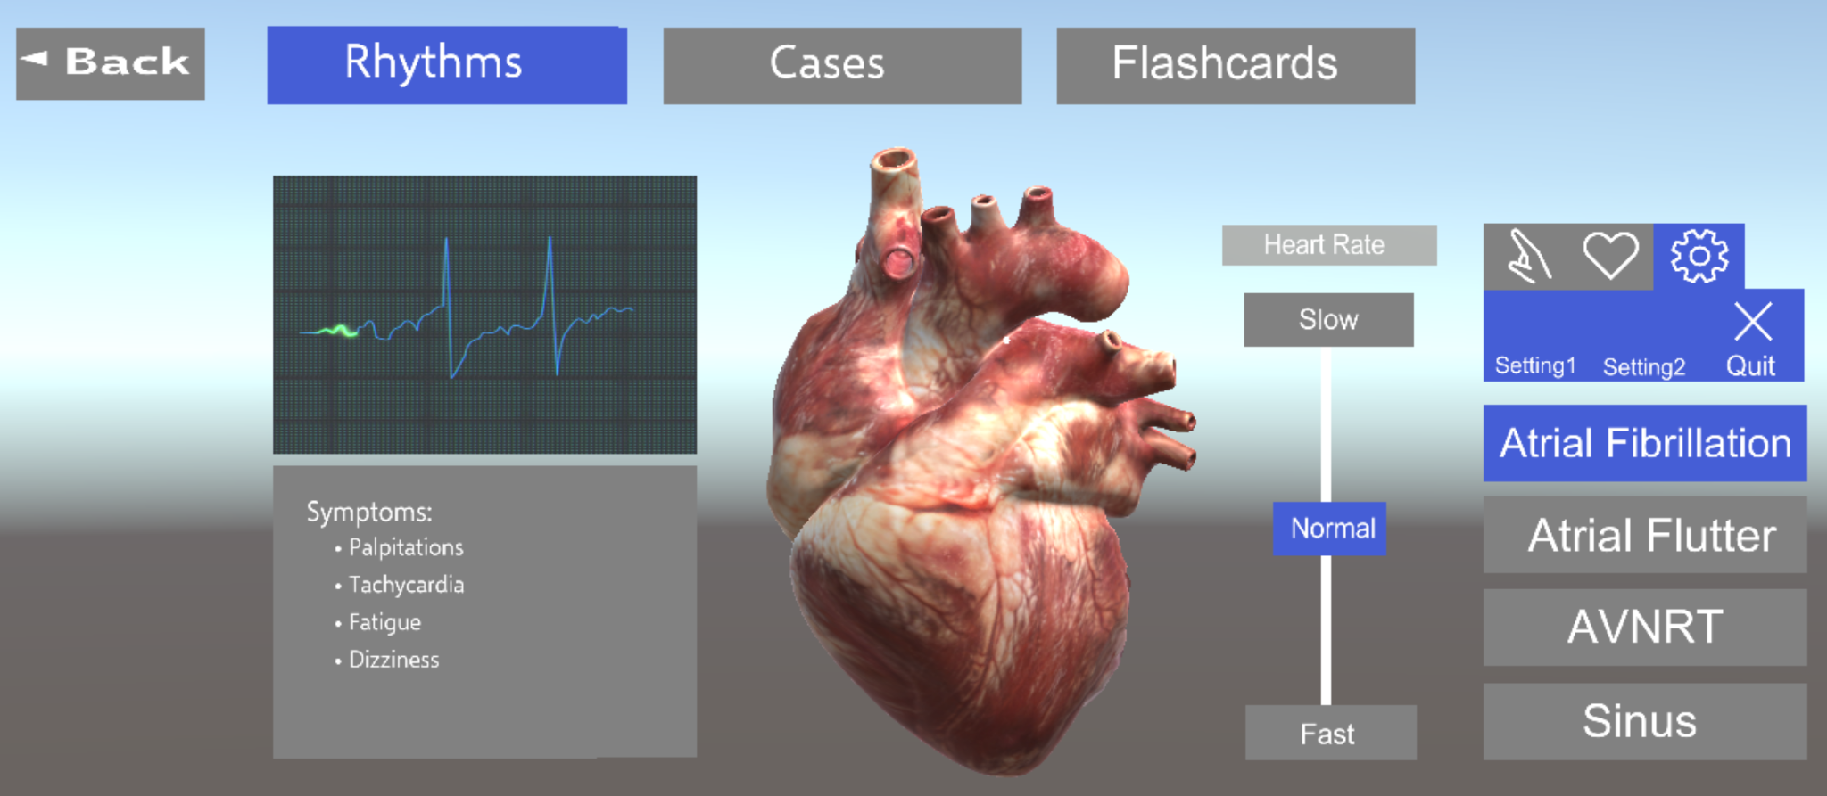

Figure 4.2 M2 Main Screen

The cARdiac AR app runs on a HoloLens1 headset and our main goal for the project is upgrade it to work on a HoloLens2 headset. HoloLens1 uses different hand gestures to control the AR environment, primarily a pinch movement with the thumb and index finger. On the other hand HoloLens2 uses a variety of hand gestures like tap, grab, and a hand rotate gesture. These gestures should make navigating the AR environment easier because they each have their specific function. The headset adjusts to each individual person wearing the headset. The app is uploaded to the headset and able to be used by the students. With these upgrades and the changes we plan to make the user experience should be a lot more user friendly.

### 4.1.3 Data gathering

There was no way to store the user data in the first version. But creating a way to identify students and report their participation was another requirement from the sponsor. This led to the development of a database for the storage of student metrics for use by instructors, with the metrics including student quiz and case performance, student engagement within the app, and a confidence rating each student would have when practicing within the app’s flashcard section. The database will also store all the M1 and M2 cases, flashcards, and quizzes that would be changeable and unique for each section of students, with instructors having the ability to change those variables through the database.

This solution has been expanded to include the cARdiac VR and the Escape Room projects to act as a central database to gather metrics from the students using the differing apps to one location for instructors to gather their metrics. This comes with the challenge of finding the right way of connecting all the different apps on the different platforms (Hololens 1, Hololens 2, and OculusVR) and the different metrics being gathered between the cARdiac teams and the Escape Room team into a single data center. With proper team communication between each team’s database and backend, the base of this data gathering central database was set up by the end of the first semester (Dec 2022). The solution we came up with collectively was an Azure Resource Group, which includes the MySQL database and a PHP application. All services are hosted on Azure to seamless integration.

### 4.1.4 Updating content of flashcards and cases

For the first version, any change to the materials presented in flashcards or cases required redeployment of the app. Due to this, the faculty is limited to making any changes to the materials that students are learning. If there is a need to adjust the case question, the faculty member would have to update the project itself and then reupload the app to HoloLens. This is not only time-consuming but very challenging to do for faculty with no technical background. For the second version of the app, the team plans to store such information on the database. So, using some GUI faculty members can adjust the materials of flashcards and cases easily and no not need to do any additional action to make those changes visible on the application.

### 4.1.5 Unity Requirements for development

When we received this project the cARdiac app was built on a 2017 Unity editor and is using hololens toolkit. The project will need to be upgraded to a newer version of unity, preferably the most current long term support version. In addition to this, the app can either continue to use hololens toolkit, which would not be ideal because it stopped receiving support and updates in 2018, or we can switch over to mixed reality toolkit (MRTK) v2 which is the most current long term support version of MRTK. The latter being the better of the two options, especially if the project has plans to be worked on in the future.

### Upgrading from 2017 to 2018

Our team did not encounter any problems when upgrading from 2017 to 2018. There were several changes to packages that helped improve development of applications in Unity but there were a few notable changes. Prefabs in Unity are fully configured game objects that can be saved and used between different scenes and other projects without having to reconfigure them repeatedly. In the 2018 version, prefabs has its own mode to edit, delete, and add to help improve workflow. C# compiler was upgraded to use Roslyn instead of MCS which allows developers to use C# 7.3 and report additional warnings. 2017 and prior editor versions used the UnityPackageManager folder that stores manifest.json. Editor versions 2018 and above will be storing this file in a folder called Packages instead to maintain consistency with virtual relative paths of packaged assets.

### Upgrading from 2018 to 2019

Upgrading from 2018 to 2019 also had several changes to packages including upgrading the assets database from version 1 to version 2. One of the biggest changes though is that HoloLens Toolkit is no longer supported after Unity Editor 2018. Instead, for Unity Editor 2019 and after, Mixed Reality Toolkit (MRTK) is used. This change will have our team rebuild the application basically from scratch or piece by piece to implement MRTK in order to upgrade to newer versions of the Unity Editor.

## 4.2 HoloLens Toolkit Vs. Mixed Reality Toolkit

Both HoloLens Toolkit and Mixed Reality Toolkit were created by Microsoft which are both collections of tools that are meant to help developers. HoloLens Toolkit is only supported on Unity versions 2018 and below and Mixed Reality Toolkit is supported on Unity Versions 2018 and above. There are several differences between how the toolsets components are implemented such as inputs, interface/event mapping, camera, speech, spatial mapping, and utilities. The next sections go further in-depth on the two toolsets:

### 4.2.1 HoloLens Toolkit

HoloLens Toolkit was created by Microsoft and is a collection of components and scripts meant to aid the development of holographic applications. HoloLens Toolkit features the following areas: input, sharing, spatial mapping, spatial sound, utilities, and build. The following subsections are descriptions of these modules:

#### 4.2.1.1 Input Module

The input module contains scripts that handle HoloLens input such as gaze, gesture, and voice. This module allows developers to handle several types of input and send them to game objects within Unity. This module contains an IInputSource interface that defines several events that can be triggered by input sources which is then sent to the InputManager interface that deals with forwarding inputs to the correct game object.

#### 4.2.1.2 Sharing Module

The sharing module allows for rapid prototyping in Unity for building shared experiences amongst components. This enables the HoloLens Toolkit menu in the Unity toolbar, contains compiled architectures that allows Unity applications to access shared API’s, and prefabs and scripts related to sharing and networking features.

#### 4.2.1.3 Spatial Mapping

Spatial mapping is the ability to create a 3D mapping of an environment which is also called 3D reconstruction. It allows devices to interact with and understand the real world helping to create a realistic blend of the virtual and real world. The spatial mapping modules provide libraries that make this process easier and provide more tools for the developers to use.

#### 4.2.1.4 Spatial Sound

Spatial sound is the ability to create sound in a 360 degree environment around the user. This is done by using positional data to create sound as if it’s coming from a specific direction thus making the audio more life-like. The spatial sound module contains scripts to help refine this functionality.

#### 4.2.1.5 Utilities

The Utilities module contains common concepts in development to allow developers to have leverage over their applications with useful simple libraries.

#### 4.2.1.6 Build

The build module builds and deploys the developer’s Visual Studio code, APPX, installs, launches, and retrieves other log files and related functions. [55]

### 4.2.2 Mixed Reality Toolkit

Mixed Reality Toolkit Unity was created by Microsoft and provides a set of features and components to aid development in cross-platform mixed reality applications. Some of the functions provided are building blocks for spatial interaction such as mapping and sound, rapid prototyping to view changes immediately, an extensible framework for developers, and supports a vast range of platforms. It was built to scale across AR and VR applications smoothly when deployed on HoloLens 1 or 2. The following goes over several tools and services that MRTK offers developers and the benefits of using it:

#### 4.2.2.1 MRTK Services

Many features included in the Mixed Reality Toolkit are grouped together in the form of services which contain three primary groups, systems, data providers, and extension services. [19]

#### 4.2.2.2 Systems

The systems services provide tools that aid the core functionality of MRTK and are implemented through the IMixedRealityService interface. The system services include boundary, camera, diagnostics, inputs, scenes, spatial awareness, and teleport systems.

#### 4.2.2.3 Input System

Mixed Reality Toolkit’s input system is one of the largest systems in MRTK and offers the following to developers:

· Handle a variety type of input sources from speech, articulated hands, and DOF controllers through input events

· Associate a variety of inputs to an abstract such as menu or select

· Create pointers that attach to controllers to help utilize UI components

#### 4.2.2.4 Input Overview

Inputs in MRTK are created by input data providers which each provider corresponds to a specific input source such as Windows Mixed Reality, Open VR, etc. which are added to Unity projects through the registered service providers profile in MRTK which will automatically create input events when the correct input sources are detected.

#### 4.2.2.5 Input Actions

Input actions were created to aid in isolating application logic from specific input sources to help produce an input which is done by making the inputs more abstract rather than taking in the raw input. This allows for users for example to map a select option to any button that will trigger that action which is more convenient for the users rather than keeping track of the many different inputs that can trigger that event.

#### 4.2.2.6 Input Controllers and Pointers

Input providers create controllers when devices are detected and destroyed when it's disconnected which can be mapped to input actions and have pointers attached to them. Pointers allow controllers to query scenes to determine which game objects to focus on and call pointer events.

#### 4.2.2.7 Boundary System

Boundary system helps support VR boundary components for applications made within mixed reality. Boundaries help create an area where users can freely roam around safely when wearing an AR/VR headset. It aids users by helping users avoid objects that can’t be seen while wearing a headset.

#### 4.2.2.8 Data Providers

The data provider service provides data to MRTK such as input and spatial awareness that is implemented through the IMixedRealityDataProvider interface that acts as a device manager for inputs.

#### 4.2.2.9 Extensions

The extension services provide the ability for components to extend the functionality of MRTK either by MRTK or through third parties. It provides optional libraries and functions for developers to use.

#### 4.2.2.10 MRTK Packages

MRTK is a collection of packages that aid in the development of cross platform mixed reality applications. The following are some the packages that are used and how they support development:

#### 4.2.2.11 Assets Package

Although the assets package provides libraries for developers to use to aid them in development and works with Unity 2018 and above, it comes with certain drawbacks. Because the MRTK is a part of the assets folder it leads to having larger projects, slower compilation time, developers are left to solve package dependencies manually which contains large files and runs the risk of losing changes.

#### 4.2.2.12 Unity Package Manager

For developers using Unity 2019 and above, MRTK is available through the Unity Package Manager that comes with several benefits. Some of the benefits are having smaller projects, faster compilation, required MRTK packages are automatically downloaded when they have dependencies, and it’s easier to upgrade to newer MRTK versions. One drawback that comes with this is that MRTK becomes immutable.

#### 4.2.2.13 Other Packages

There are other notable packages that are included such as the foundation, extensions, standard assets, tools, and test packages. The foundation package contains a set of code that contains common functionality for developers to use. The extensions package contains additional services to use with MRTK. Standard assets package contains recommended components to developers such as MRTK standard shaders, audio files, fonts, textures, and icons. The tools packages contain extra helpful tools for developers to leverage, And the test packages contain scripts for developers to use to test code and especially when MRTK components are created.

#### 4.2.2.14 Modularization of MRTK

Version 2 of Mixed Reality Toolkit has better componentization which is the ability to break down components to smaller pieces whenever possible aside from the core layer of the foundation that makes MRTK. MRTK was able to minimize dependencies between services such as spatial awareness or inputs while also becoming more modular. To communicate between components, Unity was created so there were no direct links between components but instead MRTK uses interfaces to communicate between application code, services, and data providers.

#### 4.2.2.15 Profiles

In the foundation package there is a module called profiles which is one of the main ways that the Mixed Reality Toolkit is configured. Profiles are created to support scenarios across a variety of devices which are managed by data providers. Like this, applications that use MRTK can have cross-platform support depending on what device the application is being run on. Which contains a default profile that provides default profiles that cover most scenarios and platforms. Also, a HoloLens 2 profile that provides a profile with optimized settings for deploying and testing applications on the HoloLens 2.[21]

## 4.3. Design summary

### 4.3.1 Frontend

#### 4.3.1.1 Color scheme

To ensure that the colors on the application are accessible for all users, we referenced an accessible color palette which was based on WCAG guidelines. WCAG stands for Web Content Accessibility Guidelines which are the international standards organization for the internet. The purpose of it is to make web based content more accessible for people with disabilities or people using limited devices such as mobile phones [89].

When it comes to designing with colors with Microsoft HoloLens the following should be considered:

* Rendering light colors - Bright colors should be used sparingly as it causes user discomfort when using Microsoft HoloLens. Choose darker colors over lighter colors. If white is used then choose a value R 235 G 235 B 235 or hex EBEBEB.
* Rendering dark colors - Due to the nature of the HoloLens displays the dark colors will appear transparent. While black objects will appear solid similar to real world objects.
* Color uniformity - Generally due to the bright nature of holograms, they maintain color consistency regardless of any background however large areas may become uneven. Due to this avoid using big regions of bright, solid colors.
* Gamut - HoloLens displays make good use of the large range of color.
* Gamma - The differences in different holographic devices can make color and shadows appear increasingly or lesser intensity when it comes to brightness.
* Color separation - Color separation, which is the isolation of separate photographic negatives by the use of color filters of the parts of a picture or design, occurs with moving holograms when a user tracks objects with their eyes.

[49]

Windows color principles

1. Use color meaningfully - Use color conservatively and with purpose to call attention to the important content that you produce.
2. Use color to indicate interactivity - Choose a single color to indicate the content of your application that is interactive.
3. Color is personal - Incorporate accent color and theme into your application so that users can choose a lighter or darker experience.
4. Color is cultural - Consider how colors will be interpreted by people from different cultures.

[35]

The following are the colors chosen for the application design prototypes:

| Colors | Description |
| --- | --- |
|  | This white is used for text and object borders. When it comes to rendering light colors such as white it will appear bright on the HoloLens display so it should be used sparingly. This was the recommended white value by Microsoft. [49]. |
|  | This dark shade of blue is used for the background of the application. Since light colors can cause discomfort when used in large areas within the HoloLens display, it is recommended to use dark colors for the UI window's backplates [49]. |
|  | This shade of blue is used for the buttons and interactable objects in the application. |
|  | This light shade of blue is used to show active and selected buttons and interactable objects in the application. |
|  | This gray is used for multiple choice question selections. |
|  | This shade of red will be used for anything dealing with incorrect answers or responses. |
|  | This green will be used for anything dealing with correct answers or responses. |

#### 4.3.1.2 Updating the Application

CARdiac AR overall looks and functions how it was expected to when it was first created. Our main goal is to port the application from HoloLens 1 to HoloLens 2 and in the process of this upgrade the Unity Editor to 2022 version since it is outdated currently on the 2017 version. Both using the new functionalities that comes with HoloLens 2, all the new features and tools that come with the newest Unity Editor and upgrading from using HoloLens Toolkit to Mixed Reality Toolkit, our team plans to upgrade several aspects of the cARdiac AR application for both the user interface so it can be more aesthetically pleasing and making the application more user friendly especially when dealing with certain request from the sponsor to implement. The following are some of the features that our team plans to implement and update on the application:

#### 4.3.1.3 Application Follows Eye Movement

Originally cARdiac AR was created on HoloLens 1 which didn’t support eye tracking so the application would stay in place no matter where the user looks. In order to move the application, the user would need to pinch the application and move it to their desired location. HoloLens 2 comes with the ability to track eye movements and comes with a built in feature called “Follow me” which can be activated using a voice command or appear as a small icon on the top right corner of the application. With this function activated, the application follows where the user looks and goes, offering a much better user experience and convenience in comparison to having to pinch and hold the application to move it.

#### 4.3.1.4 Flashcards

We updated the flashcards to be more user-friendly and have a better design. Once the user has a flashcard displayed it will have a flip button on the card itself and what card number you’re on out of the total number of cards. We’ve updated the flashcards design to have a pretty design and the yellow color from the first version of the app. Users are also able to rank how confident they are in their responses using the slider. Once the user wants to check the definition of the term, they can clip Flip to reveal the term. There, they have to select whether they got the flashcard correct or not to move on to the next flashcard.

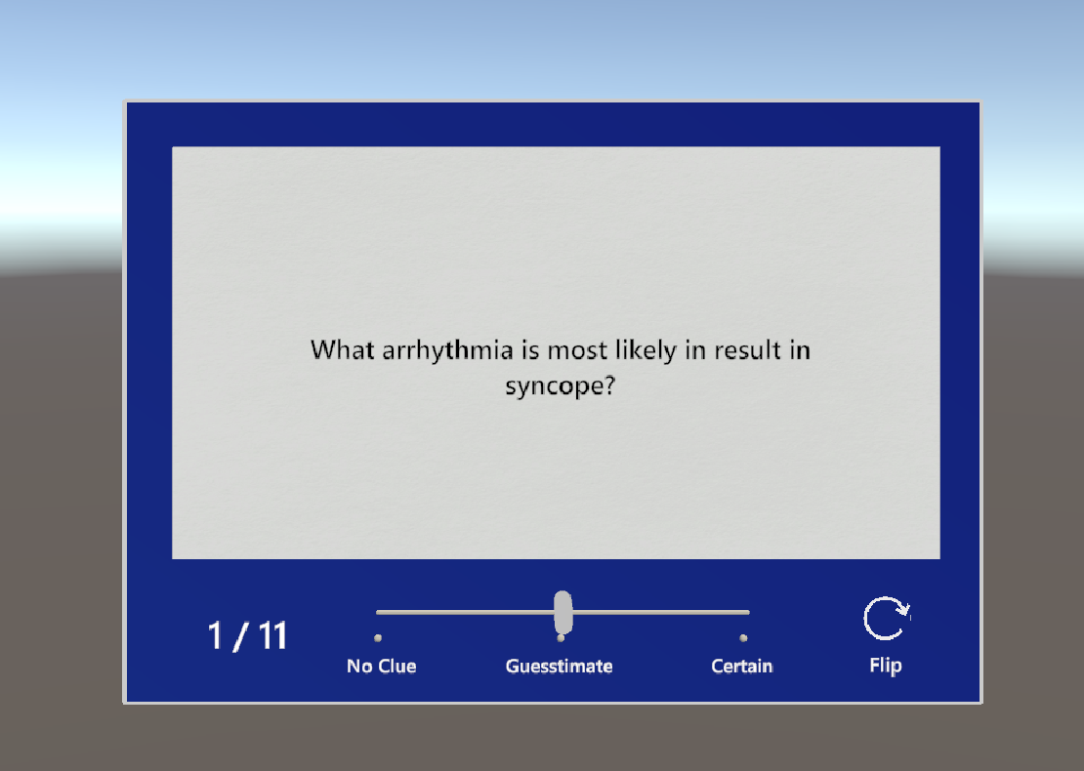

Figure 4.3 Flashcards

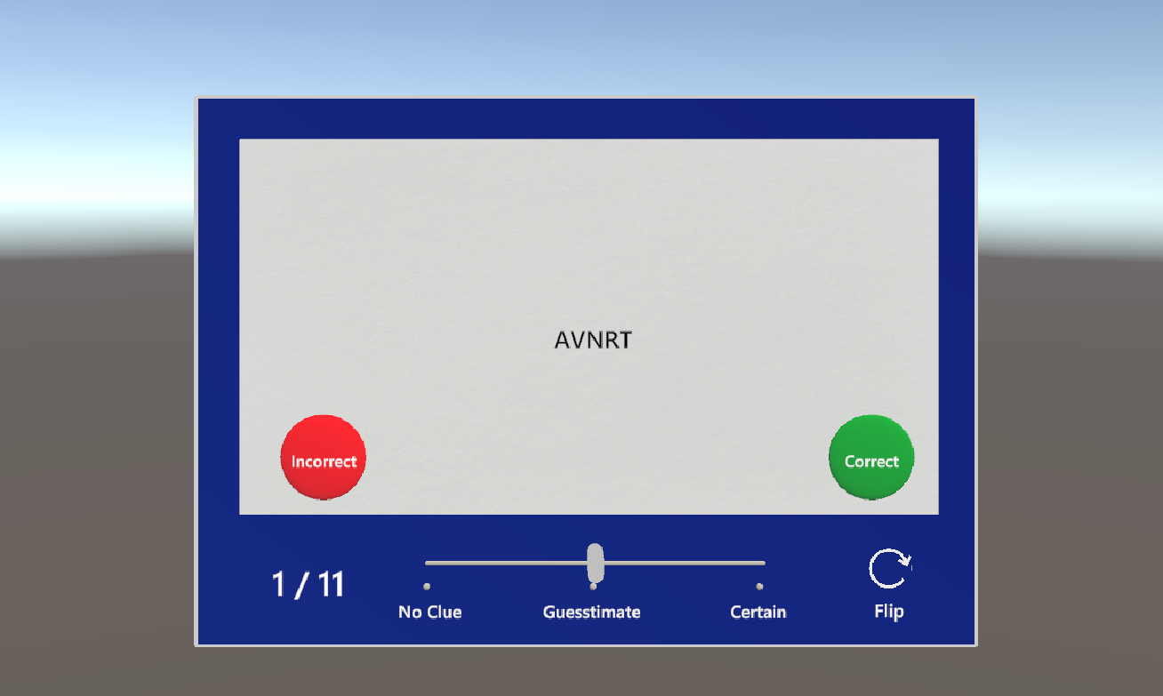

Figure 4.4 Flashcards flipped

#### 4.3.1.5 Cases

Originally, the plan was to have cases for M1 and M2 in the application. During the development, the faculty has decided to only include the cases for M2. In the first version of the application, when doing the M2 cases, if a user gets a question incorrect it displays a different page to the user that simply says “Incorrect. Try again” and make the user click a back button to return the question. To make this function more user friendly we want to change this to where if the user gets a question incorrect it simply shows a red border around the incorrect answer and displays “Incorrect. Try again” in red below the case box. When a user gets an answer correct it displays a new page giving a small explanation about it contained in the same sized box with a ton of extra space which then has the user click a back button twice in order to get a new case. To make this functionality better when a user gets an answer correct, we would like to display a new page where it displays the correct answer and explanation is a box that is more fitted to the content and has the border of the box highlighted in green. Also, instead of making the user click a back button twice to get a new case, we would like to include a next button after a user gets the answer correct to make it easier to go onto the next case.

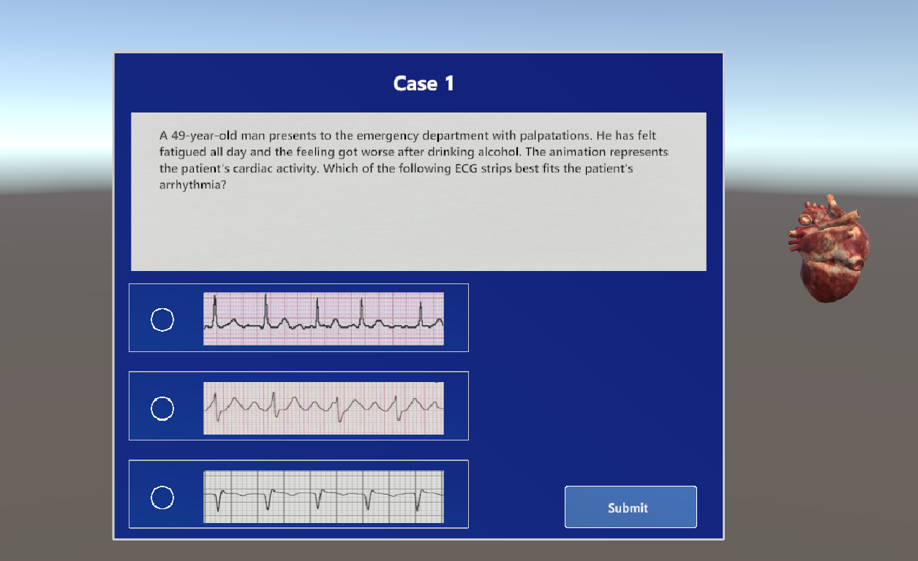

Figure 4.5 Cases scene - Main view

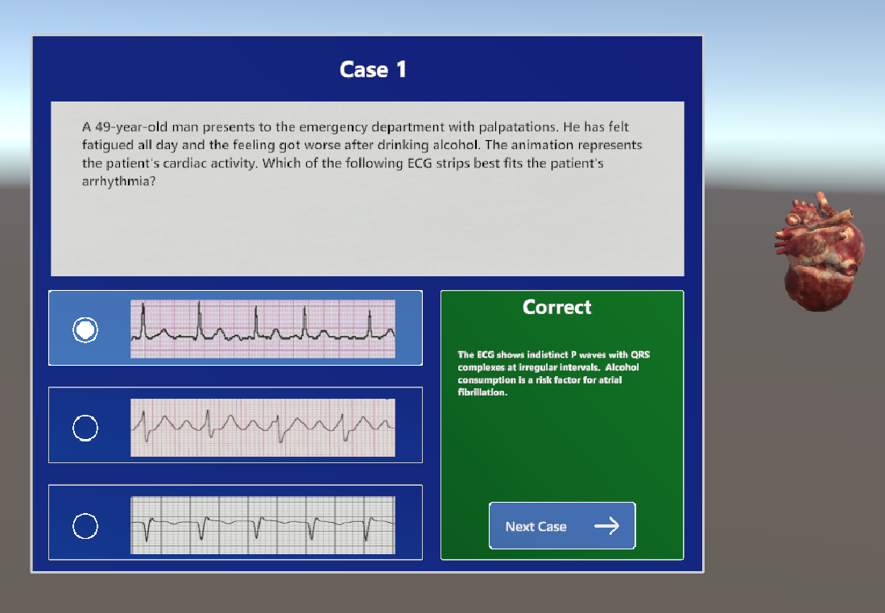

Figure 4.6 Cases scene - Correct answer selected

#### 4.3.1.6 Menu Option

In the M1 students menu option it has “Anatomy” as an option which only displays the anatomy of the heart over the different parts of the heart. This function does not change very much to the current display of the application rather than just add words to the heart. We believe that this does not qualify as a menu option but rather an extra feature that can be a small toggle button off to the side along with slice model, electrical flow, blood flow, reset option, and a button to bring you back to the tutorial.

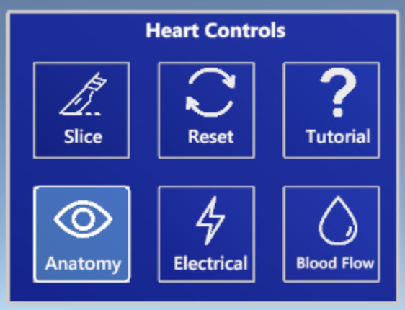

Figure 4.7 Heart Controls

Grouping like functionality makes the application more user friendly and helps create a cleaner user interface.

#### 4.3.1.7 Heart model

There are a few changes that we made to the heart model. We plan to change the look of the blood flow, electrical, etc. animation to have a more realistic look to it. To do this we used the Unity Particle System to create better blood effects. The current animation of the blood flow looks like a marker tracing through the heart which makes the application look rough given a well implemented 3D model of a heart. We improved the animations to look more realistic rather than just the red lines.

We also changed how the anatomy function displays the parts of the heart. The original function displays the anatomy directly on the heart in small black letters that are hard to see. Our new idea was to create labels with the name of each part pointed to each section of the heart to improve readability. This allowed us to make the labels as interactive buttons, by clicking on them, users are now able to get additional information on the selected part of the heart.

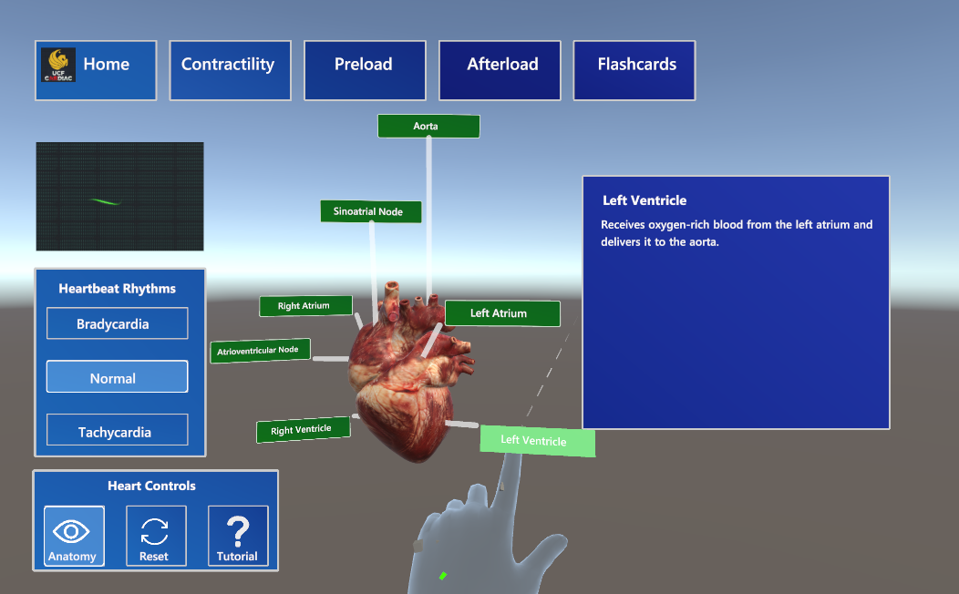

Figure 4.8 Anatomy labels on the heart

We would also like to expand on each section of the heart and give more details about that certain part when one of the labels is clicked. We would also like to give the heart its own space on the side having all the surrounding details to the side, like this the display looks cleaner and gives more space to move the heart around and rescale it as desired.

During the development process, the sponsor also provided us with the second heart model that represents a sliced heart. It already has animation for the beating, but they had to be readjusted to match the same speed and ECG and the first model. The second heart model for the application is presented in Figure 4.9.

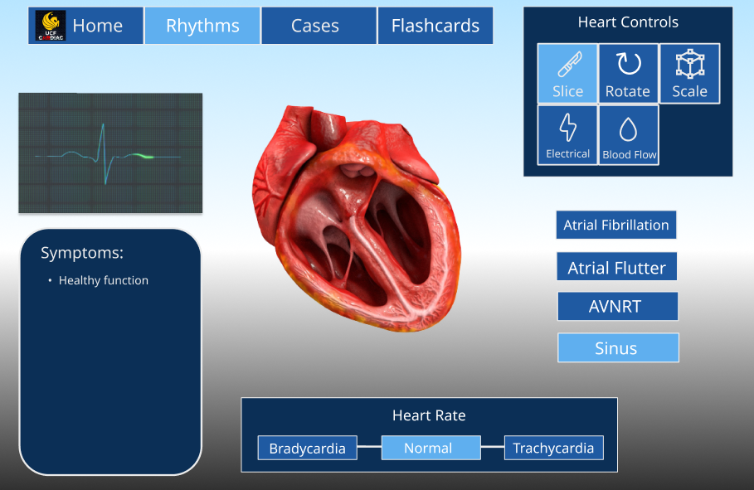

Figure 4.9 Sliced model of the heart

# Prototype plan

## 5.1 cARdiac-AR application prototype with Figma

Figma is a collaborative web application for interface design. It's a tool that helped us visualize and design the updated cARdiac application based on our sponsor's requirements and ideas. Using Figma we created wireframes that could be reviewed and commented on by our sponsor. The wireframes can showcase and give a general overview of the updated application without the time investment of having to fully build out the design or draw it by hand. It's a fast and efficient way to help the sponsor and our team agree upon what the application should look like. As well as giving us a canvas to brainstorm possible function and design ideas.

### 5.1.1 Login page

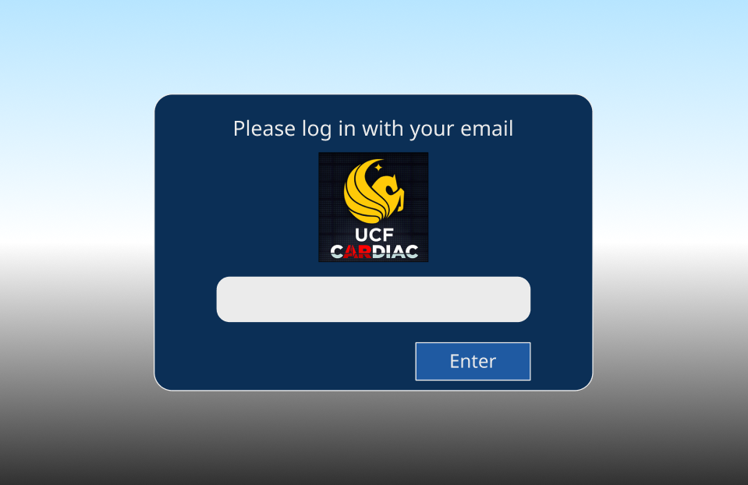

*Figure 5.1 Figma design for the cARdiac login page*

The login page is a new addition to the cARdiac application. It will be the first thing the user sees when opening the application. The purpose of it is for users to log into their account using their UCF Knights email so that their progression could be recorded. The application will track and save the user's progress through flashcards and case questions. Instructors will receive the data associated with the user's email.

### 5.1.2 Introduction Prompt

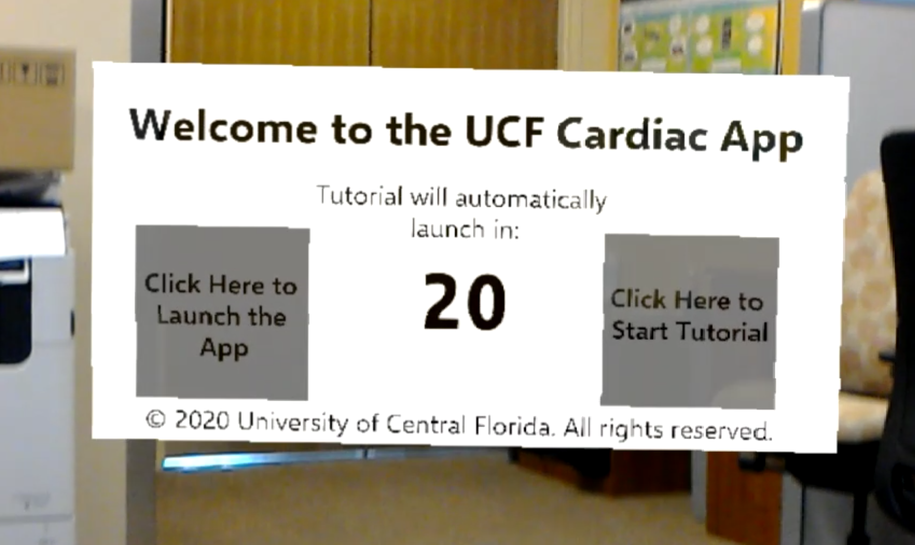

*Figure 5.2 Current design for the cARdiac Introduction Prompt*

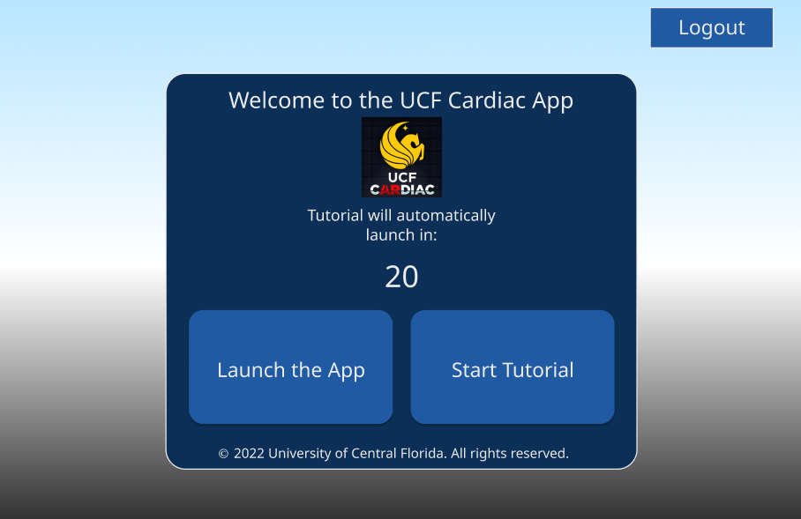

*Figure 5.3 Figma design for the cARdiac Introduction Prompt*

The introduction prompt is the first thing students see when logging into the application. They will be given the options to launch the app or start the tutorial if they are new to cARdiac. There is a countdown which will start the tutorial if a decision is not made within twenty seconds. In the updated design we included the UCF cARdiac logo as well as redesigned the menu to fit the overall theme of the application.

### 5.1.3 Tutorial

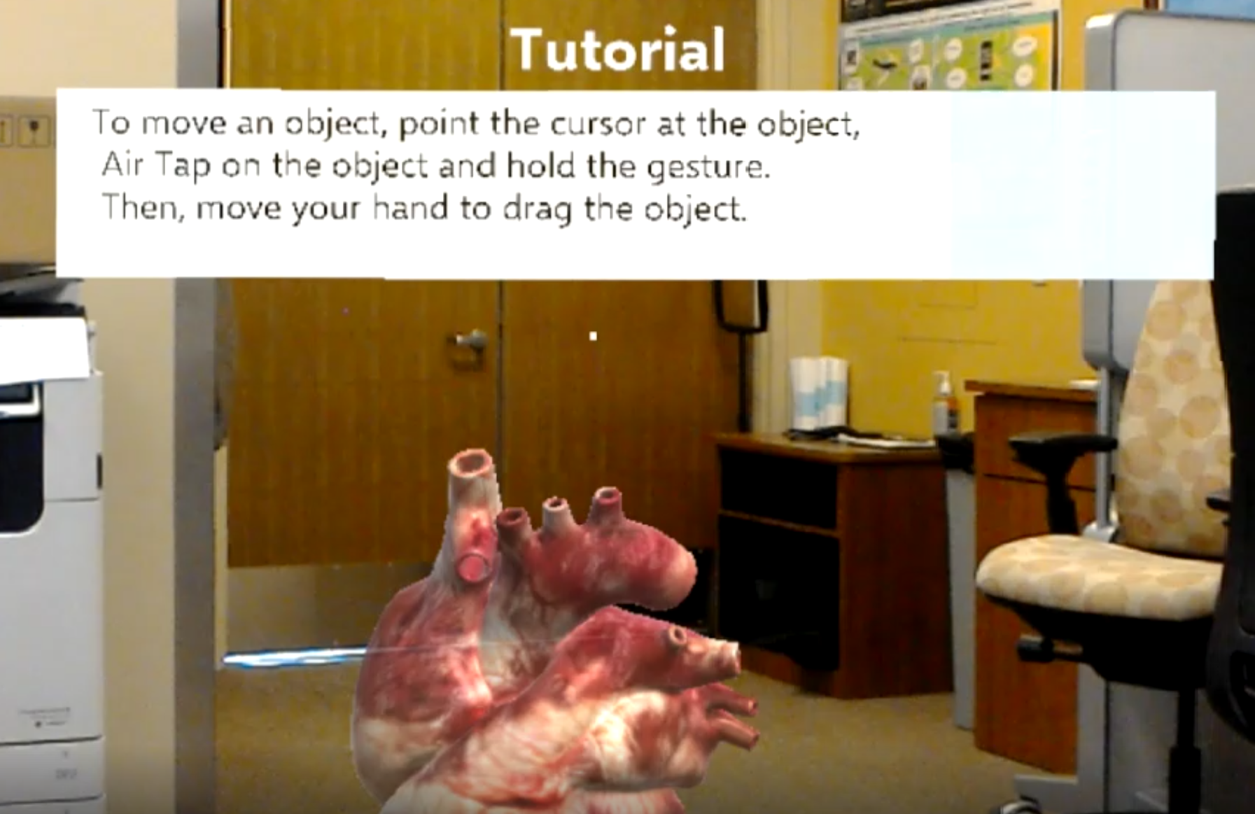

*Figure 5.4 Current design for the cARdiac Tutorial example*

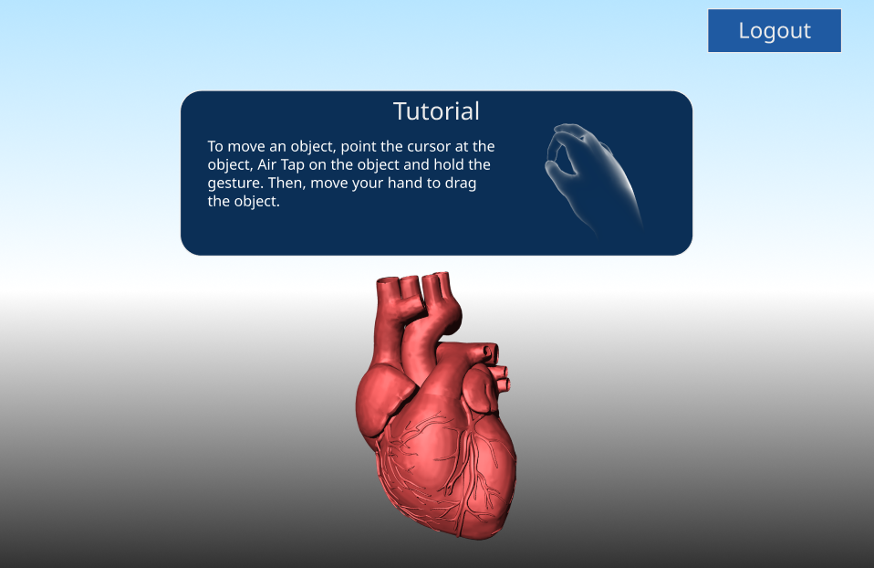

*Figure 5.5 Figma design for the cARdiac Tutorial example*

If the student selects the tutorial option or the countdown on the introduction prompt reaches zero and is automatically selected, they will go through a series of commands that will teach them the basics of using Microsoft HoloLens and the cARdiac application. We updated the look of the tutorial to fit the application theme and highlight the new gestures that are featured with HoloLens 2 that were not present in HoloLens 1.

### 5.1.4 Selection Menu

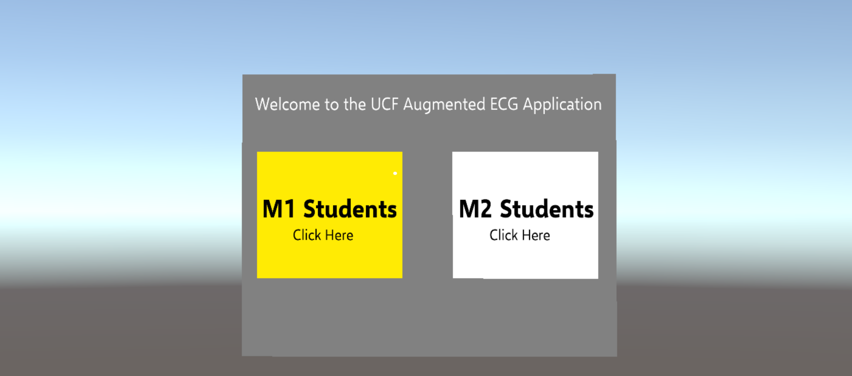

*Figure 5.6 Current design for the cARdiac selection menu*

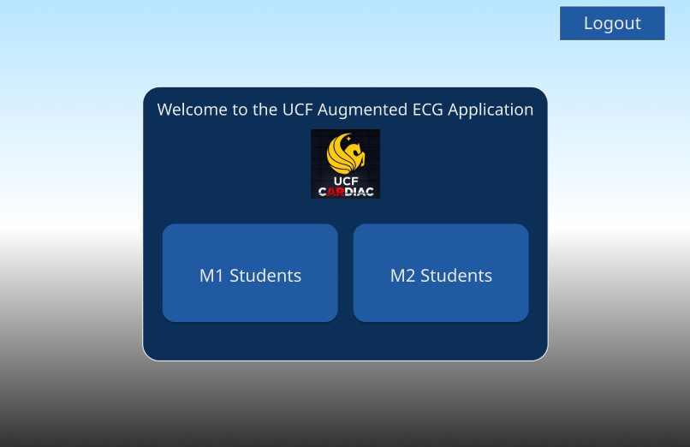

*Figure 5.7 Updated Figma design for the cARdiac selection menu*

The selection menu acts as a home page and allows students to choose their mode based on their level of experience. *Figure 5.6* shows the current design for the cARdiac application and *Figure 5.7* shows a new design update. The updated design removed the "Click Here" text and instead went with a drop shadow text plate to indicate that it's a pressable object.

For the colors we changed the original gray and white to shades of blue in accordance with Windows Accent color palette, for the main background and buttons. The purpose of color accents is to create a theme and provide contrast for the application. Blue was selected over colors such as green and red for accessibility.

### 5.1.5 Heart Scene

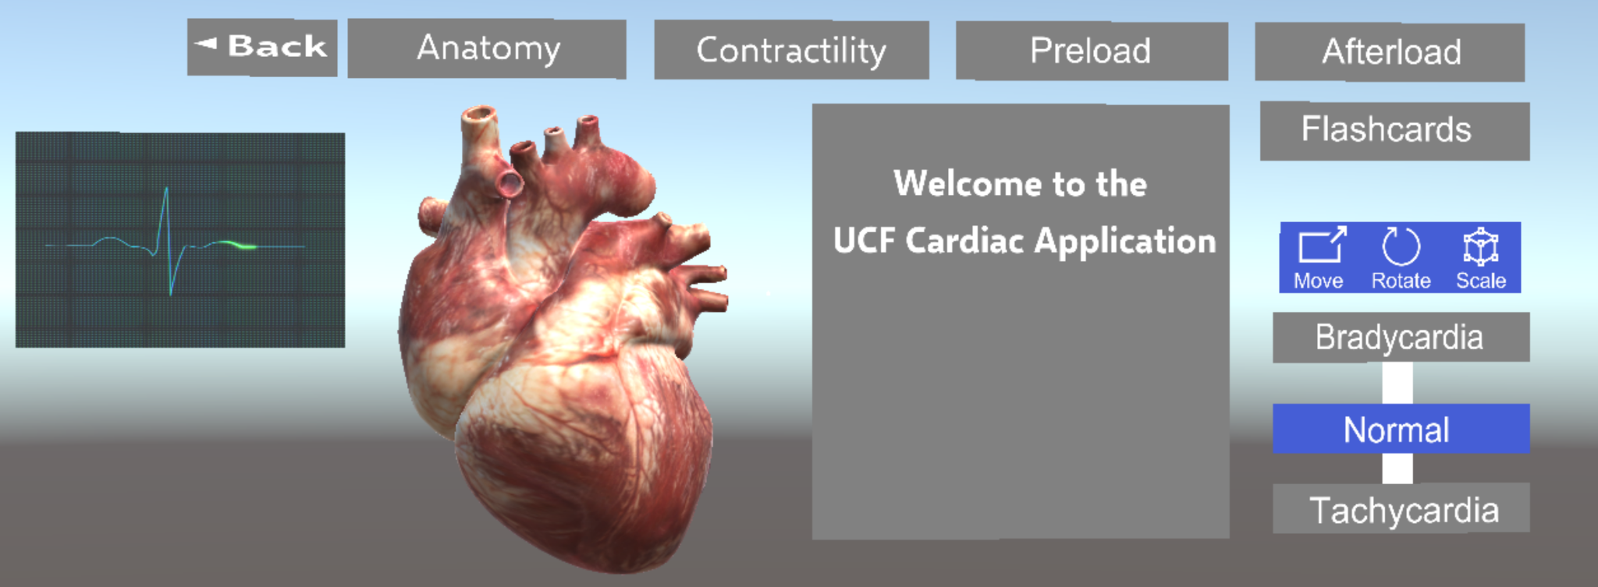

*Figure 5.8 Current design for the cARdiac M1 heart scene*

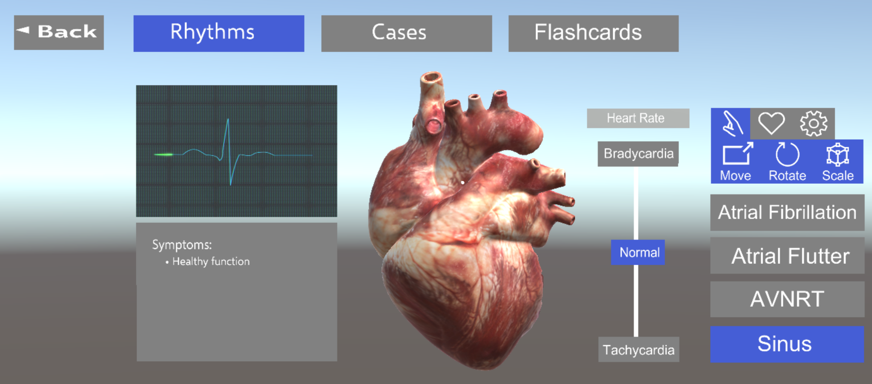

*Figure 5.9 Current design for the cARdiac M2 heart scene*

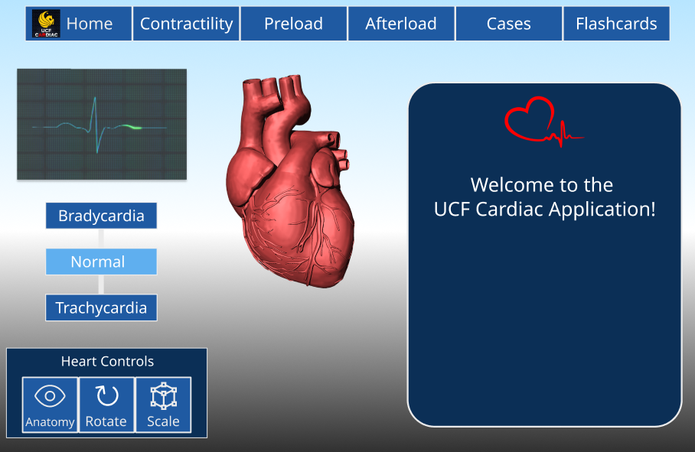

*Figure 5.10 Updated Figma design for the cARdiac M1 heart scene*

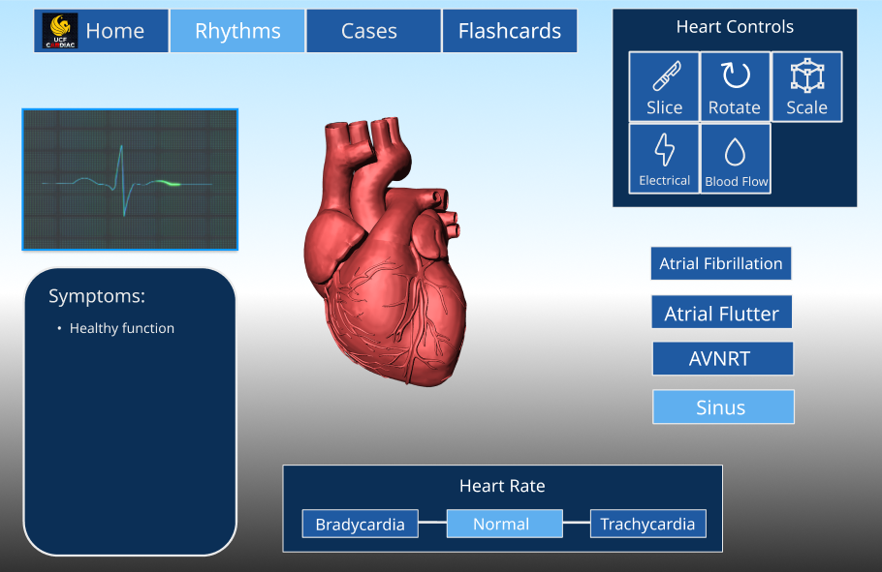

*Figure 5.11: Updated Figma design for the cARdiac M2 heart scene*

Once the student selects their category from the selection menu they enter the heart scene, which is the main page to interact with and manipulate the heart as well as access the learning tools on the application.

Some visual changes from the current version in Figures 5.8 & 5.9 to Figures 5.10 & 5.11 are updating the navigation bar to position the options better so that it wasn't bleeding into the next line thus making it look more organized. The heart options are also moved to be closer to the heart model as seen from Figure 5.8 to Figure 5.10. This will make it easier to manipulate the heart model. The heart options in the M2 level of the application were also altered from Figure 5.9 to Figure 5.11 so that the hidden options behind tabs are now fully visible. This will reduce the amount of actions required by the user to reach the options thus making using the application quicker to use. We also added a home button with the cARdiac logo replacing the previous back button. We believe this decision will provide more clarity to where the user will be navigating to and is overall a better design choice.

#### 15.1.5.1 Anatomy heart control

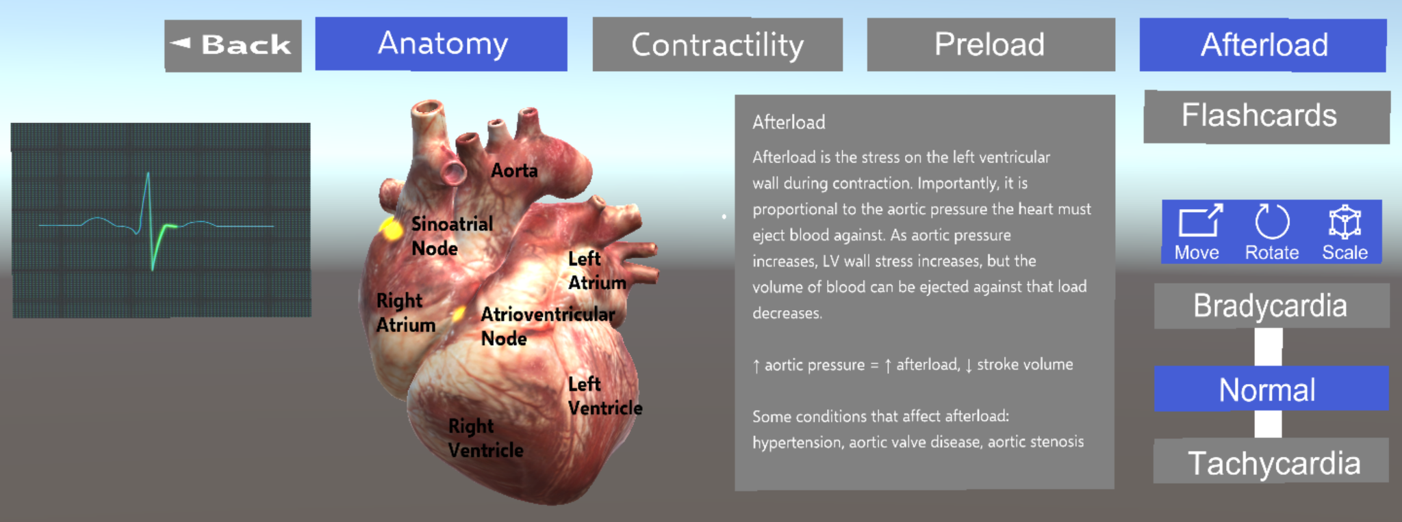

*Figure 5.12 Current design for the cARdiac anatomy option*

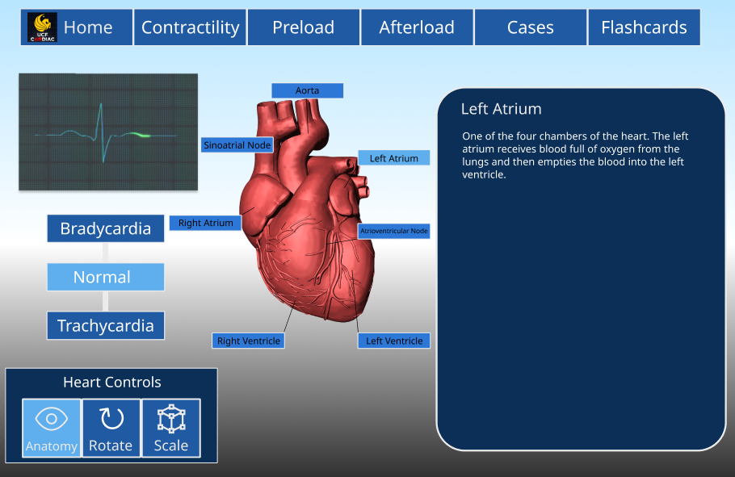

*Figure 5.13 Updated Figma design for the cARdiac anatomy*

The anatomy heart control shows the user the different parts of the heart. The move option within the heart controls was removed and changed to the anatomy option, shown in Figure 5.13, previously on the navbar. This change is due to the nature of the anatomy option being more suited as a toggle rather than an option on the navbar along with the different heart conditions. Additionally since the anatomy control is related to the heart, it made more sense for it to be included within the heart controls. Visually the anatomy labels were changed to have a box background and line pointing to the indicated section. This improves overall visibility. Another addition to the anatomy options we made is that the labels for the parts of the heart are now selectable. The selected parts will display a description of it on the main prompt slate.

#### 15.1.5.2 Open heart control



*Figure 5.14 Figma design for the cARdiac M2 open heart option*

The open heart control is a new addition to the cARdiac application. When selected it will change the default heart model to an open heart model. With this users can see the details of the heart from a cross section. Additionally, further descriptions and prompts can be provided by professors to enhance the learning experience.

### 5.1.6 Flashcards

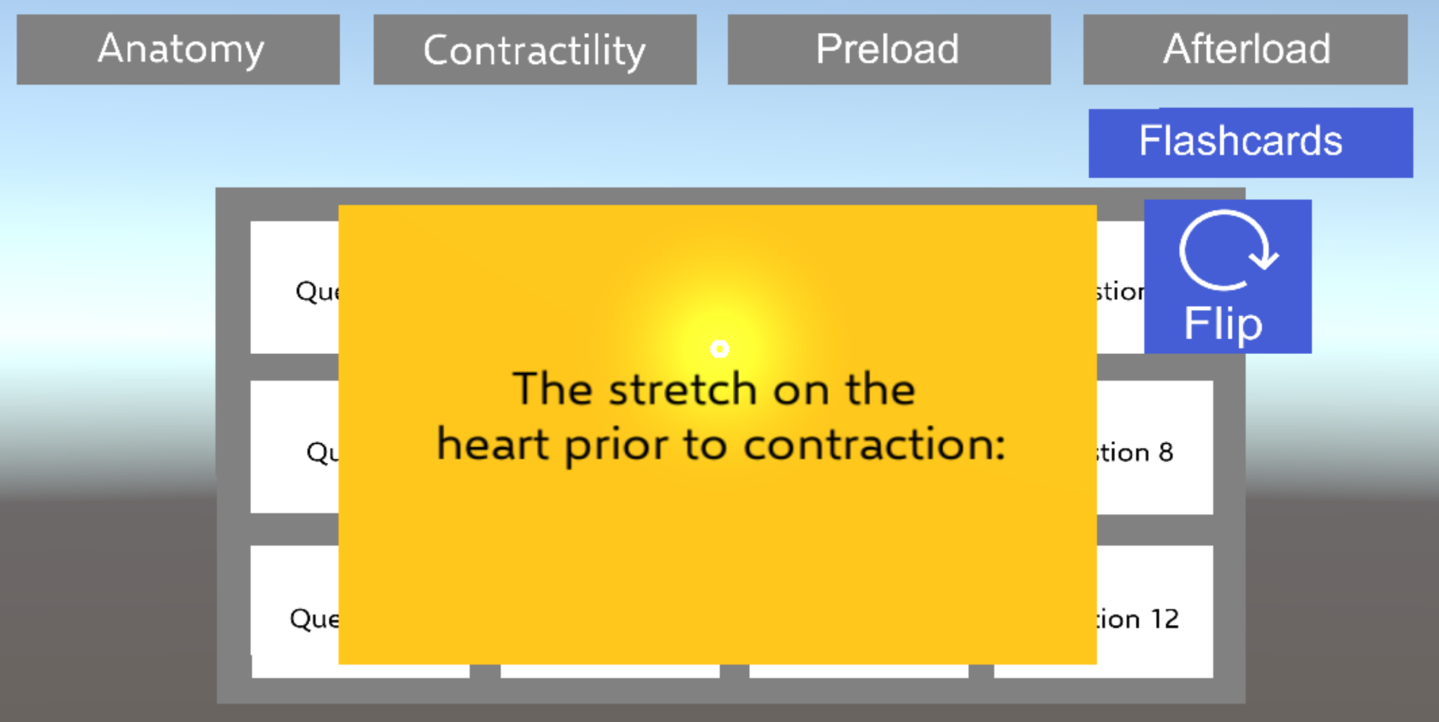

Figure 5.15 *Current design for the cARdiac flashcard*

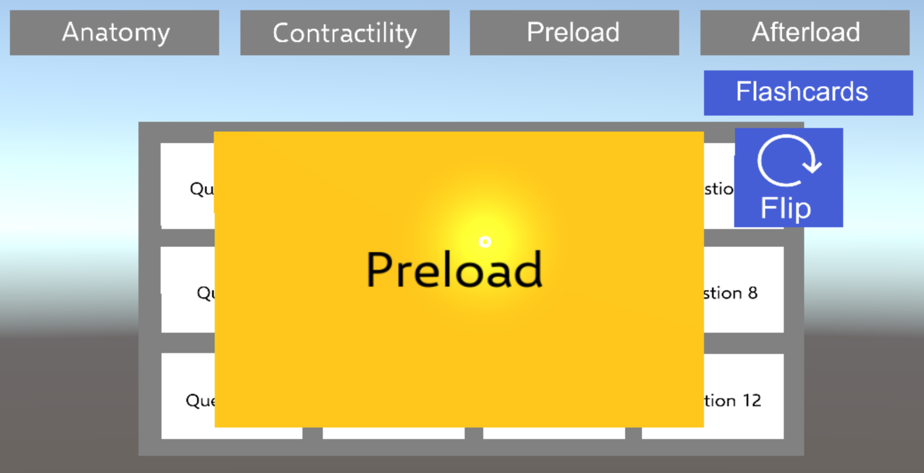

Figure 5.16 *Current design for the cARdiac flipped flashcard*

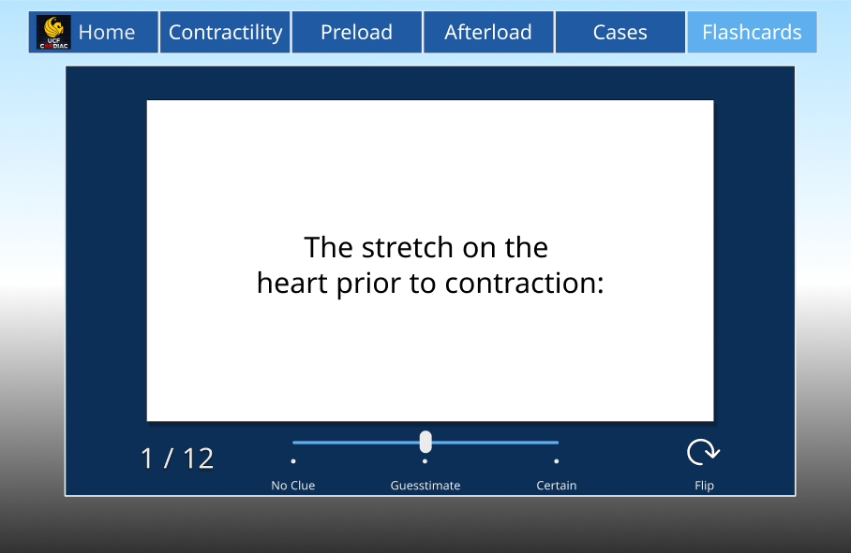

*Figure 5.17 Updated Figma design for the cARdiac flashcard*

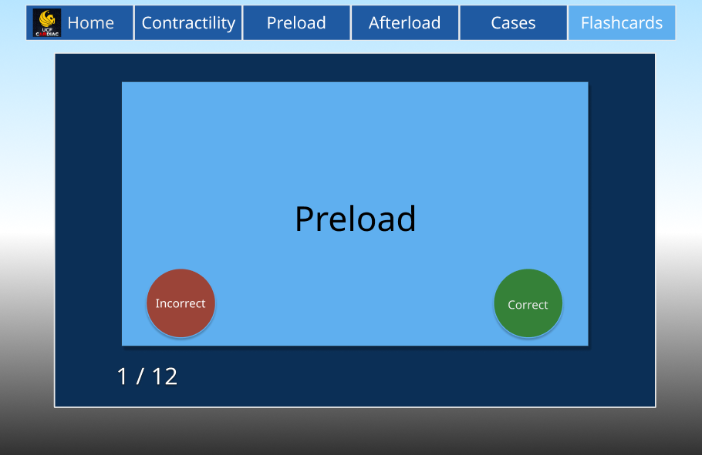

*Figure 5.18 Updated Figma design for the cARdiac flipped flashcard*

The flashcard tool lets students study and test themselves using questions curated from their instructors. A feature our sponsor wanted to add was the ability to track student progress while using the flashcards. To do this we added a slider to the design so that students could indicate how confident they were with the question. In addition we also added buttons afterwards for when the card was flipped so that the student could record if they got the question correct or not.

Additionally, we got rid of the cards in the background from the current design and opted for something that was visually less cluttered. Instead of having all the cards in the background we have a card count located at the bottom left to let the user know what card they're on and how many cards are left. Also a lot of the top buttons were linked to options relating to the heart scene of the application and were unrelated to the flashcards. So we cleared up the cluttered display of buttons on top and moved the flip button to the bottom right.

### 5.1. 7 Case Study

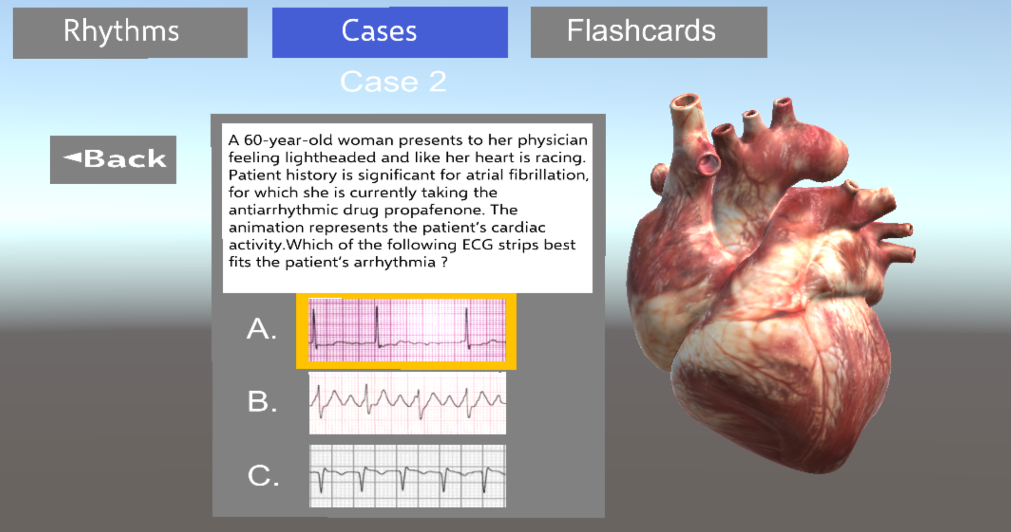

Figure 5.19 *Current design for the cARdiac case question*

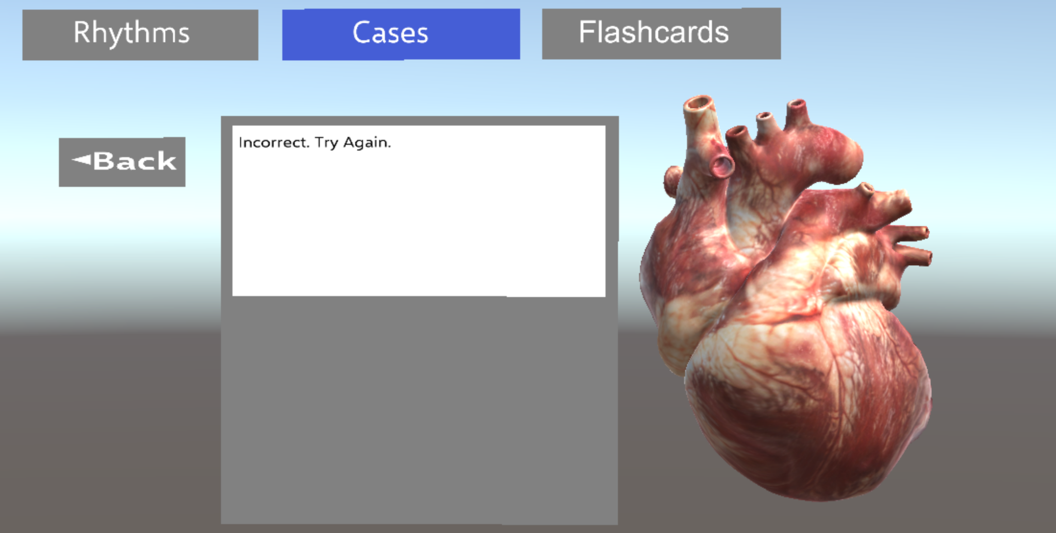

Figure 5.20 *Current design for the cARdiac case incorrect answer*

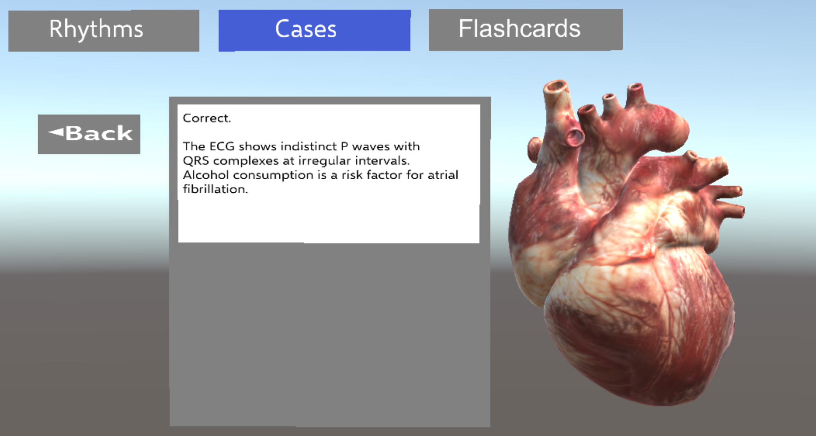

Figure 5.21 *Current design for the cARdiac case correct answer*

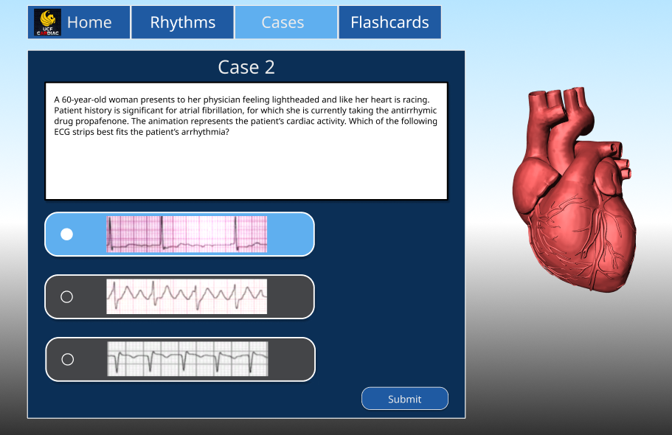

*Figure 5.22 Updated Figma design for the cARdiac case question*

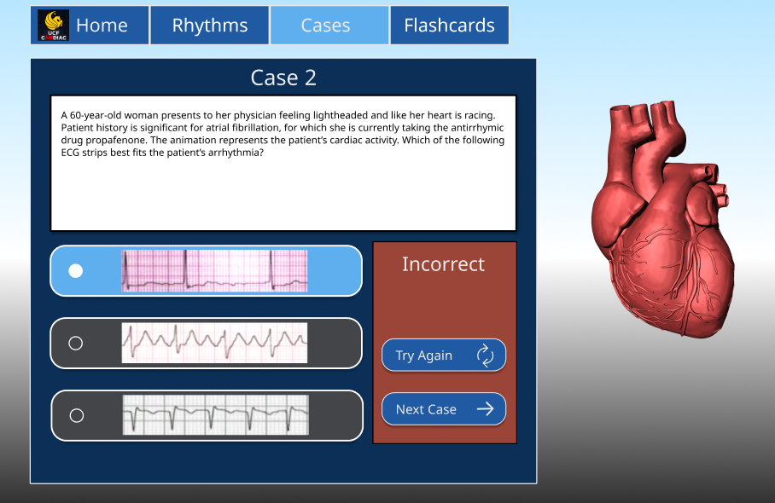

*Figure 5.23 Updated Figma design for the cARdiac incorrect answer*

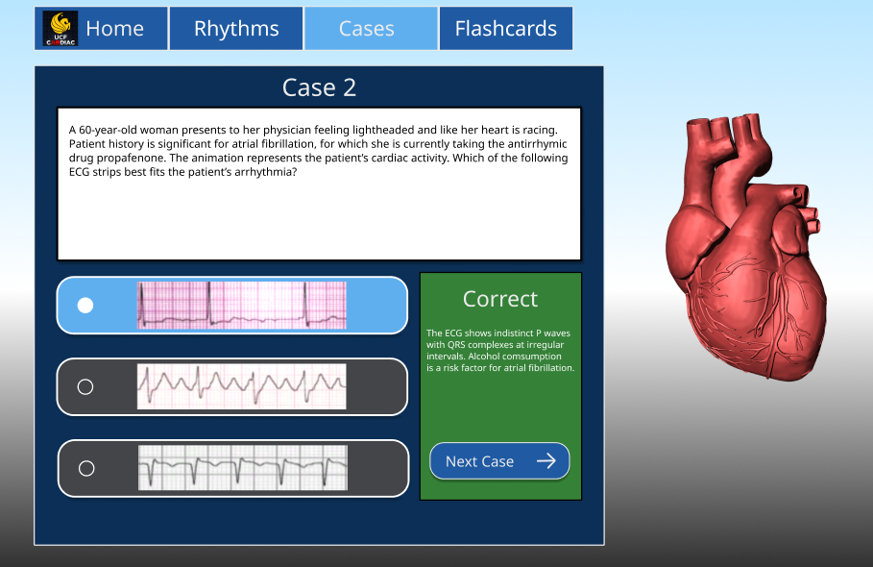

*Figure 5.24 Updated Figma design for the cARdiac correct answer*

The cases tool lets students test themselves with multiple choice questions based on cases selected by their instructors. With the inclusion of a submit button, which was a requested addition from our sponsor, students can now think over their answer after making a selection. Some other requested changes is the inclusion of a try again and next button. This makes navigation after a question more smooth. With the current layout if students wanted to go to the next case or try again they would have to back out onto the case selection menu and select a new case.

The design choice made from *Figures 5.19 & 5.20* to *Figures 5.22 & 5.23* was to keep the answer and case question on the same page after a question was answered. This allows students to better review their answers. With the current design as seen in Figures *5.19 & 5.20* it would take users to a new page with just the result of the question. This could be problematic if the student wanted to see or review their answer. To do so they would have to go back and forth from the previous question page.

## 5.2 Faculty dashboard prototype

During the initial planning, the team had an idea to create a special web portal that would allow the faculty to easily track the students progress similarly to Canvas. This application would mostly be a way for the faculty to monitor and record students progress, viewing grades and statistics on students activity on the application and updating the information that is displayed in the AR application (Flashcard terms and definitions, changes in cases). The portal would also include the Students accounts, where students would be able to view their grades and completion, as well as get the code to login into the AR application. This application was supposed to offer the faculty to be able to control the data gathered with a nice and intuitive interface instead of a CSV file, however, during the planning, this idea had to be removed from our goals due to the prioritization of other tasks. Based on our prototype, the application would have two dashboards: one for students and one for faculty and their content would be different based on the role. The advantage of this application would be that the faculty would never need to access the database, so no additional software to access it would be needed.

### 5.2.1 Faculty dashboard

The grades page would be the place for faculty to get feedback on the students progress. The statistical information would consist of information on each student. Their completion of each case would be shown, as well as flashcard information. The flashcards information that would be displayed would consist of the total of the flashcards viewed, the percentage of which the student got correct, and the confidence levels. As a nice to have, we would like to add the general statistics for all the students combined to see the total infographics of students progress and adding the export/import button so that data can be easily put into the Webcourses.

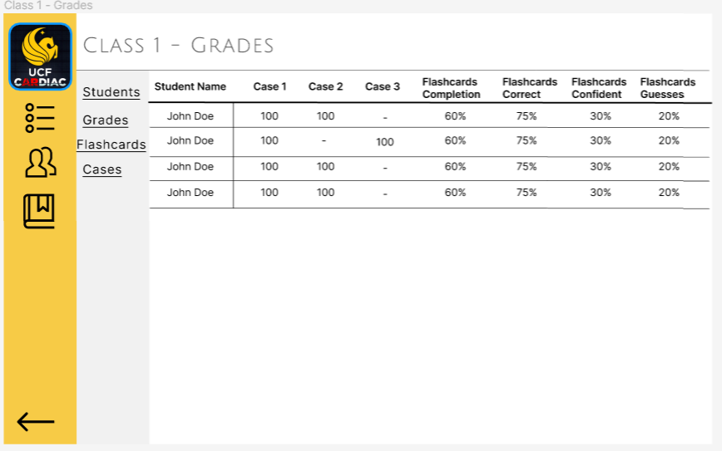

Figure 5.25 Page where the faculty can view grades for all the students

As shown on Figure 5.25, the dashboard would also include the Flashcards and Cases tab. This way, the faculty would be able to view the list of Flashcards and Cases for a certain class and update it real life from the website without the need to log into the database.

### 5.2.2 Student Portal

Student portal could be an individual dashboard for each student to track and monitor their progress. It is problematic to implement SSO within the cARdiac-AR app, so our original idea is to provide a code and a QR code for each student, which would be used as a login code to the app in the future. It is possible to look at the QR code through the HoloLens 2 set and automatically login into the cARdiac app. Otherwise, the unique code for each student and a password can be used. The dashboard would also show the completion of each module in the app, such as cases, and flashcards. Their completion is shown as passed/failed.

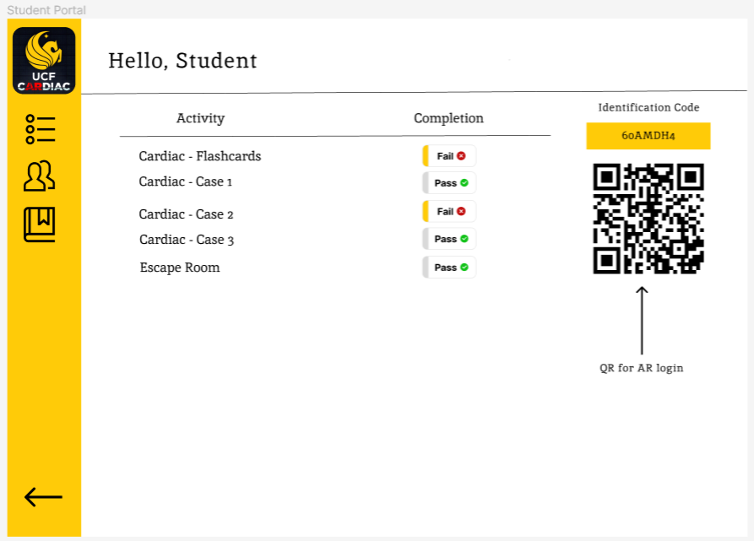

Figure 5.26 Student’s Dashboard

## 5.3 Backend prototype

#### 5.3.1 Canvas API

One of cARdiac 2.0’s ambitions is to have Webcourses Canvas implementation. This implementation will require many steps. To begin with, there is plenty of documentation for the implementation of the Canvas Learning Management System (LMS) that will aid us in our own implementation. The API Endpoint examples come in a tremendous amount. From changelogs to every new version of the API to smaller features of integration with third-party software, it is quite useful in building up the Canvas API for cArdiac 2.0. The main reason that we would have this be a part of the application would simply be that we would like teachers and students to have ease of access integration into their classes so that they can all proceed smoothly. From individual users being verified to performance metrics of those users; those features are what we are looking for in cARdiac 2.0. All access to this API would be over HTTPS in a JSON format and authentication would be done with OAuth2. However, the team faced a lot of permission issues with implementing Canvas API integration. And due to the fact that the project had to be completely rebuilt, we went with a simpler solution, but we provide our research on the topic here.

##### 5.3.1.1 Webcourses Canvas Access Tokens

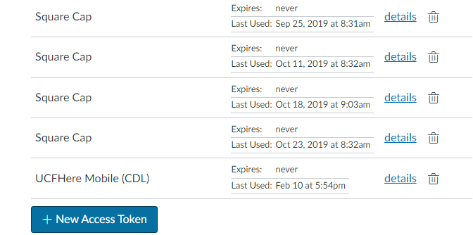

Figure 5.27 Canvas Access Token

To start integrating the Canvas API into the application, Webcourses is required. From Webcourses, one can review their history of access tokens as well as create new ones for their own use. Deletion is also an option to assure no useless and potentially vulnerable data.

##### 5.3.1.2 Shibboleth Server Provider

The server that the application will run on will need to be configured to be a Shibboleth server provider. Setting up Shibboleth access creates a service provider on the local server to communicate with an identity provider. In order to do so, an entity ID has to be created in order to give a unique string. Then the attributes for authorization have to be chosen. Essentially, who is allowed and who is not. The server must then be able to support HTTPS, thus it has to be configured as such. After generating an SSL key and properly registering the required information, the Shibboleth server should be functioning. This is all required in order for the UCF server and the application server to communicate in a proper and secure manner.

##### 5.3.1.3 EFI Sign-On Service

The Electronic Federated Identity Service is required as it is the primary service that authenticates UCF users. It is also one of the requirements due to FERPA and how they handle data security. It utilizes the identity provider mentioned before to authenticate NID and NID passwords in the system. After these users are authenticated they will be allowed to utilize their credentials for other systems such as Canvas to streamline the process. There is an annual cost to this service which is an estimated amount of $50, which will be reflected in the budget section of this document. There are no upfront costs for setup.

##### 5.3.1.4 OAuth2

As mentioned before, authentication will be done through OAuth2, a protocol that is natively supported in Canvas for its LTI Advantage service authentication. It is designed to allow third-party applications to authenticate users without needing their passwords through the utilization of tokens. These tokens are stored locally in a secure manner and users will get a 401 unauthorized error without a valid token. Testing-wise, generating a token is not an arduous process. The typical flow of use in OAuth2 is demonstrated in Figure 5.28.

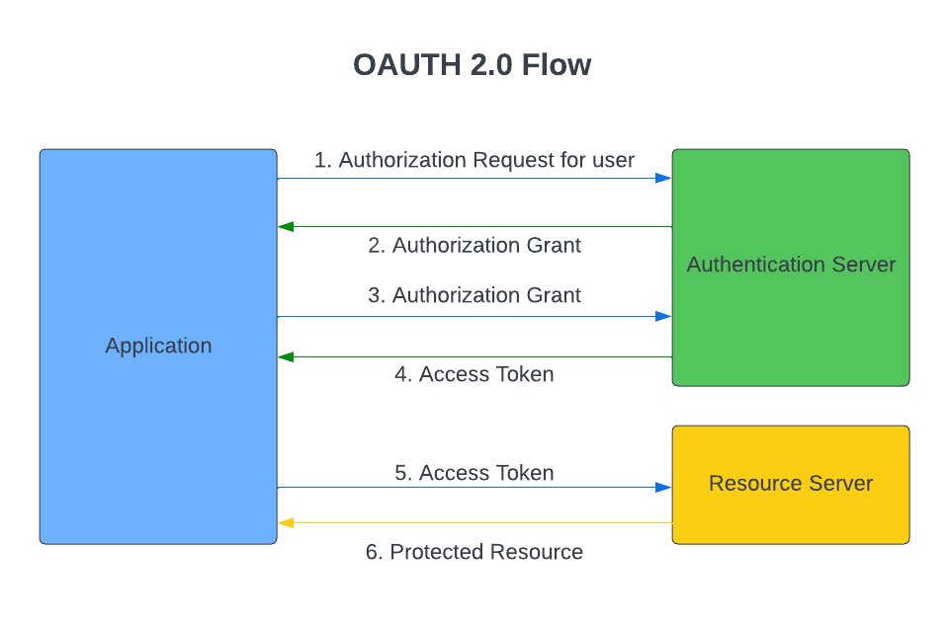

Figure 5.28 OAuth2 Flowchart

1. The application requests authorization for a user and after they input their information, it is then authenticated through the authentication server.
2. If the user is valid, then an authorization grant is passed through the authentication server to the application.
3. The application will then send back the authorization token with an extra identity token after checking the user’s credentials that are tied to the authentication. In the case of Canvas, there is also a need to ensure that the application is actually registered within the network.
4. The authentication server API then validates the tokens and sends back an access token to the application to be cached for future use.
5. If the application requests a resource, it sends a request to the resource server with the access token of the requestee.
6. The access token is then validated and the resource server returns the requested resource to the application.

This process and information are directly related to how we handle the authentication operation of access tokens through the Canvas menu previously shown in Figure 5.27. We can start by looking at step 3, where it was mentioned that the application needs to be registered in order to be fully valid within the Canvas API. In order to ensure its registration, when creating a new token it specifically asks for the Key Name, the Redirect URI, and the Vendor Code. Now rather than utilizing the access token mentioned earlier, the developer keys option in Canvas must be accessed in order for this functionality to be utilized. We can see this in Figure 5.29, as well as some other fields which are more optional. It is important that the URI matches the server of the application that will be utilized in order to ensure that it is correctly validated in the correct location.

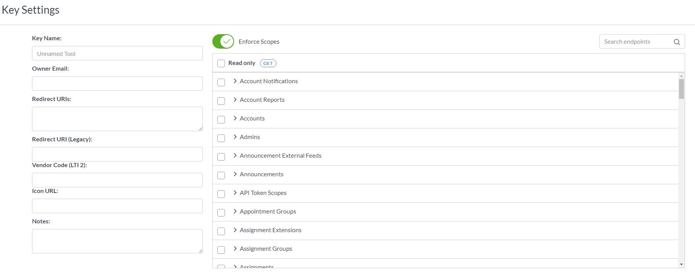

Figure 5.29 Developer Key Settings

##### 5.3.1.5 Learning Tools Interoperability (LTI)

As mentioned earlier, LTI is supported within Canvas and is utilized for a multitude of functions. Specifically, it is the part of OAuth2 that allows third-party applications to launch from Canvas after it has been authenticated. We are looking into this functionality with limited testing due to figuring out the scope of how friendly these tools and Unity work alongside each other. One of its features would be quite useful if it can all work together. This feature is the Names and Role Provisioning Services. This feature allows for assigning different roles given specifications of data which can help in separating students and teachers and could lead to considering a variety of different functionalities when it comes to a teacher being logged in. It works through its own authentication system of allowing and limiting access with different memberships and roles to a Resource Link. The context id functionality of LTI will also be useful in separating what section of the course we are looking at as the cARdiac application looks at different levels of knowledge of the heart. The external apps of Canvas for LTI tools can also be a valuable option for importing external applications into Canvas as demonstrated in Figure 5.30. There could be a concern in the sharing of personal data by separating the memberships and roles for features so that will be looked upon. Another concern for LTI is that ordinarily, it is not very great at sending information out as well as it is in retrieving information; However, Canvas’ functionality has its own way of pushing that information out alongside LTI, that way we could look into this for showing student performance metrics out of cARdiac 2.0 instead of sending output through an excel sheet as originally intended. Of course, this functionality requires having the user tied to their information so that functionality would also have to be fully present in order for this to be considered.

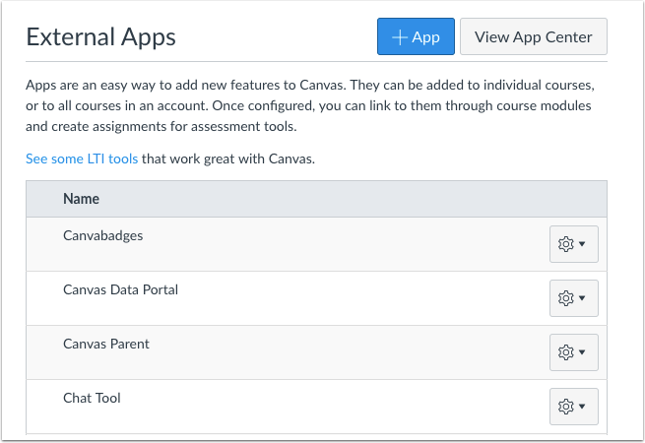

Figure 5.30 External Apps (LTI tools) for Canvas [14]

#### 5.3.1.6 QR Code Functionality

The HoloLens2 and Microsoft’s MixedRealityToolKit both have native functionality for reading QR codes. With this in mind, we can consider static QR Codes for login within the application so as to make the process more seamless if the device already has the credentials stored. Creating a QR Code utilizing the tools of the MixedRealityToolKit does not seem expensive in computing either. It is all mainly simple code and calls from packages that are already installed by the MixedRealityToolKit. There’s the QRTrackerController that will read QR codes and validate if it is the desired code which can help filter out unwanted QR codes if we are seeking to log in with credentials through a QR code. Then, there is the initialization and processing of the QR Codes. A marker is utilized to actually display any sort of prompt when a QR Code is recognized. There is also a reset functionality that can reset the orientation of the displayed object if needed. With all of these functionalities, a static QR Code to help read data for the application is a possibility that we would like to implement.

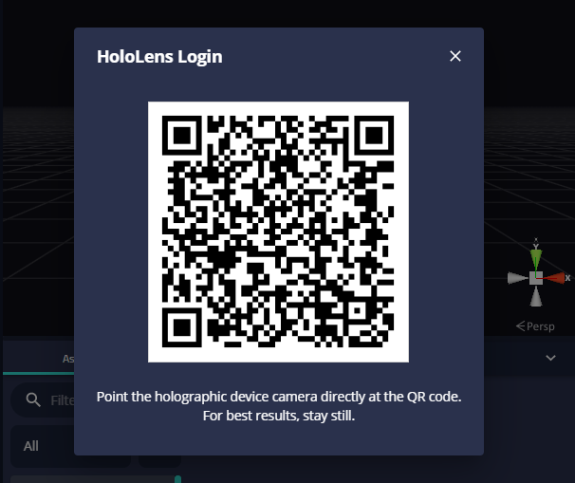

Figure 5.31 Example Image of a QR Login [69]

#### 5.3.1.7 Connecting Database to Unity

While Unity does not have any specific packages for handling APIs, it is possible through a series of steps to connect them in a way. With the utilization of assets in SimpleJSON, Unity can parse JSON for C# functionality. Utilizing GameObjects and TextMeshPro. An alternative would be to consider utilizing NodeJS and its Canvas packages to send data through Unity and the API. This approach could potentially be more doable as more documentation is available for this and its functionality would seem to fit expectations of what the API and Unity should be doing together. In terms of data, Unity can also store the data through the use of XML. Unity has built-in packages to read and store XML files. With the use of XML files, we can store information from students such as their performance metrics and we could output them utilizing the XML builder from the creators of Canvas, Instructure as shown in Figure 5.32.

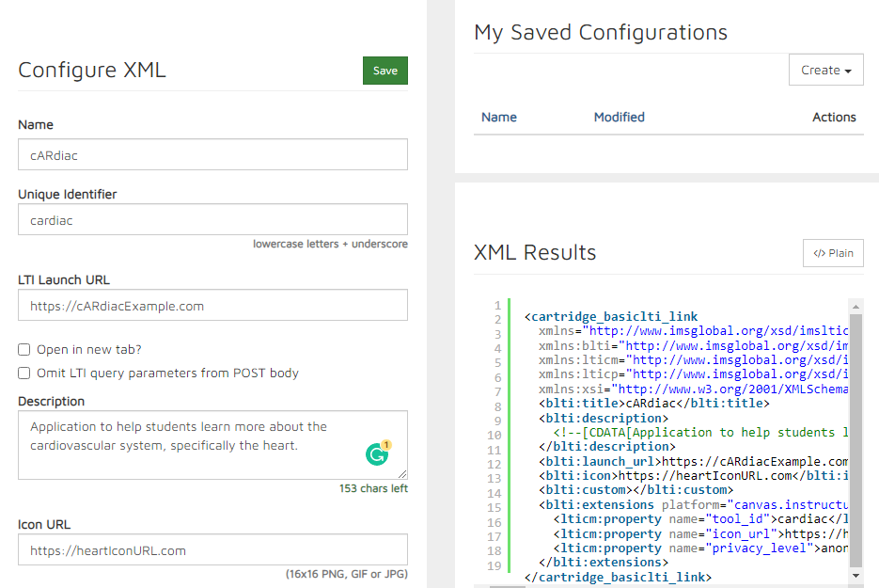

Figure 5.32 Example Image of XML Builder [3]

##### 5.3.1.8 Unity and MongoDB

If we were using MongoDB as our database for the app, connecting the Unity application to the database would require the use of the MongoDB C#/.NET Driver for database access with the HoloLens App. MongoDB C#/.NET Driver is the MongoDB driver used by apps in the C# and the .NET framework, which works for this application as Unity utilizes the C# language and the Mixed Reality Toolkit requires the .NET desktop development workload for development in Visual Studio.

Installing MongoDB C#/.NET Driver:

For installing the MongoDB driver into the application for database connection, the following connection string must first be added to the application to connect to the MongoDB Atlas cluster string [54]:

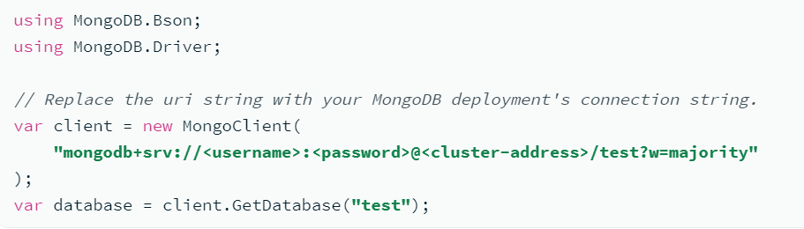

Figure 5.33 MongoDB Atlas Cluster string [54]

The Stable API feature will also be added with the MongoDB Driver to add API backwards compatibility and stability within the application’s backend calls. This feature will be used to ensure future versions of the app can still use the API calls while updating to newer MongoDB server versions or the development kit versions. The Stable API feature works with MongoDB Server version 5.0 and C#/.NET Driver version 2.13 and all following releases. The Stable API feature can be constructed with the following string:

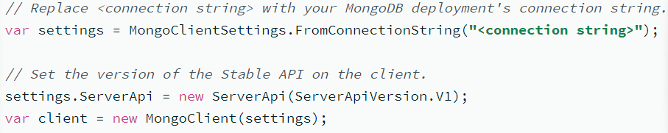

Figure 5.34 StableAPI cluster [54]

We then can start using the MongoDB database in creating, reading, and updating data from and to the app.

MongoDB CRUD API Operations:

* Create:



Figure 5.35 Example Create API Call [54]

Used to create BSON (Binary JSON) documents to insert into the MongoDB database. Will be used in the cARdiac application to insert the student metrics such as quiz grades and confidence ratings into the central database.

* Read:

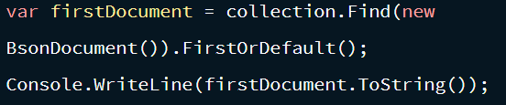

Figure 5.36 Example Read API Call [54]

Used to read BSON documents from the MongoDB database. Will be used in the cARdiac application to read the selected cases, flashcards, and quizzes from the database to the actual Hololens app after login.

* Update:

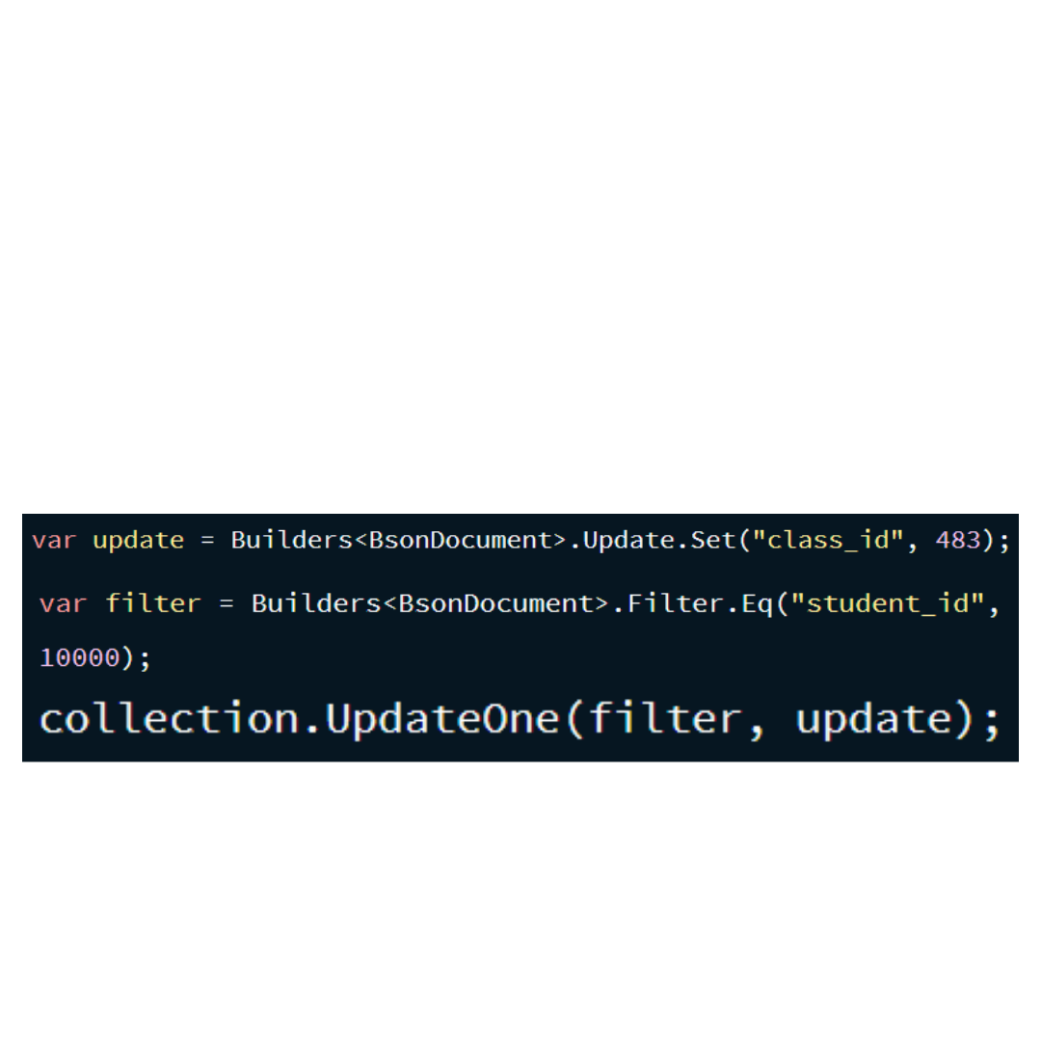

Figure 5.37 Example Update API Call [54]

Used to update from a given object within the MongoDB database and update it with the new data given from the update variable. Will be used in the cARdiac application to update student metrics such as quiz grades and flashcard confidence ratings after a student completes another quiz attempt or changes the confidence after studying the flashcards.

* Delete:

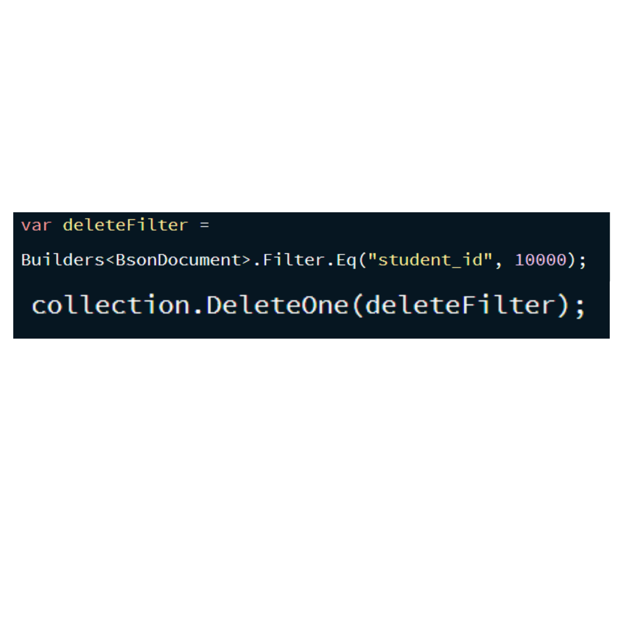

Figure 5.38 Example Delete API Call [54]

Used to delete an BSON object within the database that meets the parameters given from the variable used to filter the object from the rest of the database. This operation might be sparsely used in our project.

## 5.4 Unity and mySQL

### 5.4.1 Connecting to mySQL:

Using mySQL as our central database for our project, connecting to the Unity application would require a similar driver to be added to our Unity project to establish a connection between the database and the cARdiac app used to extract and import the appropriate information needed by both. The said driver, MySQL Connector/NET, will be installed from the source code, as stated on the mySQL official website for projects built in Visual Studio, such as this one [56]. In order to build from the source code, which is a zip file of source and test files downloaded from mySQL website (<https://dev.mysql.com/downloads/connector/net/>), the following instructions provided by mySQL must be done:

1. Navigate to the root of the source code directory and then to the directory with the source files to build, such as “MySql.Data”. Each source directory contains a Microsoft Visual Studio solution file with the .sln (for example, MySqlData.sln).
2. Double-click the solutions file to start Visual Studio and open the solution. Visual Studio opens the solution files in the Solution Explorer. All of the projects related to the solution also appear in the navigation tree. These related projects can include test files and the projects that your solutions require.
3. Locate the project with the same name as the solution (MySql.Data in this example). Right-click the node and select ”Build” from the context menu to build the solution.

After building the MySQL Connector/NET driver within the project, the process to connect the Unity application to the mySQL database begins. The first step to complete in this process is to build a mySQL Connection String, or as formatted in the code: MySqlConnectionString. This String will contain the mSQL server location, the mySQL’s username and password used for accessing the database, and lastly the database’s name. The connection string is formatted as such, sourced from the mySQL website:

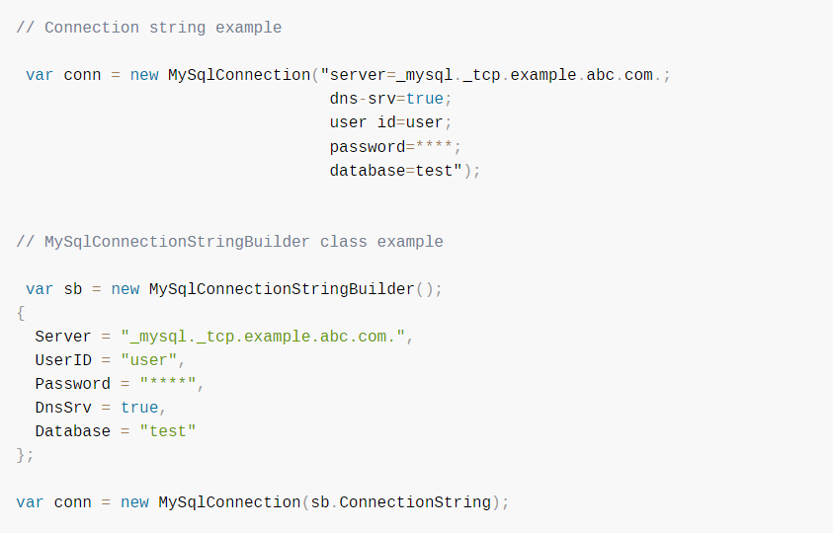

Figure 5.39 MySQL Connection String [56]

After the MySQL Connection is properly formatted and created, it can be used to open a connection to the MySQL server. The following code from the MySQL website shows an example code that is used to create a “MySqlConnection” object, assign the connection string, and open the connection:

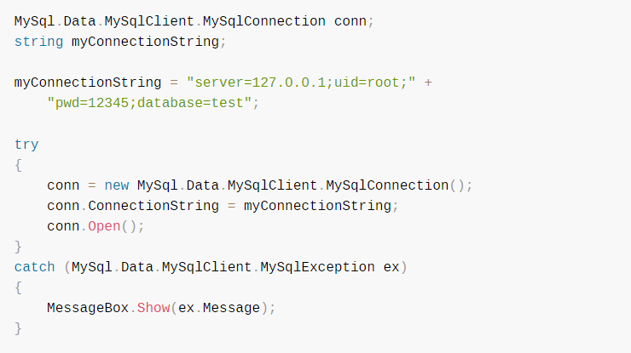

Figure 5.40 Example of MySQL Connection String connecting to server [56]

Alternatively, the MySQL Connection String can be passed to the constructor of the “MySqlConnection” class for a more compact stylization, which is seen in the following example code:

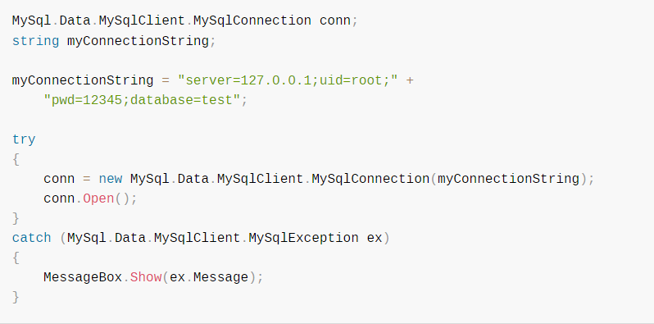

Figure 5.41 Compacted MySQL Connection String Example [56]

MySQL CRUD Operations:

The following are the CRUD (create, read, update, and delete) operations for the X DevAPI (API used to connect between the database and the application), although the function names for the operations are instead add, find, modify, and remove respectively [95]. Each operation will be used to insert and export necessary datapoints required for the cARdiac application for login and student metrics needed by the central database from the app.

Create (add):

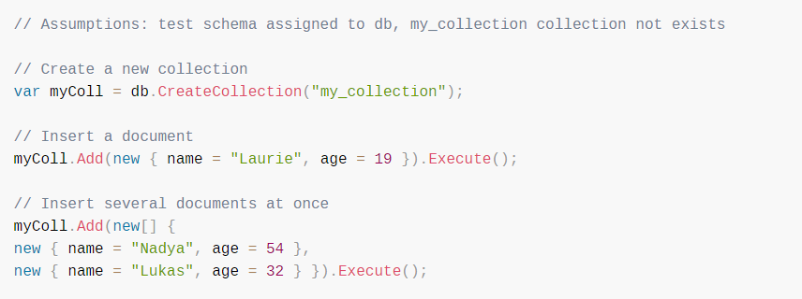

Figure 5.42 MySQL Create Operation Example [95]

The Collection.add() function acts as an INSERT statement for an SQL database, as it is used for storing JSON documents in a collection. It can input a single or multiple documents at once. This function will be used in the app to insert student metrics recorded in the cARdiac application, such as quiz grades and flashcard confidence.

Read (find):

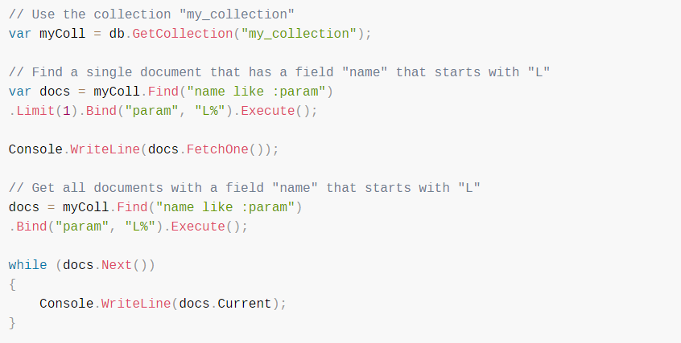

Figure 5.43 MySQL Read Operation Example [95]

The Collection.find() function is an operation function used to search through documents in a collection and acts similar to a SQL database’s SELECT statement. It searches by taking a condition string (SearchConditionStr) as a parameter used to specify the JSON documents that are wanted from the database. This function will be used in the cARdiac application to read the selected cases, flashcards, and quizzes from the database which were selected by the instructors.

Update (modify):

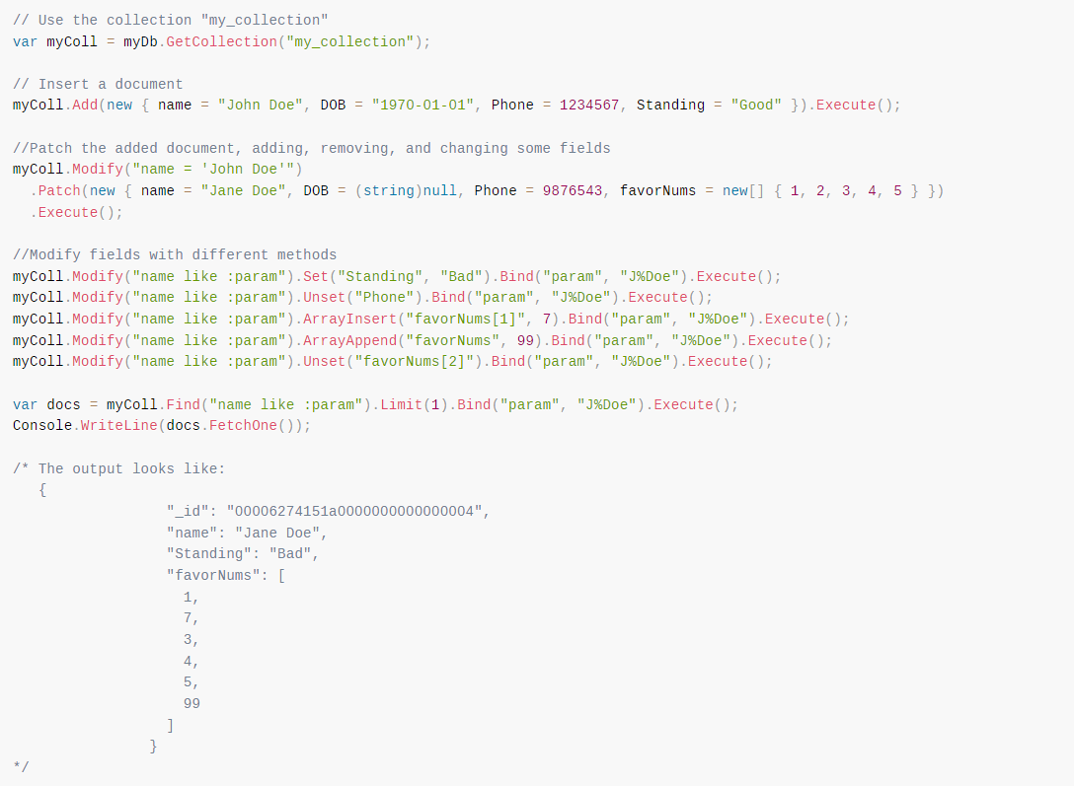

Figure 5.44 MySQL Update Operation Example [95]

The Collection.modify() function is the operation function that acts as an SQL database’s UPDATE statement, as it is used for the modification of documents in a collection. Similar to the find function, Collection.modify() takes a SearchConditionStr string as a parameter in order to specify which documents are set for updating and modification. This function in the cArdiac application will be a complement to the insert function, as it will be used to update student metrics such as quiz grades and flashcard confidence ratings after completion of another quiz attempt, or changes to the confidence after more studying of the flashcards.

Delete (remove):

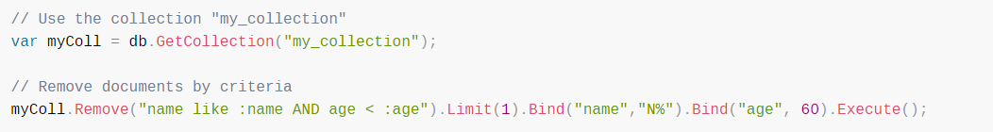

Figure 5.45 MySQL Delete Operation Example [95]

The Collection.remove() function is the delete operation of the X DevAPI and acts as a SQL database’s DELETE statement. The function is for removing documents in a collection and does so by, similar to the Collection.modify() and the Collection.find() functions, taking in a SearchConditionStr string to search and specify the documents ready for removal from the collection. The function’s use in the cARdiac application will be sparing, but useful for students who might mistakenly use the quizzes or the cases.

Relational CRUD Operations:

The X DevAPI also offers the use of SQL CRUD Operations for tables instead of collections. Most of the statements are similar to their collection counterparts, with some differences here and there. These operations will be used in the insertion, modification, and search of the quiz questions, case selection, and flashcards selection.

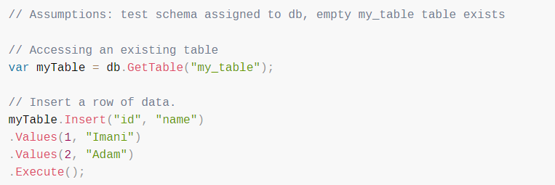

Figure 5.46 MySQL Relational CRUD Operation Example [95]

* Create (add):

Table.insert() is the method that works like a SQL INSERT statement

* Read (find):

Table.select() is the method that works like a SELECT statement in SQL

* Update (modify):

Table.update() method works like an UPDATE statement in SQL

* Delete (remove):

Table.delete() works like a DELETE statement in SQL

Collections as Relational Tables:

X DevAPI can take collections and cast them into a table. “Schema.getCollectionAsTable()” can fetch a collection from the database and treat it as a Table object, allowing it to treat collections as tables, along with the CRUD operations being allowed to change from the collection functions to the table methods. This function will be used by the cARdiac application in the organization of the student’s quiz grades and other metrics, which will be extracted and imported by the MySQL database as JSON documents converted into .csv files.

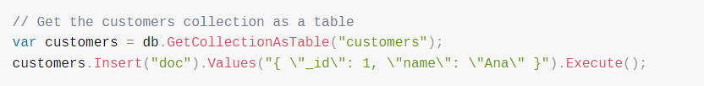

Figure 5.47 MySQL CollectionsAsTable Example [95]

## 5.5 API Testing

API testing will be handled primarily through Visual Studio and a REST Client if necessary. REST Clients are useful in formatting inputs properly and sending them through the API.

## 5.6 Collaboration

As with the database, the API teams from the cARdiac AR, cARdiac VR, and the Dr Hemo’s escape room projects will need to collaborate together to ensure that the central gathering database is working for what each respective project needs. The cARdiac AR and VR teams will work with the most similar API calls, as both of the projects are different versions of each other on different platforms, one on the Microsoft HoloLens and the other built for Virtual Reality Headsets. Both projects will require the use of student credentials in order to login, and both will need to import and export student metrics to and from the database such as quiz grades, confidence ratings, and overall student engagement. Dr Hemo’s Escape Room will also need to export student engagement, as well as students’ puzzle performances. It will be vital to the database that the returning information from each project is easily identifiable to their source application, which will be handled by an ID parameter for each student to differentiate what application they were using.

## 5.7 Group Member Ideas

### 5.7.1 Emmanuel Pineda

* For the flashcards, instead of clicking a flip button just click on the card again to flip it
* Better animation for blood flow
* Better frontend work for labeling of the heart
* Perhaps section the heart with dashed lines and the user can click each individual part and the app will expand more on that portion of the heart and leave the labeling until clicked on
* Following the above idea, perhaps expanding on each part of the heart can lead to new functionalities or more detailed picture of it
* Add audio of a heartbeat
* Heartbeat audio changes depending on if the heart is moving slow, normal or fast

### 5.7.2 Anthony Tran

* Use Unity Plastic SCM for version control.
* Add questions where the 3D model of the heart lights up on a section and students must classify or answer questions about the certain section.
* Record questions answered for each section.
* Randomize questions.

### 5.7.3 Alexandra Krivonos

* One of the ideas that I have is to log students in using the UCF SSO. That would help identify the students who are using the app. In case it would also be difficult to do, there is a possibility to simply ask the students to login with their UCF email.
* My other idea is to create a dashboard for the professors to make it easier for them to use the app. On this dashboard the teacher would be able to see the list of the students for the class, and their grades for the quizzes. In the same dashboard the professors would be able to view and update the flashcards and quizzes materials. The dashboard would allow the professors to keep all the functionality in the same place. The structure of the dashboard would allow us to incorporate the database into the application, it would help with storing the information on the students, flashcards, and case questions.
* I also have some ideas on changing some functionality of the front end of the app. I also think it might be a good idea for students to see the progress bar of how many cases, flashcards they've viewed. Another idea is to allow different modules for the flashcards, their flashcards are more organized on the same theme. So students can choose the area that they think they need to study the most. For this, we can add a function for the professors to create modules of flashcards on their webPortal. I would like to change the theme of the front end, so it matches the UCF colors more, and contains some symbols that show that this app is affiliated with UCF.

### 5.7.4 Andrew Rodriguez

* Modify the heart rate speed scale to be a slider instead of buttons that do not allow for intermediate speeds.
* Add an option to the flashcards to study all questions where it would randomize the questions or choose sections/topics, i.e. previously incorrect, specific diseases, etc.
* Change the flip and next card so that if card clicked again it flips to other side and make the current flip button into the next card button Add a previous button for flashcards and current flashcard progression, ex. 4 / 15.
* Remove the new case button and case selection upon clicking cases and have it open to a random case and add a next and previous button.
* Have incorrect answers create a temporary pop-up message rather than changing to a different window.

### 5.7.5 Chris Mathew

* Collaborate with the cARdiac VR team to help develop the instructor dashboard to help keep track the student metrics
* Use new points of hand articulation in the Hololens 2 for use in interacting with the heart. Upgrade from HoloLens 1’s basic finger and palm movements.

### 5.7.6 Alexander Melendez

* Use Github version control if not Unity Plastic SCM.
* Utilize a database for student information and quiz questions.
* Utilizing a HoloLens to test the program.
* Carrying over progress from CARdiac 1.0 instead of rebuilding from the ground up for CARdiac 2.0.
* Confidence ratings for flashcards

## 5.8 Database selection

### 5.8.1 Firebase

One of the possible choices for the database was Firebase.[33] Firebase is a software development platform offered by Google. This is typically the top choice for developers who are working on the prototypes due to its efficiency, budget, and speed. The main purpose of such software is delivering a working prototype. Some of the best features and services it offers include easy authentication methods, convenient hosting services, real-time database Cloud Firestore, Cloud Storage for media, and scalable functions to process data. There are several pricing models, all of which offer relatively different opportunities. One of the main reasons the database is widely used for small apps and prototypes is due to the fact that there exist pre-made APIs that can handle easy tasks. One of the biggest disadvantages for this database would be the limited querying capabilities, data migration.It is also important to note that the platform is Android centered. There is also a limitation on how many users can be simultaneously signed up for the free version of the database. Firebase is designed for real-time updates, which makes it a great possible choice for the app.

One of the downsides of this selection is the fact that it is impossible to download the .csv straight from the database. The only format available for download is JSON. This format is not user-friendly, especially for faculty that would have trouble reading the data about the students. We would either need to convert the JSON file into .csv ourselves or give the faculty access to the database to see the data. Either way, it is not an ideal solution in our case.

### 5.8.2 MongoDB

MongoDB is a NoSQL document database. It is an open-source document-based tool used for high-volume data storage. [12] One of the strongest advantages of this database is its flexibility and scalability. It is also known for its high speed and availability. MongoDB performs 100 times faster than other relational databases and provides high performance. A friendly-user interface is also something worth mentioning, as well as its simplicity of the setup. One of the biggest disadvantages is the limited data sizes, and high memory storage. There is a limitation for the size for the document: 16MB. Also, while MongoDB offers high-speed and convenient ideation, if the indices are implemented incorrectly, the database can start to perform very slow in comparison to other databases.

Another important feature is the possibility to extract the data as a .csv file from the table. MongoDB offers special software MongoDB compass, which offers a special GUI interface for managing data. This would allow faculty to download and visualize reports without accessing the database directly, which is a great tool for various reasons. The user-friendly interface should make it easy for the faculty to access the data without any additional resources and help. Additionally, this tool provides an additional level of security by the fact that MongoDB allows us to select which users have different levels of access to the database. We can even configure what IP addresses are allowed to view the database. It also has various roles to choose from, so that some users who have access to the database would not be able to change anything in it. This is a great solution due to the fact that the database will store some sensitive data such as grades and students’ identification information.

### 5.8.3 MySQL

There are several factors that make mySQL a good candidate for this application. First of all, it is a relational database management system and it presents data in the form of tables[8]. It is considered to provide a solid data security layer and protect sensitive data, because the passwords in MySQL are encrypted. Due to its architecture it is considered to be faster than no sequential databases. It is also able to deal with a lot of data without significant decrease in performance. The structure of the table is making the MySQL tables not flexible enough for our application. We might need to have different attributes for different types of users. For example, the students will be separated by two types of classes: M1 and M2, both of which will need to store information related to flashcards, but only one for cases. If all users will be in the same table, M1 students will also need to have a column for cases and use this storage space for nothing.

MySQL has a pretty straightforward process of downloading the data from the table from the MySQL server. However, there it is done through the terminal similarly to querying, which might not be the most straightforward task for the faculty. MySQL also offers the MySQL Workbench for simple viewing of the data. It also allows exporting data as a .csv file. However, it does not show any flexibility in terms of which data should be exported, it only exports the full dataset, which, in some cases, is not ideal for this application.

### 5.8.4 Azure Cosmos DB

Azure Cosmos DB is a fully managed NoSQL for database development [73]. This is a great solution due to its low latency and high availability. The database is designed for modern applications that require very fast response time to provide instant scalability. It provides an open source API which makes app development much faster and easier. The database is also capable of providing automatic management, updates and patching.

The main advantage of this service is the fact that it is Microsoft developed and hase easy integration with other Azure services. The COM is interested in migrating all the services into Azure, so having a database there would ease further analyzing the data reports from the app.

The only downside is the fact that it doesn’t have an intuitive way to export the data from the table to a CSV file. However, there is a possibility to use Azure Cosmos DB change feed to visualize real-time data analytics via Stream Analytics [74]. It allows the user to graphically visualize data via a set of simple queries. An example of that would be the number of visitors in the application, average time spent on the app. In this case, having a native solution is a plus.

### 5.8.5 Our Choice (MySQL)

When selecting the database our team needed to make sure that the database is fast, and it is possible to integrate it with Azure services as in the future the reports based on the data collected from the apps would be processed and visualized through these services.

The team made the choice to use MySQL as a database after talks with cARdiac-VR and Dr.Hemo’s Escape Room teams. The sponsor suggested that all of the data from three apps would be stored in one place. The idea was that the faculty would need to login and extract the data from one source, instead of doing it separately for each application. The choice was between MongoDB and MySQL. While MongoDB would offer easy Integration with Azure services, such as Azure Stream Analytics to visualize the data from the app, and CosmosDB, which is the database service offered by Azure, due to the structure of the applications, we came to the conclusion that relational databases would be the best choice for all of the teams.

Additionally, the sponsor wanted the data stored about the students to be downloadable as a .csv file. Out of all our options, MySQL offered an easy solution. There is a lot of additional software that is available, including PHPmyadmin that has a very straightforward process to extract the data as a .csv file. It also offers a lot of other formats in case the users would need to extract it somehow else in the future.

One of the most important factors we had to consider was the security. Since the app will contain some sensitive information such as students’ grades and identification, we must be sure that the database is secure and only authorized people can get access to the data. MySQL not only provides secure authentication to the database, but it also allows users to select which user/IP addresses are allowed to view/edit information. This is an additional level of security that will be useful for us.

We expect that around 500 students might be using the app during the semester for both M1 and M2 classes. Due to the limitation of the amount of HoloLens 2 available to students, we can expect around 5 users to be logged in simultaneously, which is an insignificant amount for the database. Similar amounts can be expected for cARdiac-AR and EscapeRoom users, but the amount that might simultaneously use the application will be greater. However, MySQL is known for easily handling a big amount of connections, so this shouldn’t be an issue in our case.

## 5.9 Database structure (version 1):

We will have three separate collections to store different information for our application. One would be storing all the user's (student in this case) information, another would be storing the flashcards information, and the third would be dedicated to the cases (quiz section). This is the most logical distribution between the data from both of the apps. Ideally, the sponsor would like to store the data from three apps (cARdiac-AR, cARdiac-VR and Dr. Hemo Escape Room); some additional collections might be added later to the same cluster for the other apps.

### 5.9.1 User table

First table would contain the student information, like user authentication data, such as tokens after user authentication via SSO (or students’ knight emails and passwords) so that the app can track individual progress for each student. The database would also store to which class the students belong (M1 or M2 are two possible years of students who will be using their app, the content for them would be a little bit different). Then, for each student we would store the grades for each case in an array, the total number of flashcards that were completed by the user, the total level of confidence for each flashcard completed, and an array of confidence for each flashcard. The Figure 5.48 below demonstrates the schema for this collection.

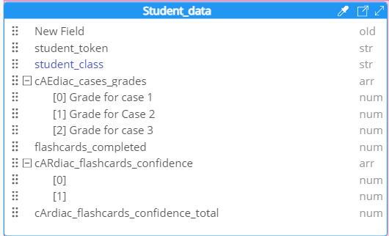

Figure 5.48 Schema for Student’s data

### 5.9.2 Flashcards table

Another collection would be dedicated to the flashcards information. Each flashcard would have the term, definition, and class section. Term and definition for each flashcard would be stored as string, the class selection is represented as a boolean: M1(lower class) is 0, and M2 would be 1. Also this collection will potentially be used by two applications: cARdiac-AR and cARdiac-VR as the flashcards for both apps would be identical. The schema for this collection is shown in Figure 5.49. Each Flashcard is a separate document, which allows us to dynamically change the number of flashcards in case faculty would want to delete/insert additional flashcards.

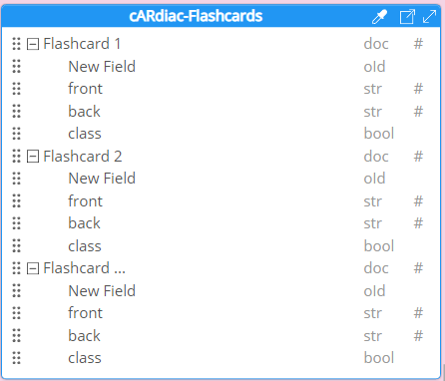

Figure 5.49 Schema for Flashcards for the application

### 5.9.3 Cases table

Last collection in the database would be the Cases collection. The structure of the data would be similar to how it was set up in version 1 of the application in order not to stay consistent. Each case would be represented in a separate document. The case document would have an objectID. It would store the Question for each case, the type of rhythm that should be shown in the heart for each case. It would also have three answer choices that are linked to the pictures that would represent the correct rhythm for the heart. The document would also contain the correct selection and the explanation on why the answer choice is correct. The schema for this collection is described below in Figure 5.50.

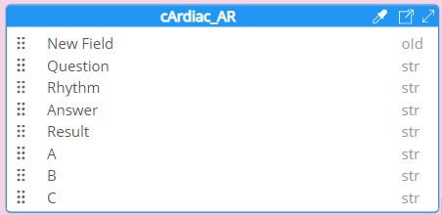

Figure 5.50 Schema for Cases for the application

## 5.10 Database structure (version 2)

The other version of the setup of the database is in case three teams (cARdiac-AR, cArdiac-VR, and Dr. Hemo’s Escape Room) decided to collaborate on the database upon the sponsor’s suggestion. The purpose of this is to have one space for the faculty member to use to export the user data of the students. As a result of this proposed schema, the faculty can simply download the .csv file with all students' grades for all the apps and see all their progress in various applications at the same time.

## 

Figure 5.51 The schema for the database for three apps.

### 5.10.1 Students

Students table would consist of SID INT and Password, which is the token for the student logging in. Ideally, the SID would be the token received upon the Login through canvas, so that each student can easily be identifiable. It would also help in the future development in case we would be able to integrate the grade posing with Canvas. But for now it was decided that the randomly generated Access code and password would be used. The faculty would need to import that table of students as a .csv in the beginning of the semester and give them out their Access code and Password. This table would also store the Student Name, CourseInfo (what anatomy course does the student belong to, M1 or M2), and App Settings. The table would additionally contain necessary components for Dr. Hemo application that will not be used in cARdiac application.

### 5.10.2 CaseAttempt and Cases

Cases is the table that would store all of the cases for the cArdiac applications. For each case, we would have its unique identifier: CID. Section would store whether the case is from M1 or M2 (currently the 1st version of the app has cases only for M2, but there was a requirement for this project is to add a quiz element for the M1 section, which is decided to be the cases for M1 class. We have implemented the app in such a way that the cases for M1 would also work, but it was decided by faculty not to implement cases for M1. Description element would store the description, or the question for the case. The rhythm would store the mode of the heart that would be shown supplementary to the Description of the problem. For each case, there might be a change in the mode of the heart, so it is important to store what heart mode should be shown for students. The databases will also store the Correct answer supplementary description that would be shown once the user selected the correct answer. Lastly, the answer choices would store the string which will represent the EKG mode. The database stores the type of EKG, but the pictures themselves are stored in the app and accessed from there. The user will need to select the correct EKG that matches the description of the case. The answer choices would be shown as images that are stored in Unity, instead of storing the images in the database due to the fact that storing images takes much more space in the database, and the pictures in the answer choices will repeat in some cases. It makes more sense to store just the string with the name of the image. An example of what case prompts would look like is provided in Figure 5.52.

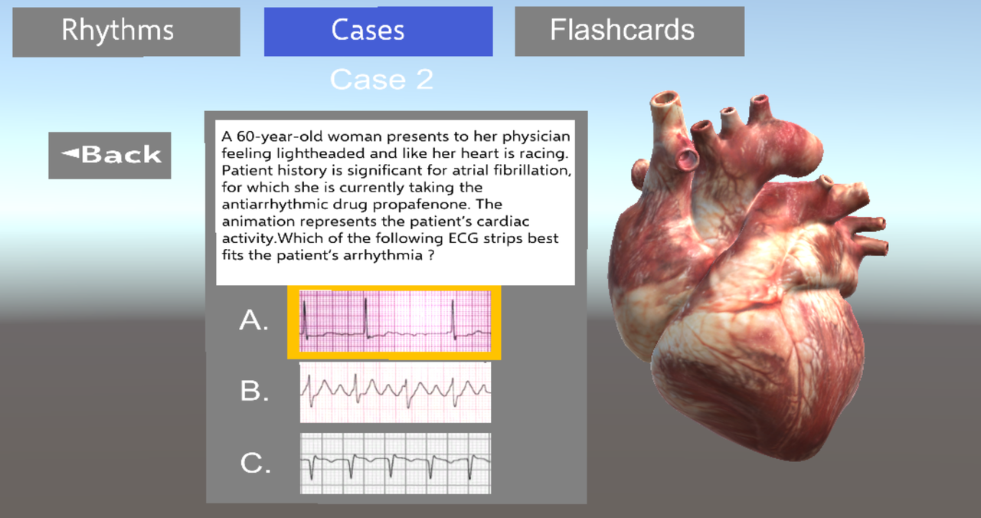

Figure 5.52 Case structure in the 1st version of the application.

The CasesAttempts store each student’s attempt for each case. The attempt would be relational to the SID ( ID of the student, to identify which student made the attempt), and to the CID (ID of the case the student approached). It would also store a grade received for the attempt, and the time spent on the case.

### 5.10.3 Flashcards and Flashcard Attempt

The logic for the Flashcards and Flashcard Attempt would be similar to the cases. Flashcards table would contain the FID - Flashcard unique ID, Promt, Answer, and the Class Section the flashcards belongs to (M1, or M2). The Flashcard Attempt is also identified by the Student ID and FlashCard ID in order to identify which Flashcard is the Student attempting to complete. For each attempt we would store whether the student got the flashcard correct and their confidence level (1-3, 1-most confident, 3- least confident).

### 5.10.4 Dr Hemo schemas

Additionally, the database would also store the information that is required for the functionality of the Dr.Hemo’s escape Room. They will also have a similar logic of attempts for each team in the escape room, but the structure is different

### 5.10.5 MySQL Workbench

During the development the MySQL Workbench would be used as a visual database tool for working with MySQL servers and databases. It provides an interface It is one of the most convenient tools for SQl Integration which is very useful for setting mySQL database with Azure Flexible Server. MySQLWorkbench allows you to run SQl queries in order to insert, read, update, or delete data. In order to run any query on Workbench, select the database, type the query, in the toolbar click the lightning bolt icon. The changes in the database resulting in the query should show up automatically.

### 5.10.6 Exporting the Database tables as .csv file

As part of the requirements for this project, there is a need to be able to export data from the mySQL database as a .csv file. The output file would consist of information about the students, mostly their grades and progress in the apps. The csv file should contain the grades for each student for cARdiac and Dr Hemo’s escape room. Due to the structure of the database that the teams have decided on, the app will contain several tables that would contain information of students, that is why it is important to have a functionality of exporting several tables from the database into one .csv file. While mySQL Workbench is shown to be very useful with the setup of the database, PHPMyAdmin works better for visualizing the database to faculty and exporting the data from the tables. In order to export the data tables, there is a tab Export that allows the faculty to manipulate which data is needed to be exported in the Custom options. It would join the tables based on the unique IDs of students and provide a coherent .csv file that contains the information about each student.

### 5.10.7 Database connection

It has been decided to use Azure Flexible Server for MySQL deployment option. Azure offers a simple connection to MySQL Workbench. In order to connect to Azure Database for MySQL Flexible Server: Launch the MySQL Workbench. Then, Click Setup New Connection. Specify label for the connection. The connection method in our case is Standard (TCP/IP). There is a possibility to change it, but this method works for our purposes. For Hostname we specify the server name value that was used to create the Azure Database for MySQL. Port should always be 3306. For Username and password we use the values predefined when setting up Azure database for MySQL. [67]

An example for the New connection with the is shown in Figure 5.53

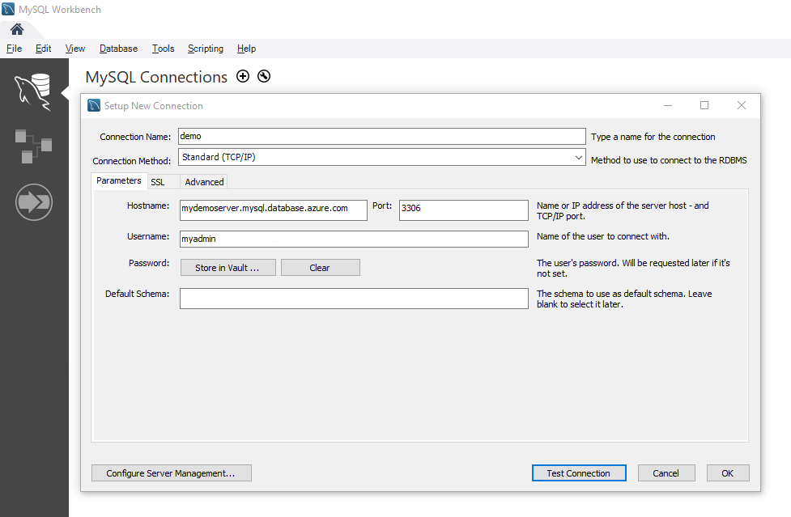

Figure 5.53 New connection for MySQL Flexible Server. Source: [67]

After testing the connection, press OK, and in the listing of MySQL Connections, select the server that was previously setup. After the step is completed, the database is connected to the server.

### 5.10.8 Azure App Services

In order to connect the database to the Unity App. Once the database is connected to the Azure Service, there is an easy way to integrate MySQL to the App Service [68]. The convenience of this approach is that Azure App Services are located on the Azure Portal, so it is the same place where the database is hosted. All resources are located in the same place. The first step to connect is to Allow Azure services for the mySQL database in the Connection security tab. As a security measure, we can create a firewall rule to explicitly allow outbound IPs in the Connection security tab for MySQL.

Once the database is connected, we can use Azure App Services in the Unity application. One of the required dependencies for that is a RESTClient for Unity. This is needed so that Unity libraries for Azure could be supported without adding duplicate scripts [68]. Another requirement for this implementation is to have a UnityWebRequest and JsonUtility. All of the dependencies should be placed into the Assets folder. For the ease of Setup, Microsoft provides an easy setup tutorial [68], the only difference is that the storage for the application in tutorial is done via Azure Storage, in our case, the data will be stored on the MySQL database on Azure.

# 6. Build design

## 6.1 Unity app

Here the detailed description of our final application is shown.

### 6.1.1 Login

Students should log in with their Access Code and a password provided by the faculty. In case there is no Internet, the Students can login with a Guest Login, but then, their progress won’t be tracked. If anyone apart from the students is using the app, the Guest Login should be used.

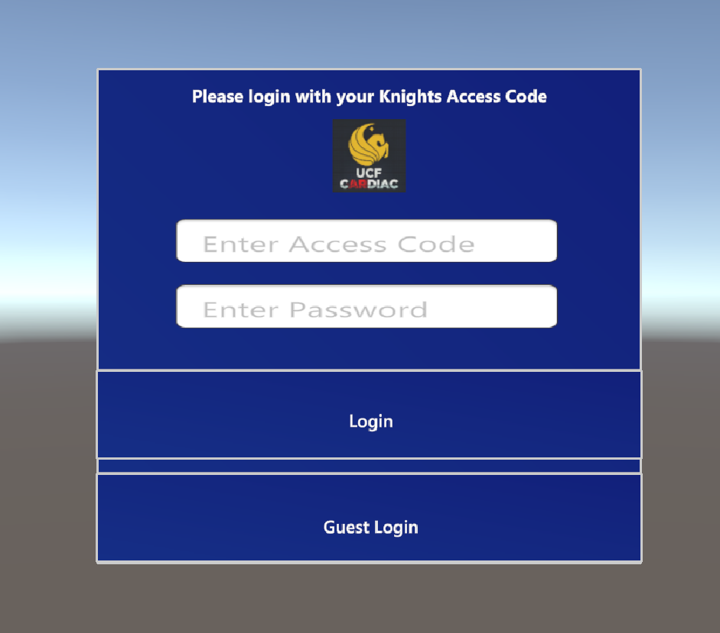

Figure 6.1 Login Screen

### 6.1.2 Welcome scene

On the welcome scene students would be able to select Tutorial to enter the Tutorial scene or press Launch app to skip the tutorial and access the app directly. The Tutorial will be launched automatically once the Countdown is finished.

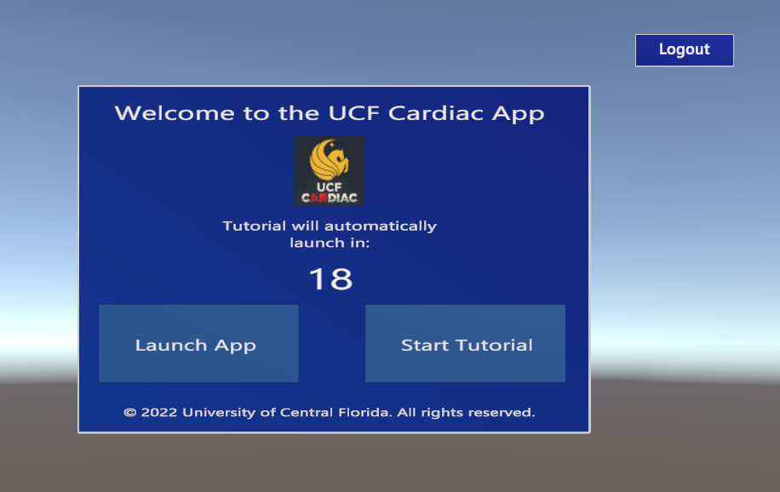

Figure 6.2 Welcome Screen

### 6.1.3 Tutorial

Students who select to start Tutorial in the Welcome scene will need to go through the tutorial to proceed to the app. The tutorial teaches the users to move the heart object, rotate, scale it, as well as familiarize them with other objects that are used in the app, such as sliders. Users are able to move to the next step of the tutorial only once they complete the current step. This ensures that they understood the functionality. Once the tutorial is finished, it automatically redirects the users to the Class Selection Scene.

### 6.1.4 Class Selection

This scene is needed so that students can make a selection which content they want to use: for M1 or M2 students. Any user (guest or student) is allowed to view both scenes, no matter what class section they are in. Both of their progress in the scenes would be recorded. On this scene students would also be able to logout of the app.

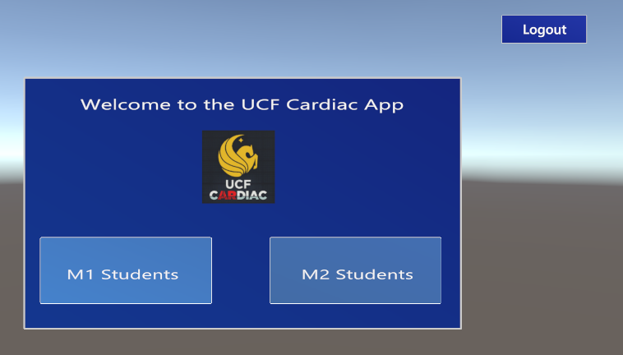

Figure 6.3 Class Selection

### 6.1.5 M1 Students

The main scene for M1 students has several sections, as shown on Figure 6.4

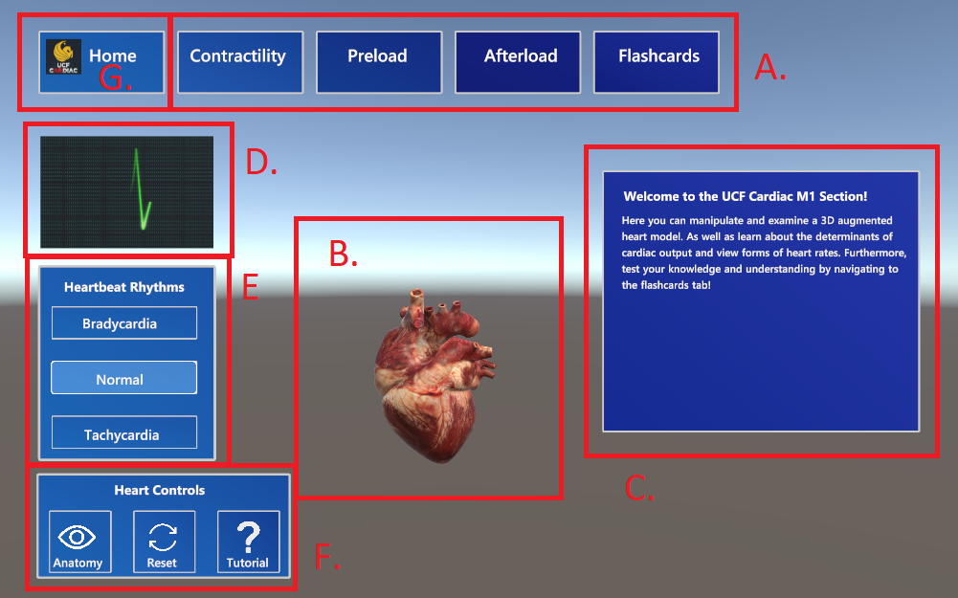

Figure 6.4 M1 Main Scene

1. Scene Menu

Displays the Information about the heart functionality on the Information panel. From here the Flashcard scene can be accessed and users can tap on Contractility, Preload, and Afterload to access additional information that will be shown in field C on the Figure.

1. Heart model

Displays Sinus rhythm animation and labeled heart anatomy.

1. Information Panel

Displays the heart functionality information and additional information on the anatomy when it is selected. Serves as a text box for any necessary information.

1. ECG Video

Displays Sinus rhythm ECG video for various heart rhythms

1. Heartbeat rhythms

Changes the speed of the heart animation by pressing the buttons: Bradycardia, Normal, or Tachycardia respectively.

1. Heart Controls

Anatomy - allows the user to enable/disable anatomy labels on the heart model

Reset - Reset the position of the heart to the default position in case it gets out of sight

Tutorial - Launches the tutorial again, in case any help is needed

1. Home Button

Returns the user to the M1/M2 selection and the logout

### 6.1.6 Flashcards

Flashcards is the scene where students can master the concepts for their class. Immediately after selecting the Flashcards, the scene changes. The Scene menu is still present in the visible view of the user, so they can easily go back to the main menu. On the scene, the definition, or question is shown. Students need to select the confidence level using the slider object. At the bottom right, there is a counter of how many flashcards there are in total, and which is the current flashcard. On the bottom right there is a flip button that students use to flip back and forth between the front and back page of the flashcard.

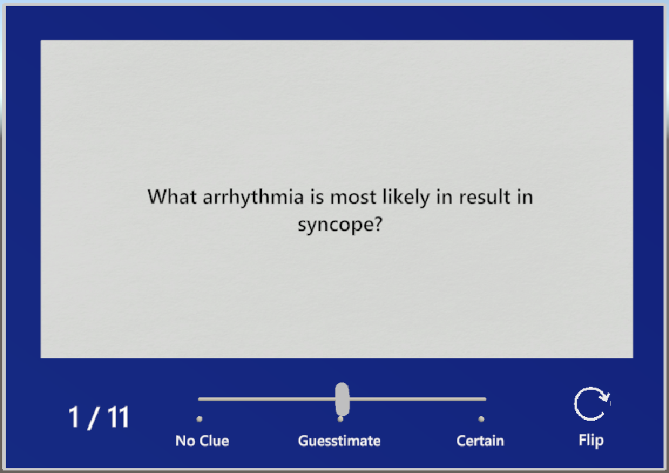

Figure 6.5 Flashcards

Once the flashcards are flipped the correct/incorrect buttons appear. The student can still flip back and forth between the term and the question, but to move to the next flashcard, the user needs to select whether they got the flashcard correct or incorrect.

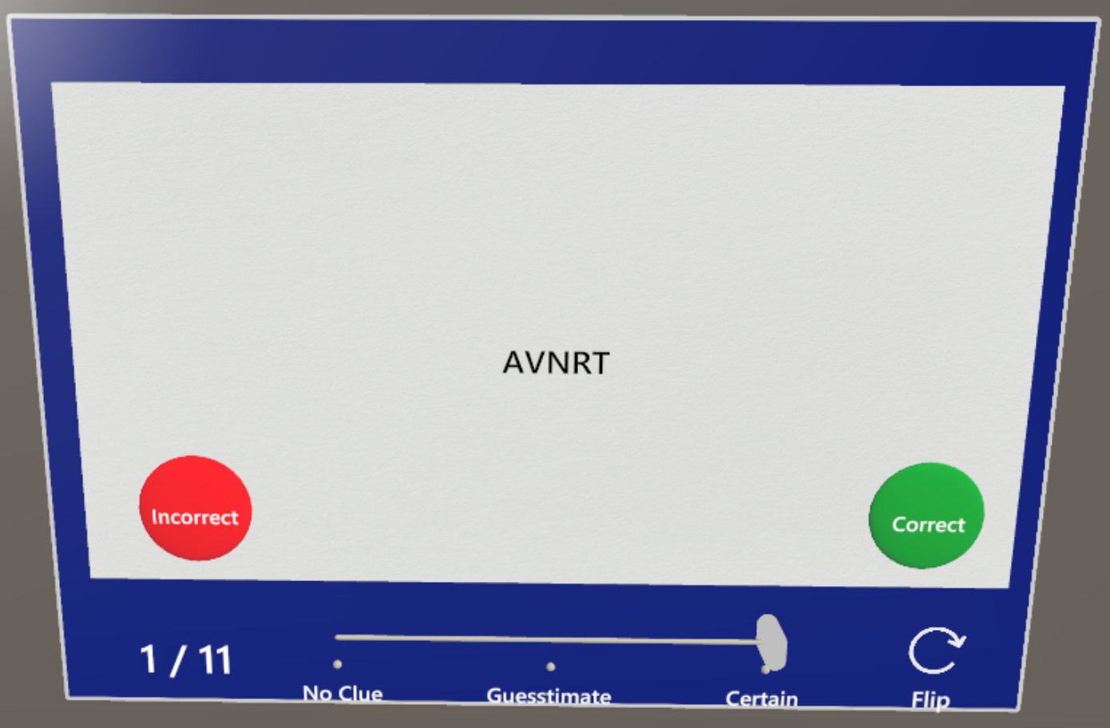

Figure 6.6 Flashcards flipped

### 6.1.7 M2 Students

The Scene for M2 students contain similar basic logic, but with extra features and the content for them is updated to match better what they learn in second anatomy class.

### 6.1.7.1 Main Scene

### 

Figure 6.7 M2 Main Scene

1. Heart Functionality Buttons
2. Home - Goes back to M1/M2 selection and logout.
3. Rhythms - Loads the default screen for M2 which shows the heart model.
4. Cases - Loads the Cases section for M2 students.
5. Flashcards - Loads the Flashcards screen for M2 students.
6. ECG Video

Displays corresponding ECG Video for the corresponding Heartbeat rhythm.

1. Information Panel

Displays Symptoms for currently selected Heart

Rhythm, and additional information on a selected anatomy label.

1. Heart Rate Buttons

Select the speed of Heart, Blood, and Electrical animations.

1. Heart model

Shows a 3D model of the heart, animations of it would change based on the speed and mode selected.

1. Heartbeat Rhythms

Select which Heart Rhythm animation to display on the Heart Model.

1. Heart Controls

Slice - Shows an alternative sliced heart model with insides. Yet to be updated to show various heart rhythms.

Reset - Resets the heart position to the default location if the heart was moved out of sight.

Tutorial - Reloads the tutorial in case it's needed.

Anatomy - Shows anatomy labels on the heart model. Each label is clickable, and more information on the anatomy label will be shown in the Information Panel.

Electrical - Activates the electrical animations on the heart model for various heart rhythms.

Blood Flow - Activates the blood flow animations on the heart model for various heart rhythms.

### 6.1.8 Cases

Cases is the quiz component of M2 scene which allows the faculty to test the knowledge of the students. There are 3 cases for M2 students. Upon selecting, the users are prompted to select which case they want to attempt.

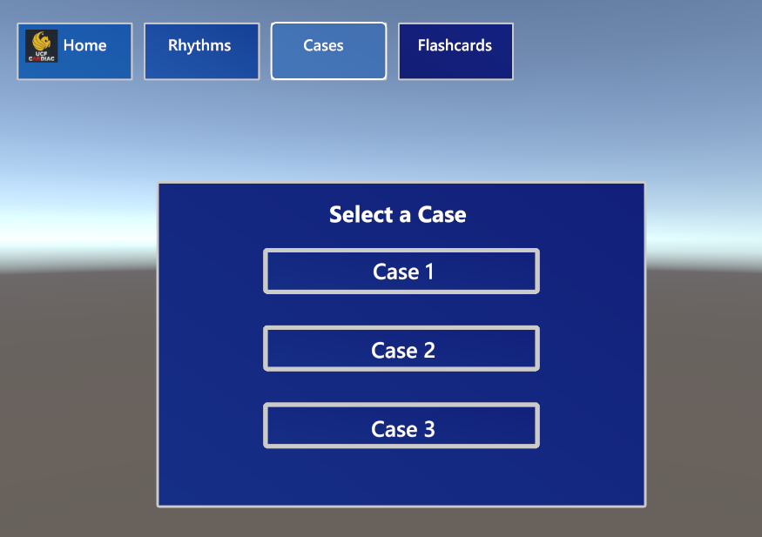

Figure 6.8

An example of the scene is shown below in Figure. On the right of the case box,there is also a 3D model of the heart that is beating, showing a certain pattern that represents a disease that matches the case question. The students can select that EKG that correctly identifies the case described. Once the user clicks submit, a menu appears and whether the user got the case correct or not, they can either move to the next or previous case, or attempt the case again. The text box provides additional feedback to the user on the case they attempted.



Figure 6.9

Once the user selects the answer choice they believe best matches the case, they can click submit and view the result they got. If the answer is wrong, the user will see a red box, prompting the user to either try the case again or move to the next one as shown on Figure 6.10

### 

Figure 6.10

If the user selects the correct answer choice, the user will see the green box which includes a more detailed description why the answer selected is correct. Here they can also click to move to the next button as shown on Figure 6.11

### 

Figure 6.11

## 6.2 PHP app

### 6.1 General information

Direct access from Unity app to database is not a very secure practice, additionally, the sponsor was interested in having one database for 3 applications: cARdiac-AR, cARdiac-VR, and Dr.Hemo. Due to the fact that different projects might have different Unity settings for their apps, the teams have chosen to have a PHP application as a buffer between the applications and database. It is responsible for posting and retrieving the content for the application and students login functionality.

The app is hosted on the Azure App services called hemo-cardiac. Detailed setup information is available in the documentation folder on the Drive. The App service is a part of the Resource group called SD2, which holds all of the necessary resources for the applications, including the database. On the main screen of the WebApp, there is a default information about the app that shows the status, and other important monitoring information. Several tabs that are important to note:

1. Deployment Center

The app is deployed automatically from the Github repository. Any update to the main branch of the repo means that the app will be automatically redeployed to the server. The deployment Center allows you to change the repo the app is connected to in the Source section in Settings tab. It also contains the Logs tab, that provides additional information of the status of the deployment attempts and history of previous deployments. Here it is also possible to stop the deployment if necessary.

1. Certificates

This tab allows us to manage the certificates. The teams have found that this would sometimes be useful in order not be flagged by UCF IT for insecurity. However, certificate features can only be used in the Basic plan and higher, which means that the price of hosting would be increased.

1. Networking

This tab is important for monitoring who is accessing the app. It contains a lot of managing tools of the Inbound traffic. There are several options that are only allowed as Basic tier and higher which might be used a lot in the future for the security of the app. Our app has an access restriction enabled. In this tab, you can manage which IP addresses are allowed to use the app. Currently, it is set to public access as there is no sensitive information in the app. Once the students are using the app, the firewall rules can be set in this tab so that only authorized devices get access to the app. This can be done by selecting Unmatched rule action to be Deny. And in the rules below, all devices that should be allowed to access the information(such as HoloLens and Quest devices, as well as faculty who will be viewing the students' information). The priority can also be set there.

### 6.2 Functionality

There are several scripts in the app that are responsible for various scripts. Here, only the cARdiac-AR scripts will be described, while the code in Github also contains several scripts that are only used by Dr.hemo Escape Room and several testing scripts that are used for debug purposes.

#### 6.2.1 Login

This apps receives the SID and password of the user trying to login. Then, it checks if the user is in the database and if the password matches the one in the database. Then it updates the counter in the database to show how many times have the user logged in and allows the app to login the students

#### 6.2.2 Cases and Flashcards

These scripts are responsible for retrieving the content for cases and flashcards from the database. The Unity app sends whether the content needs to be for M1 or M2 students, and returns a JSON file with all necessary information. Important to note, in case there is no Internet connection, then Unity app retrieves the case from the .csv data stored within the app. In the future we planned to have a script that would periodically update the .csv when the Internet connection is there and update the content dynamically. For now, however, the content in CSVs will have to be manually updated.

#### 6.2.3 Case and Flashcards attempts

These scripts are needed to store the attempts for each student. After each case or flashcard, the Unity app sends the Form to the PHP app with the students performance. The PHP app then puts the data into the database. WSe have set it up so that the database stores all of the attempts, not just the best ones upon the request of the sponsor.

## 6.3 MySQL and Unity connection

UnityWebRequest handles were used as the flow of HTTP communication with web servers. To download and upload data, [DownloadHandler](https://docs.unity3d.com/ScriptReference/Networking.DownloadHandler.html) and [UploadHandler](https://docs.unity3d.com/ScriptReference/Networking.UploadHandler.html) respectively were used. Based on the scripts used, the PHP receives the information in a form of POST or REQUEST. Based on that the Unity application either passes the Form prepared prior to the API calls to the PHP app or embeds the variables that the PHP requires in the URL passed in the Unity Web Request.

To send a web request from a UnityWebRequest instance, call [UnityWebRequest.SendWebRequest](https://docs.unity3d.com/ScriptReference/Networking.UnityWebRequest.SendWebRequest.html). After the UnityWebRequest begins to communicate with a remote server, you can't change any of the properties in that UnityWebRequest instance. UnityWebRequest includes static utility functions that return UnityWebRequest instances configured for common use cases. For example:

* [UnityWebRequest.Get](https://docs.unity3d.com/ScriptReference/Networking.UnityWebRequest.Get.html)
* [UnityWebRequest.Post](https://docs.unity3d.com/ScriptReference/Networking.UnityWebRequest.Post.html)
* [UnityWebRequest.Put](https://docs.unity3d.com/ScriptReference/Networking.UnityWebRequest.Put.html)

More detailed information on implementation is present in the documentation folder.

## 6.4 Final Database Structure

After working with the 3 teams, we have had to readjust the database structure from our original ideas a little bit to match the requirements for all of the teams and sponsor requirements, as well as the best practices that would allow for the best security. In Figure 6.12 is presented as part of the full structure of the database that is used by cARdiac app.

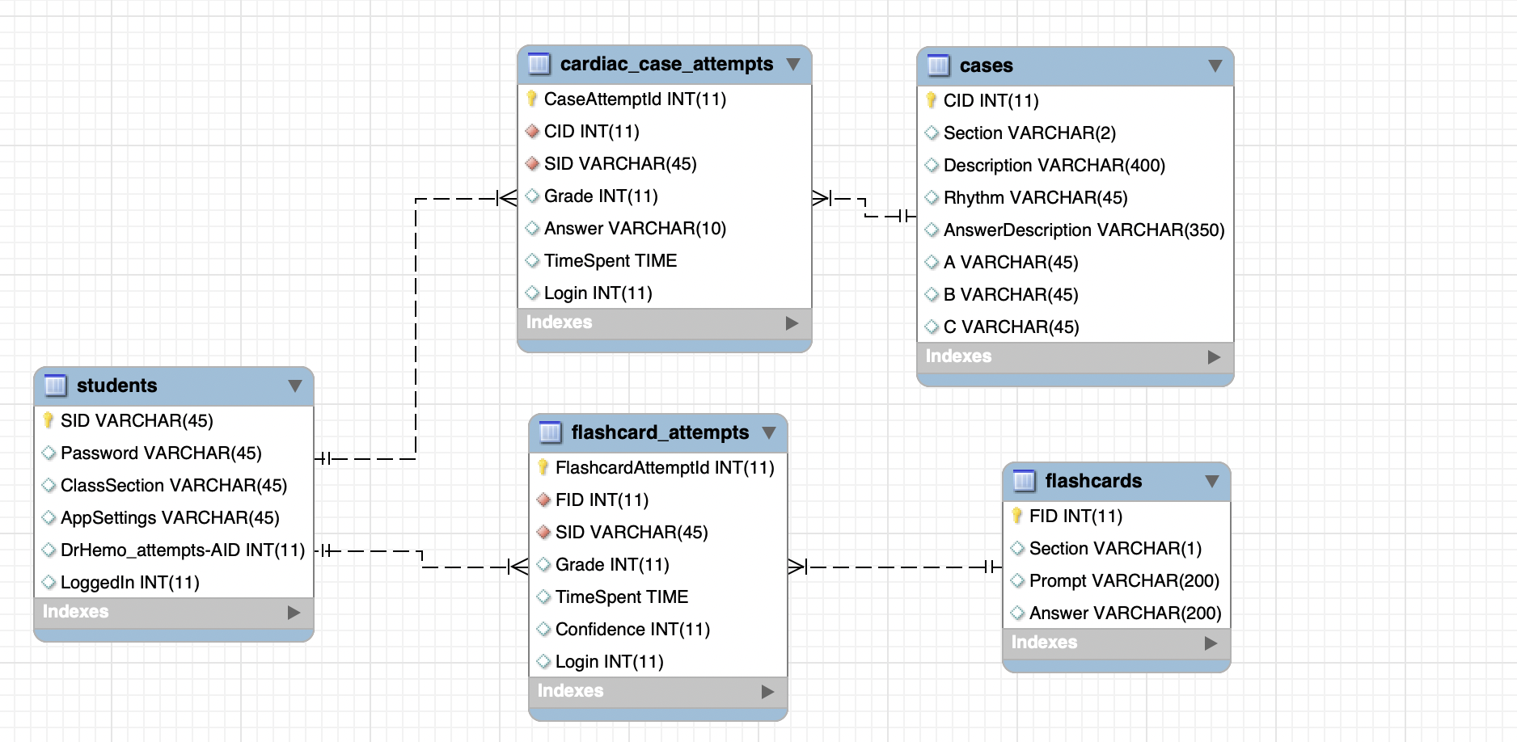

Figure 6.12

In the end, the cARdiac uses 5 tables from the database: students, cardiac_case_attempts, flashcard_attempts, cases, and flashcards. Students are storing the data of the users, such as their unique access code password that was randomly assigned by faculty to each of the students to be able to identify them. It was decided not to use the NID yet, to prevent the user data from any security risks. Instead, the NIDs and access codes would be linked on the UCF IT servers, so that the app can never identify actual students and no valuable information is stored in the database until it is verified by UCF IT that the database is safe to store the NIDs.

Flashcards and cases attempt tables are storing the data on which student attempted what flashcard/case. It also reports on whether the student attempted what was made during his first login or not, the grade that was received for it and the time spent. The flashcard additionally stores the confidence level reported by the student. This way the faculty can track whether returning students are performing better than the students who are only accessing the app once, and see the overall class performance.

Flashcards and cases tables store the functional content of the app. This includes the section of the flashcard/case and the information needed for it.

# 7. Images and Diagrams

## 7.1 Use Case Diagrams

### 7.1.1 cARdiac App Use

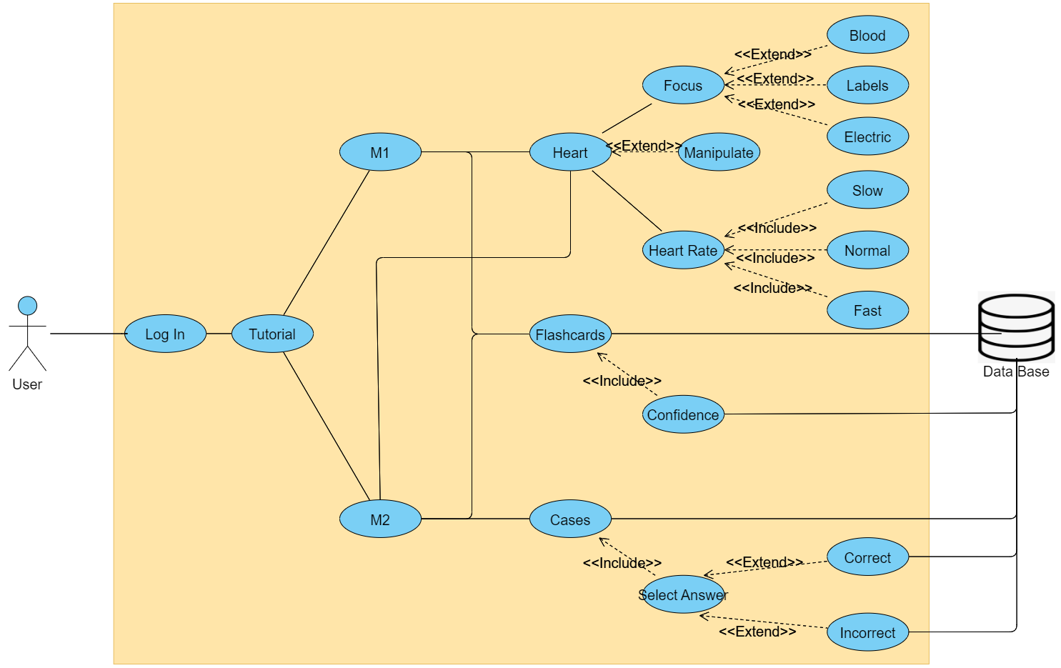

Photo 7.1 cARdiac App Use Case

This use case diagram shows the different functionalities of the cARdiac app and how they are related. The diagram breaks up the app into three main sections: rhythms, flashcards, and cases. Each section can be broken down further as seen in the diagram.

## 7.2 Permissions Diagram

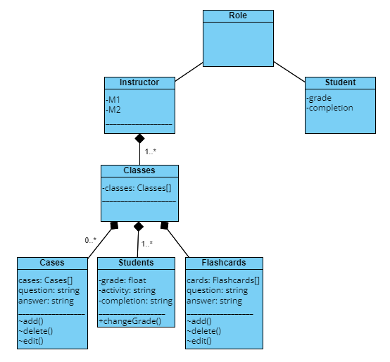

Photo 7.2 Class Diagram

This class diagram serves two purposes. The first being a normal class diagram that can be used for the project; the second being a permissions diagram which shows what role has what permissions.

### 7.3.1 User software/AR interaction

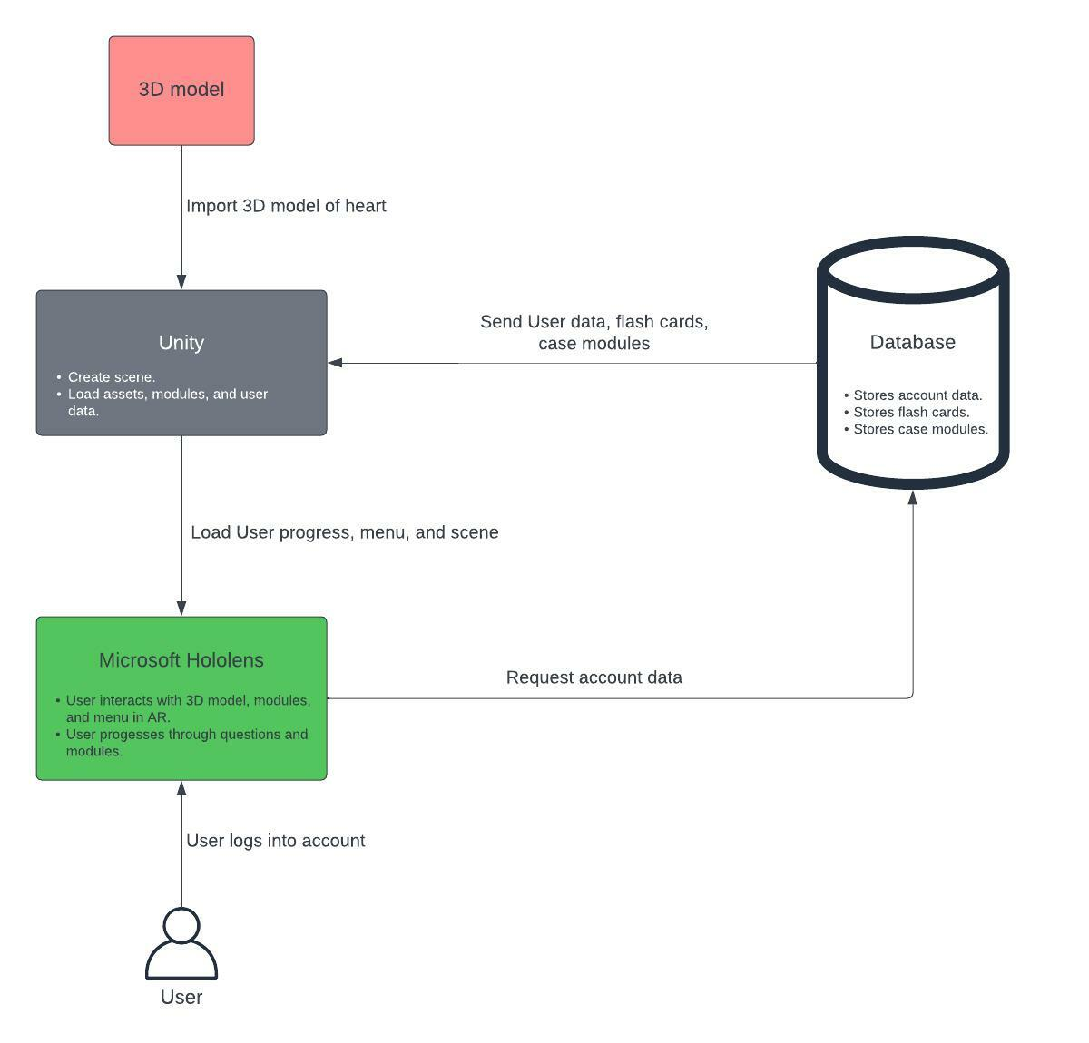

Figure 7.3

*Figure 7.3* displays how the user interacts with the software components. Assets will be imported into Unity where it will then be implemented onto the Unity scene. The database will provide the test cases and flash card questions as well as the user progress to Unity. Once the user has logged in, a request for user’s data will be made and sent to Unity.

### 7.3.2 Development Lifecycle

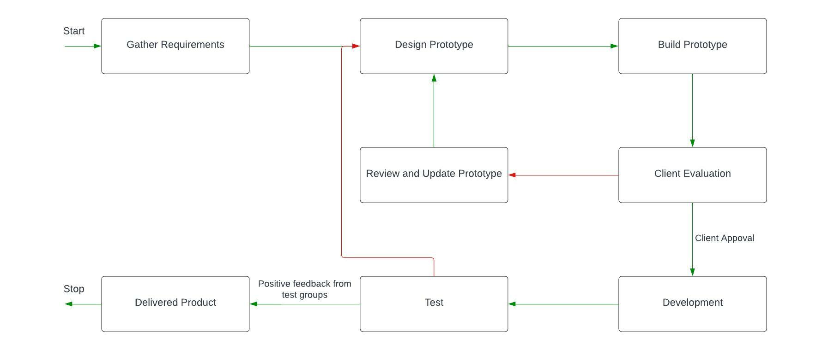

Figure 7.4

*Figure 7.4* displays the development life cycle for the application. Once the team has the requirements, we will undergo a cycle of designing, building, evaluation, and updating. Only after client’s approval will we move forward to the development stage. Following development, the team will start testing using test groups from the UCF college of medicine. If testing is received negatively the team will undergo the development cycle once again, otherwise the team will deliver the final product.

## 7.4 Gantt Charts

### 7.4.1 Gantt Chart for Senior Design 1

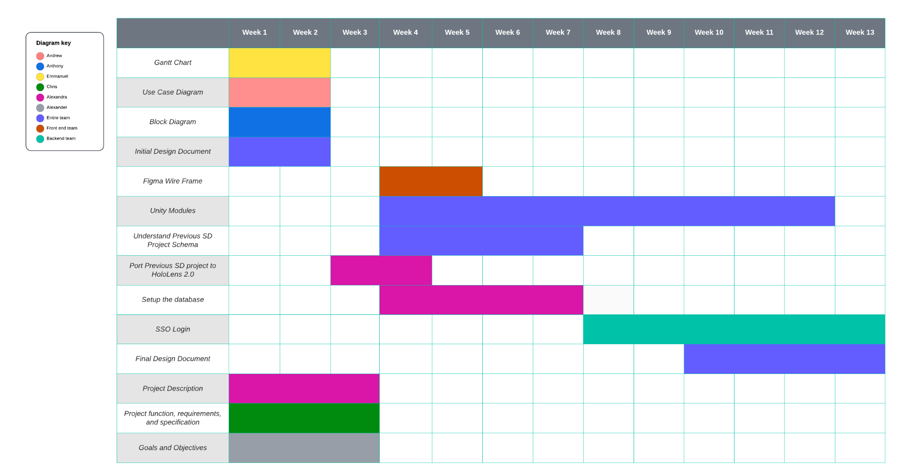

Figure 7.5 SD1 Gantt Chart

### 7.4.2 Gantt Chart for Senior Design 2

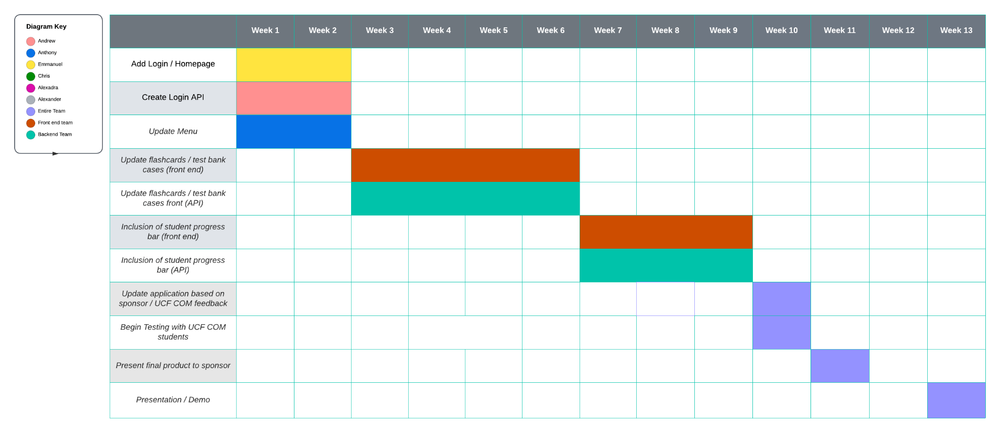

Figure 7.6 SD2 Gantt Chart

# 8. Setup/Deployment of AR Project

## 8.1 General AR Setup

1. Create an account for Unity and log in
2. Download and install Unity Hub and install your preferred version of Unity (Ensure that it supports Universal Windows Platform)
3. Create a new 3D Core project in Unity with your preferred version (2018 and up, AR Core is deprecated)

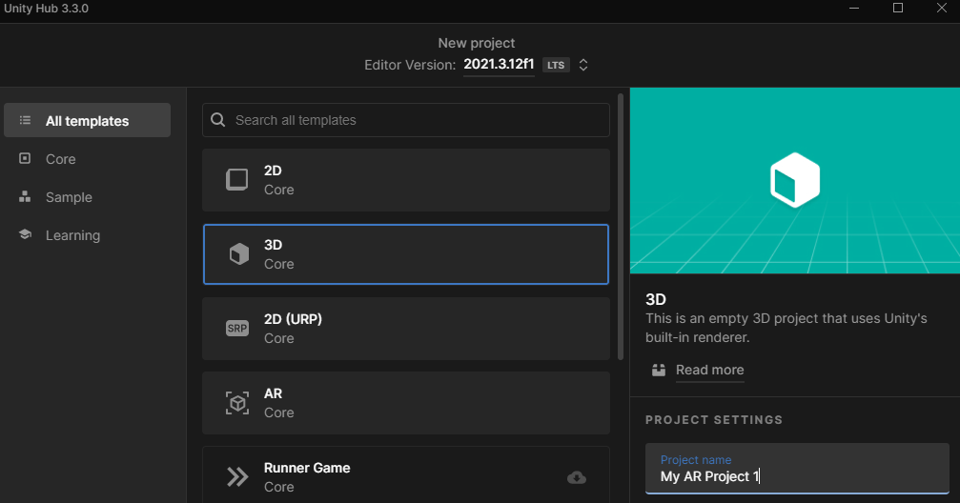

Figure 8.1 Unity Project Template

1. Within the project, on the top left under File, click on the Build Settings option
2. Click on Universal Windows Platform, Set Architecture to ARM64, then click Switch Platform

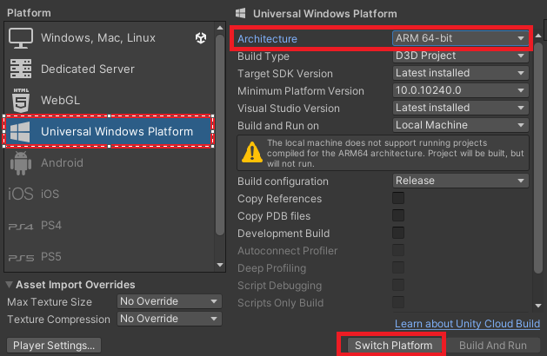

Figure 8.2 Build Settings to switch platforms

1. Now download and run the Mixed Reality Feature Tool
2. Select your Project Path and click Discover Features
3. Under Mixed Reality Toolkit, click the Mixed Reality Toolkit Foundation. Under Platform support, click Mixed Reality OpenXR Plugin (1.5.2), and then Get Features.

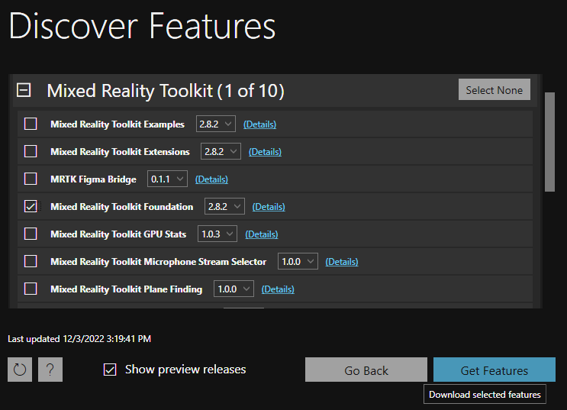

Figure 8.3 Mixed Reality Feature Tool

1. In Unity, accept the Unity OpenXR platform in the MRTK popup.
2. Follow along with the MRTK Project Configurator (Do not skip setup).
3. Once the MRTK Project Configurator states “MRTK Setup Completed!”, the foundation of the project is established. (Note: There may be a validation window popup, clicking Fix All should solve these issues.

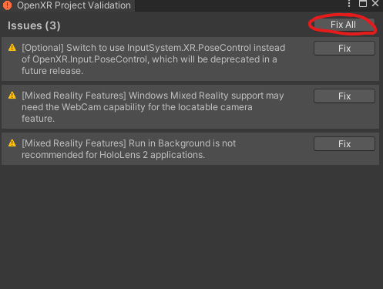

Figure 8.4 Validation Window Popup

1. Top left of Unity under Edit->Project Settings->Player->Publishing Settings, Change the package name to the desired name of the deployed product.
2. Create a new scene and on the top of Unity under Mixed Reality->Toolkit, click add to scene and configure. Start developing your application.

Things to note:

* MixedRealityPlaySpace object is where the user’s headset is determined to be placed at the startup of the application.
* For an object to be tangible and manipulatable, It requires three components: A Collider, An Object Manipulator Script, and a NearInteractionGrabbable Script.
* MixedRealityPlaySpace object is where the user’s headset is determined to be placed at the startup of the application.

## 8.2 Deployment of the app to HoloLens2 for debugging

In order to test and debug the application on the HoloLens 2, we need to deploy the application to the device. One of the ways would be to Build the app and run it on the Device via USB [29]. To do that, we need to select the correct settings for the project. The project settings can be changed in Unity via File > Build Settings. Then, select the scenes that would be shown on the device.

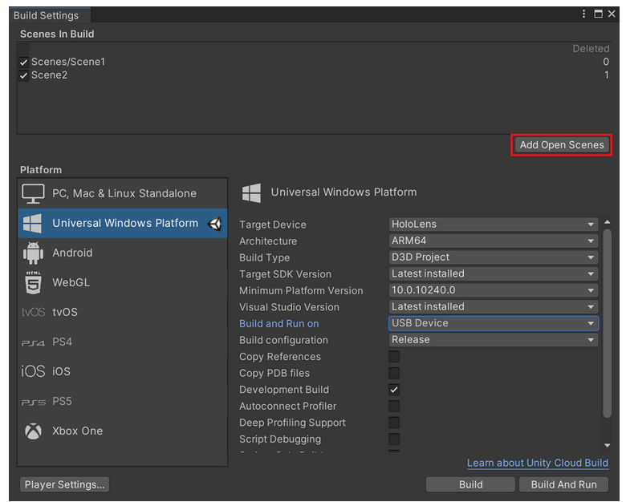

Figure 8.5. Build settings to run on HoloLens 2.

After the application is built, the solution file for the project needs to be opened in Visual Studio 2019. Visual Studio 2019 is the latest version of VS that allows for deployment to the HoloLens2. From here, there are several ways to run the solution on a physical device. First step is to enable Developer mode on HoloLens. This can be done in Settings > Update > For developers > Use developer features. Additionally, Device discovery should be enabled. Developer mode should also be enabled on the PC through Settings > Update and Security > For developers > Developer mode.

First option is to deploy the HoloLens app over USB. This option is straightforward, however there is a limitation that the device should always be connected to the PC during the testing of the app.There are three Compilation options: Debug, Master, and Release. Debug is primarily used to debug scripts. Master is used to submit apps to the Store, Release is mostly used to evaluate the app performance. In order to deploy the app, we need to change the Compilation Options to Release. Then, the build configuration for the build is ARM64 (Same as the configuration build for Unity project).Then, in order to deploy the app to the physical device via USB, select Device, and select Start Debugging.

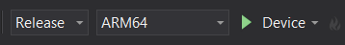

Figure 8.6. Setting for deploying the app over USB.

For running the device over Wi-Fi, the settings are similar.but instead of Device, the selection should be Remote Machine. Additionally, to set the remote connection, the IP address of the device should be added. This can be done in Project > Properties > Configuration Properties > Debugging. In the debugging to launch tab, Remote machine should be selected and in the machine Name, the IP address of the HoloLens2 should be entered as shown in Figure 8.7

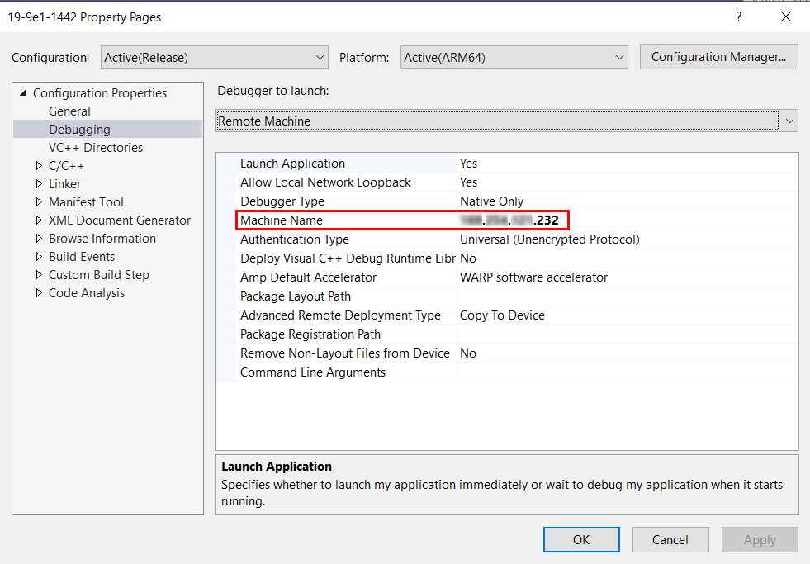

Figure 8.7. Setting to deploy Unity app on HoloLens2 via Wi-Fi

## 8.3 Deploy final application

As our deliverable, we need to have a .appx application that is possible to install on a HoloLens 2 device. There are several steps for it [67]. First, in Unity, select File > Build Settings > Player Settings. In the Publishing Settings and in the Certificate section, select Create as shown in Figure 8.8.

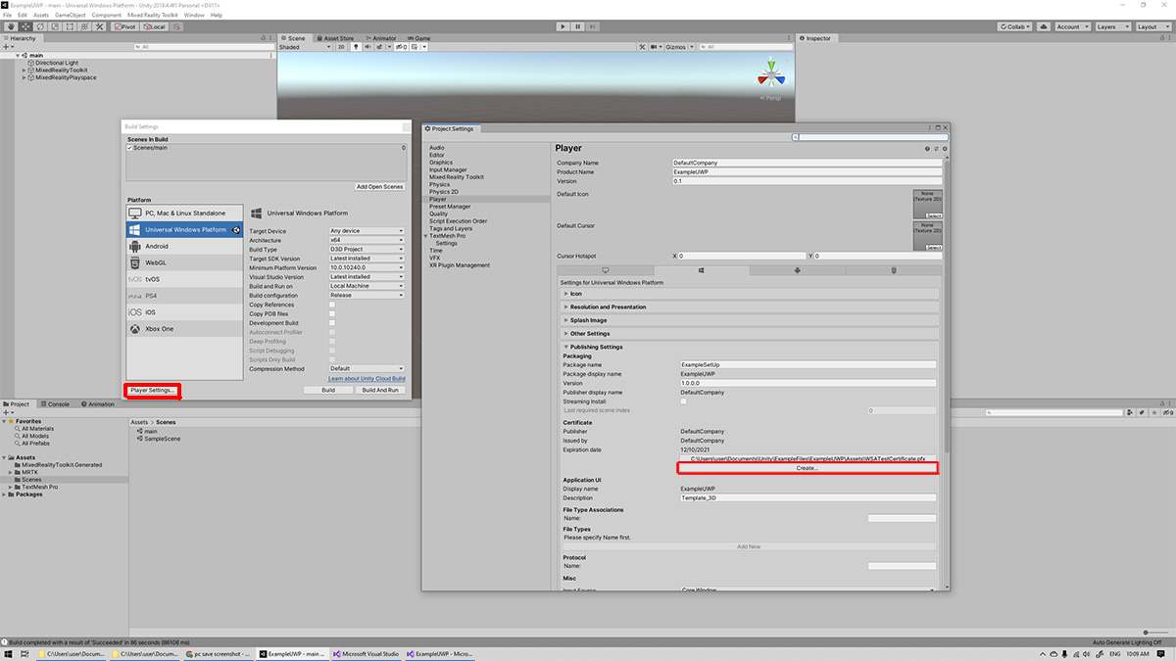

Figure 8.8. Publishing Settings

Then, in the popup, select fill in the Publisher information (in our case, we use UCF_cARdiac and a password). After the certificate was created, we needed to go back to the Visual Studio and in the solution explorer, open Package.appxmanifest. In the Packaging heading, select Choose Certificate > Select from File. Find the WSATestCertificate.pfx in the Project Assets folder (not the Builds Asset folder) as shown in the Figure 8.9. Then, enter the password created when creating the certificate in Unity.

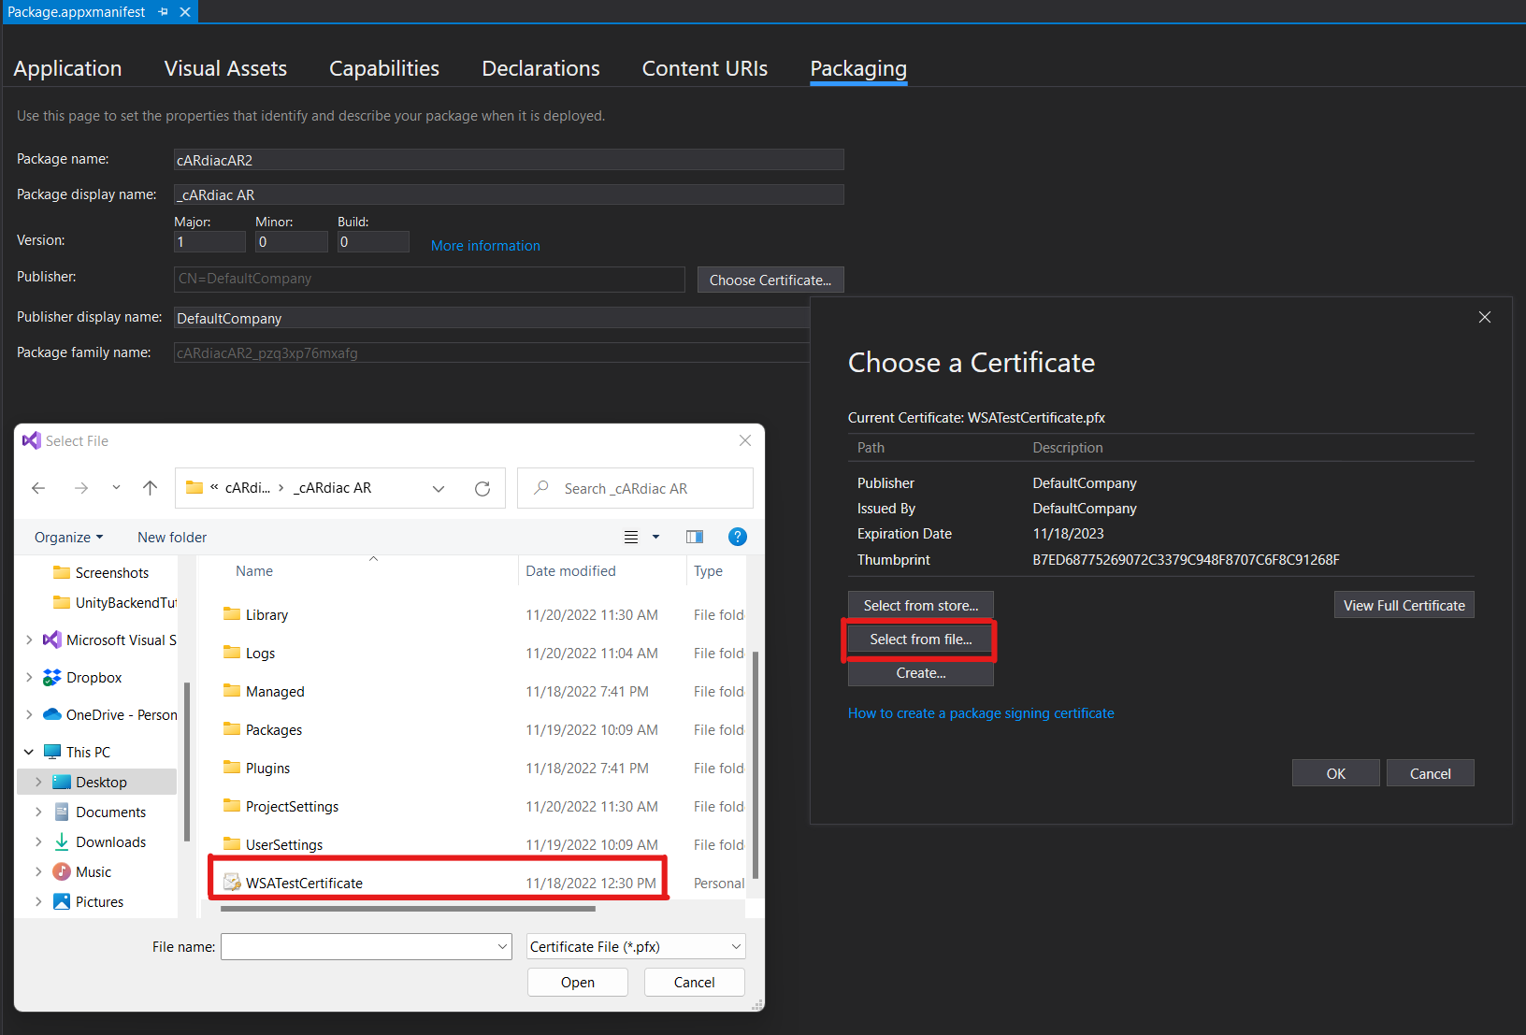

Figure 8.9 Configure Certificates in Visual studio

After this, click View Full certificate > Install Certificate. Select Current User and place all the certificates in the following store button. Choose Trusted Root Certification Authorities. After the import was successful, we can create an App Package by locating in the Solution explorer cARdiac > Publish > Create App package as shown in Figure 8.10

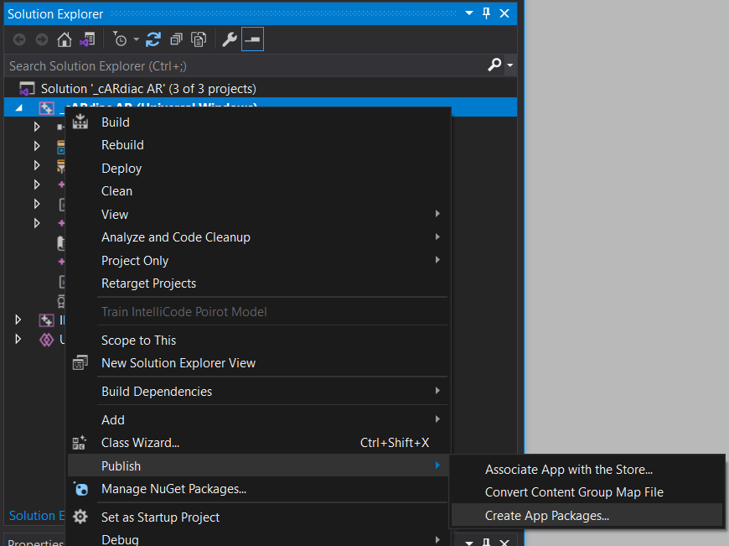

Figure 8.10 Create App Packages

Here, select sideloading (necessary for the apps that would be downloaded not from the official source (ex. Microsoft store or LOB apps created by the organization itself). Then, select Yes use current certificate and check that the ARM64 is checked. Then, select Create. Now, the app should be created in the file path indicated and it is possible to share it as a package with other users. It is now possible to open the created app on HoloLens 2.

## 8.4 Sideloading app onto Hololens 2

In order to sideload the app that we created onto HoloLens 2 without publishing the app to Microsoft Store, we can use the Device Portal. First step would be to set up the HoloLens to use the Windows Device Portal. To do this, first, verify that the device is in the developer mode using Bloom gesture open Start menu > Settings > Update & Security > For developers > Turn on Developer Mode. Additionally, check that the Enable Device Portal is on. Next step is to connect the device to Wi-Fi. Then, from the web-browser on the PC, go to https://<HOLOLENS_IP_ADRESS>. The IP address of the HoloLens 2 device can be found in Settings > Network & Internet > Wi-Fi > Advanced Options. The IP address to use is located under IPv4 Address. Skip all the warnings about the security risk, since these steps are necessary only to load the app on the device for the first time, they will not be harmful for general users of the app. Then on your browser, the pop-up will appear to sign in. The username and password should match the username and password for the device. This will load Windows Device Portal to HoloLens as shown on Figure 8.11.

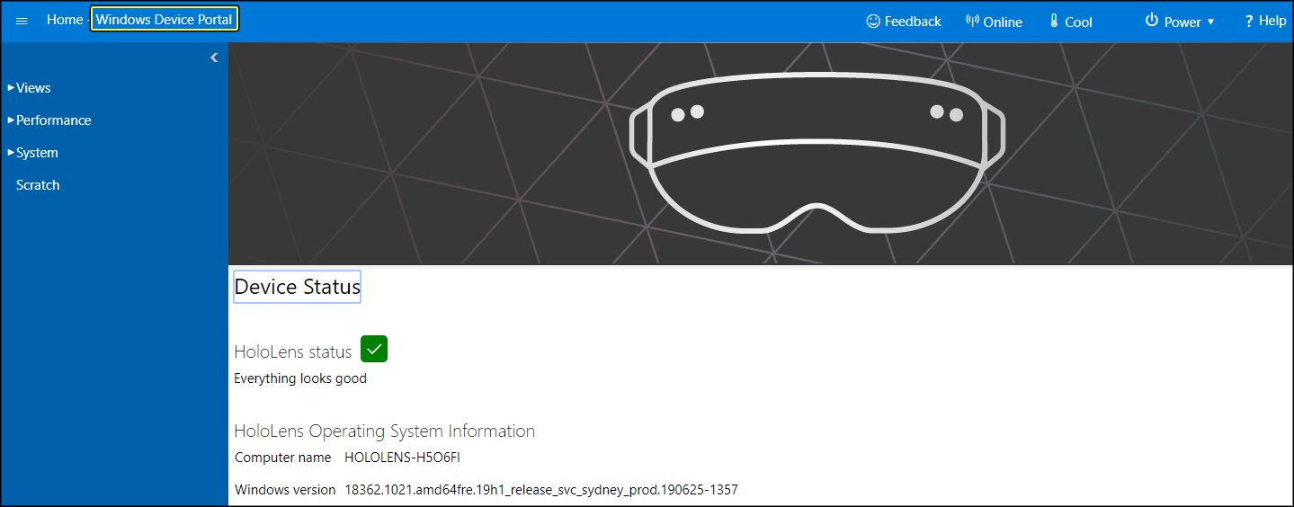

Figure 8.11 Windows Device Portal. Source [87]

Then, we deploy the app to the HoloLens2 from the PC by selecting Views > Apps from the toolbar in the windows Device Portal as shown on Figure 8.11.

Press Choose File and browse for the .appxbundle file in the build of the app. This will specify the package for the installation. Select Allow me to select optional packages. Choose the file from Local Storage as shown on Figure 8.12. Then, select the .appx file that matches the platform of the device (ARM64 for the device, x64 for Emulator) as shown on Figure 8.13.

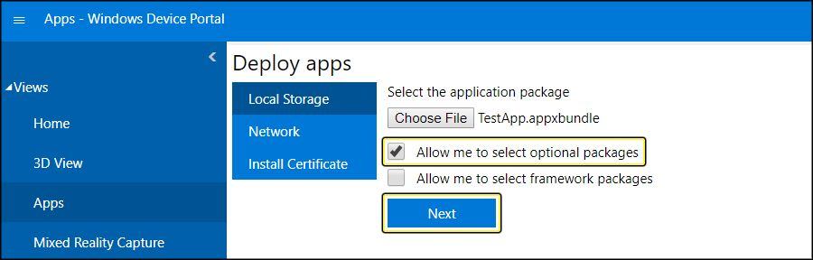

Figure 8.12 Deploy app to HoloLens 2. Source [87]

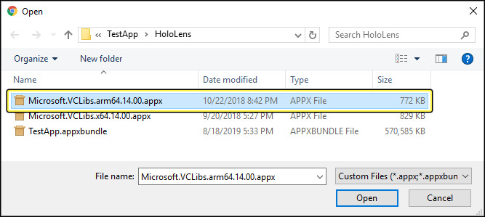

Figure 8.13 Example of the .appx file for the application. Source [87]

The last step is to click Install (Figure 8.14)

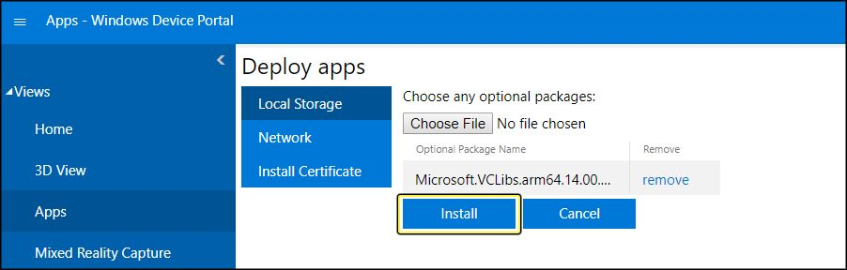

Figure 8.14. Installation of the app to the HoloLens2.

After the installation is completed, navigate to the the Main menu on HoloLens 2.0, select All Apps and locate the installed app icon. After that, the app is runnable for all users on HoloLens. In order to install the application package to the device, these steps are required:

1. On your PC navigate to your custom app, and copy yourapp.appxbundle to yourdevicename\Internal Storage\Downloads. After you finish copying your file, you may disconnect your device and finish the install later.
2. From your HoloLens 2 device Open the Start Menu, select All apps and launch the File Explorer app.
3. Navigate to the Downloads folder. You may need to on the left panel of the app select This device first, then navigate to Downloads.
4. Select the yourapp.appxbundle file.
5. The App Installer will launch. Select the Install button to install your app.

## 8.5 Windows Device Portal

The Windows Device Portal for HoloLens allows you to configure and manage your device remotely over Wi-Fi or USB. The Device Portal is a web server on your HoloLens that you can connect to from a web browser on your PC. The Device Portal includes many tools that will help to manage the HoloLens and debug and optimize your apps as well as allow you to stream the HoloLens output on the computer screen. First, the HoloLens needs to be set up to use the Windows Device Portal. Developer mode and Device Portal should be enabled in the Setting on HoloLens 2 as shown on Figure 8.15. To deploy apps to this HoloLens over USB or Wi-Fi, select Pair to [generate a pairing PIN](https://learn.microsoft.com/en-us/windows/mixed-reality/develop/advanced-concepts/using-visual-studio). Leave the Settings app at the PIN popup until entering the PIN into Visual Studio during your first deployment. For this to work, the device and PC needs to be on the same network.

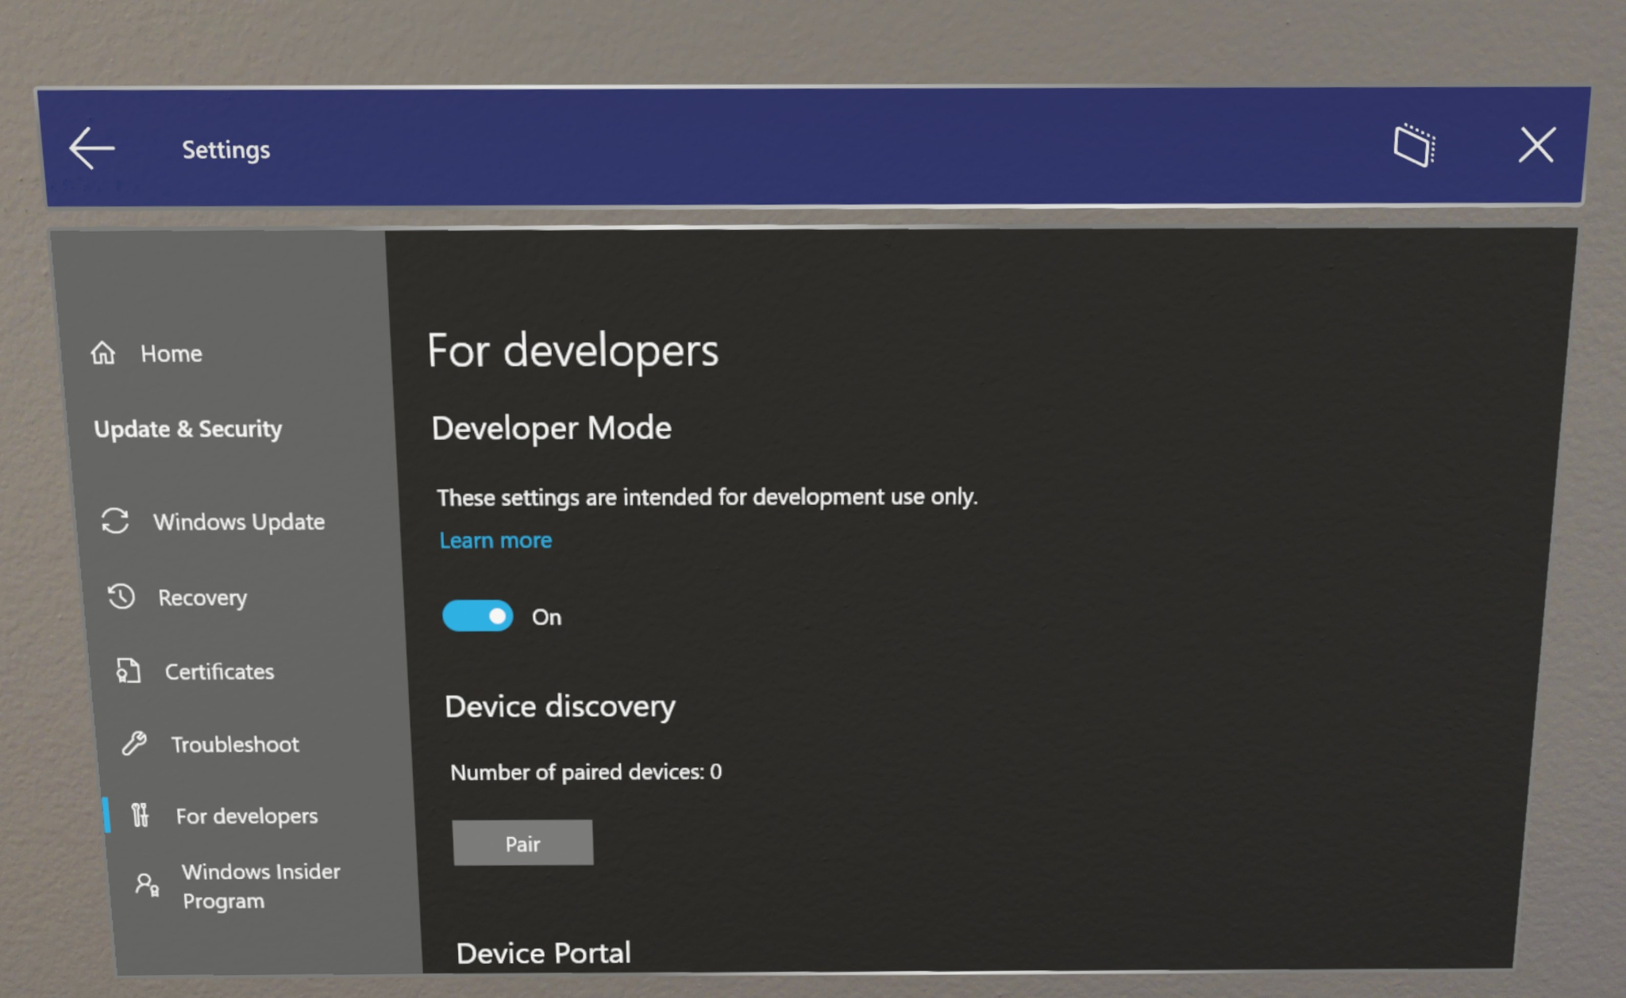

Figure 8.15 Developers mode on HoloLens2 [34]

Windows Device Portal can be used for various things when working with the HoloLens 2. Once the HoloLens is connected to the PC, you can deploy the application through it, whether using the USB or Wifi connection. Additionally, there is a toolbar that allows you to see some commonly used features and general status of the device, such as Wifi-connectivity, the temperature of the device, whether the device is charging, critical errors and health monitoring, Windows information and preferences as shown on Figure 8.16.

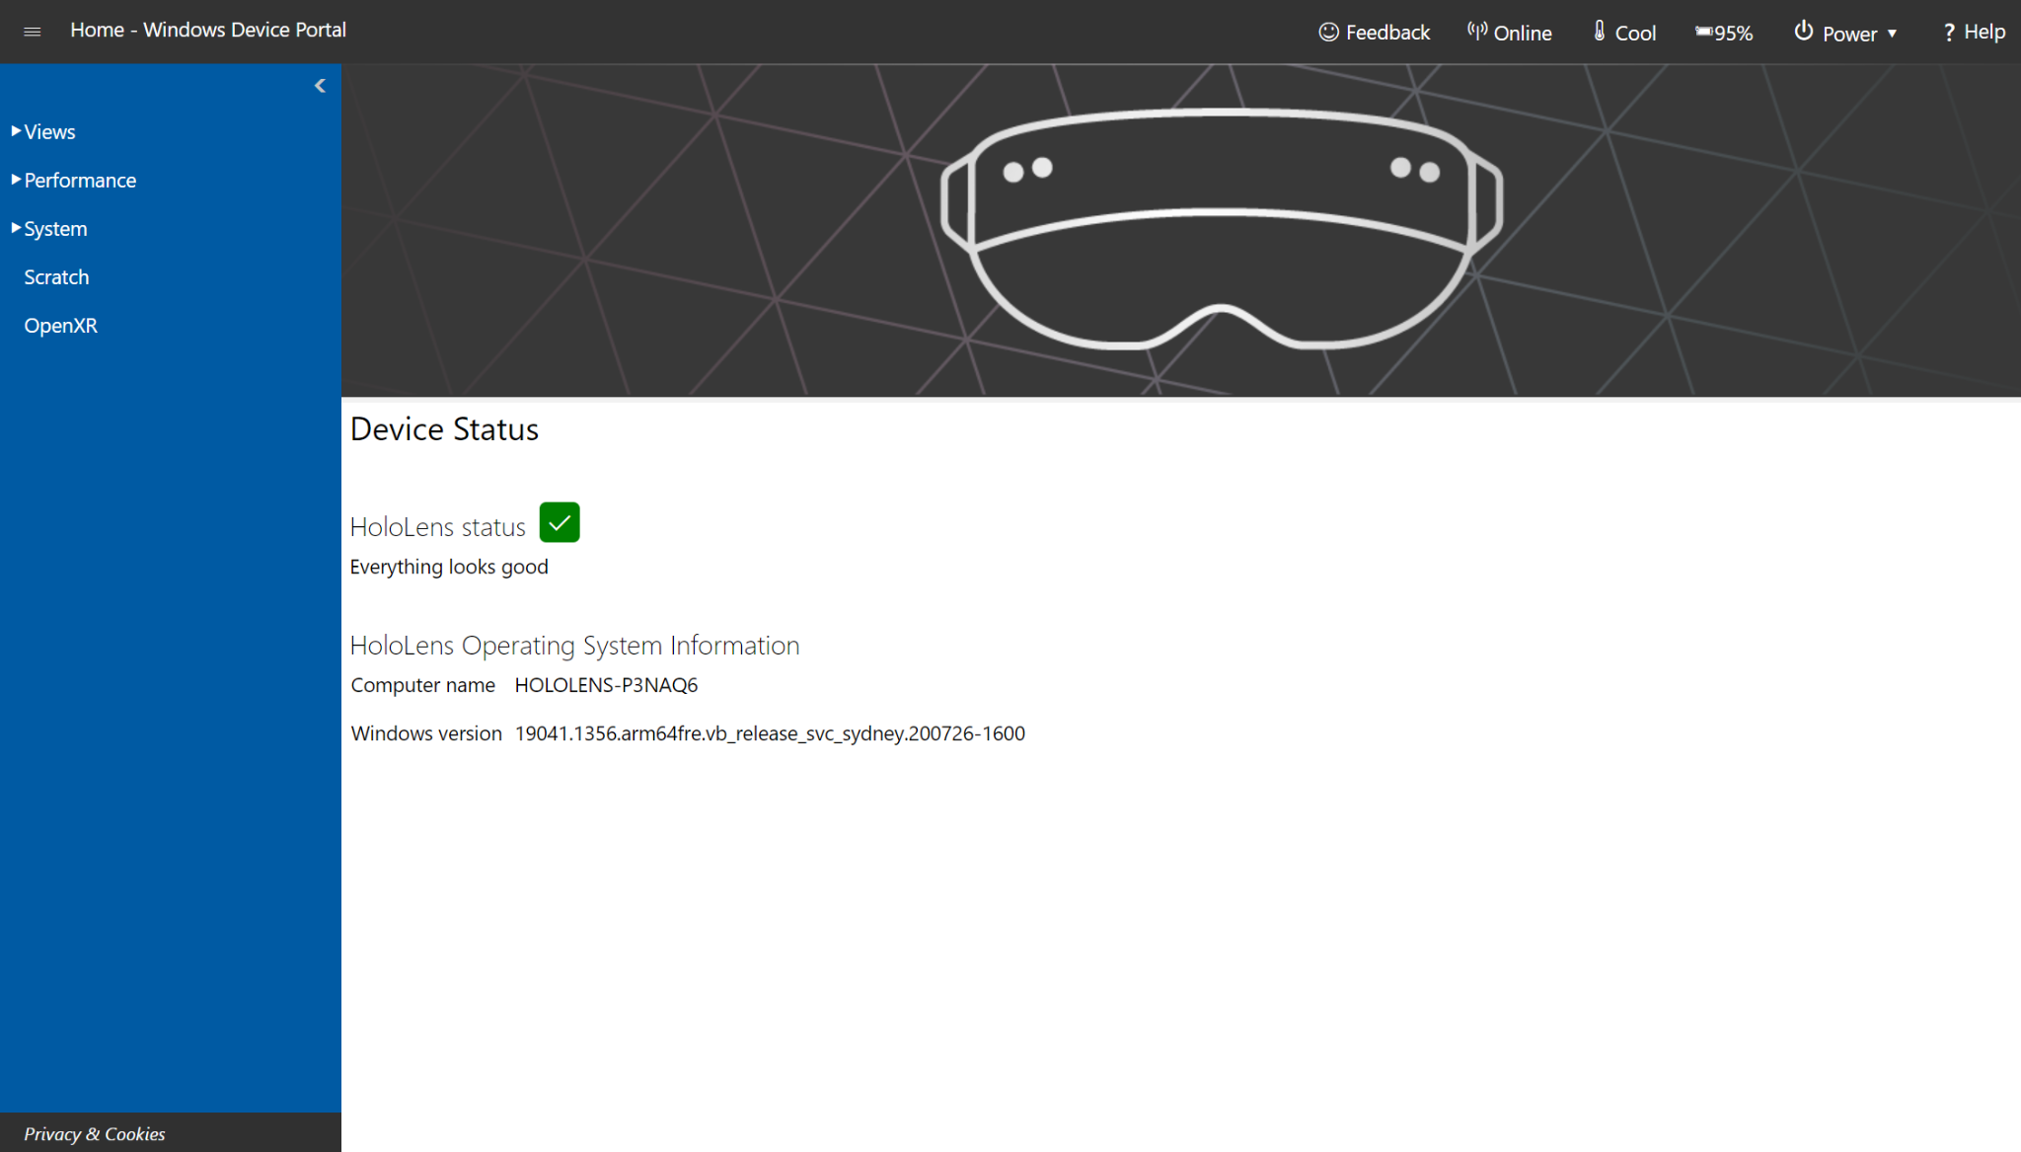

Figure 8.16Widnows Device Portal Dashboard [34]

There are also features like 3D view to see how the HoloLens 2 interprets the surroundings, Map manager, which can be useful for Location-Based Entertainment customers, Mixed reality capture that can capture various media streams from HoloLens and save them, System Performance, and Performance tracing.

# 9. Testing

## 9.1 Different types of Testing

# 

*Figure 9.1: Different levels of testing* [94]

Unit

* Focuses on testing a single component.
* Provides more direct and concise feedback.
* Fastest to test.
* Least expensive in terms of time and resources.

Integration

* Tests multiple components and their interactions to make sure they work well together.
* Middle ground for speed and expense.

End to end testing

* Testing as a user would experience it.
* Slowest to test.
* Most expensive in terms of time and resources.

Testing with Unity

When it comes to automated testing, Unity provides its own testing framework package to install called Unity Test Framework (UTF) to test code in both Edit mode and Play mode. Automated testing helps check parts of code so that they are operating as expected. Using automated testing can help isolate bugs and is more efficient than manual testing. As the project grows, having unit tests can be beneficial as it is increasingly difficult as time goes on to search for bugs.

To create a unit test within Unity we must create a tests folder to place all of our tests scripts within the test runner. Test scripts are C# files specifically created to check a single method or function. It is best practice to logically divide and organize your unit tests among different class files called test suites. This way if one unit test fails, the entire test suite fails, and you can identify the problem area [42].

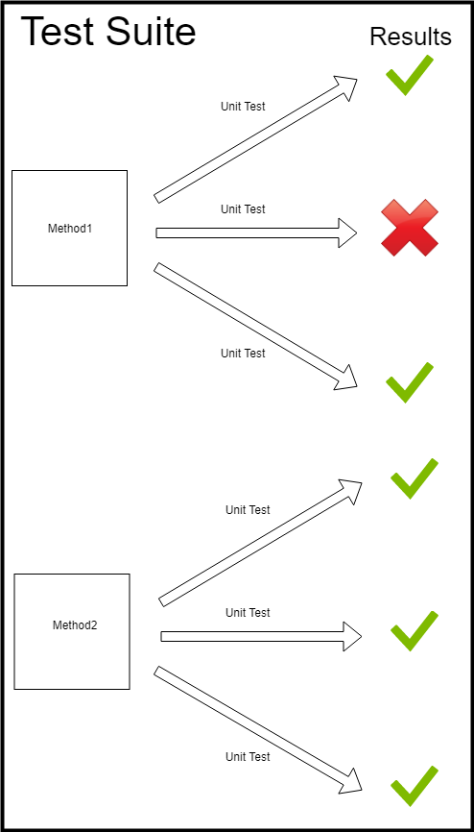

*Figure 9.2: Diagram on how test suites operate* [42]

When it comes to integration testing, we must consider how individual modules interact with one another. For instance within cARdiac one of the integration tests would be assigning a grade to a student when they clear the case section. The integration test would involve a few modules such as the individual case questions, student progression within the cases, and the overall score of the cleared cases. The integration test would simulate all of the modules in question to make sure that a grade is given to the student [42].

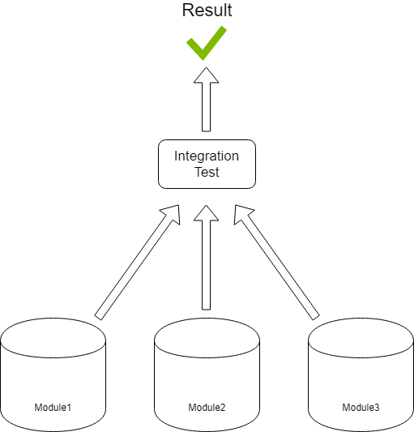

*Figure 9.3: Diagram on structure of a integration test* [42]

Testing with Hololens

Things to consider when testing an application with Microsoft HoloLens:

* The environment: The room size and the type of room can influence the application. So when testing the application it is best practice to try it in as many different types of rooms as possible. Such as larger rooms or smaller rooms; kitchens, bathrooms, bedrooms, offices, etc.
* Lighting: Different types of lighting on the environment around you can change the response of the app such as dark, transparent, and reflective surfaces.
* States of motion: Test to see if the application is affected by steady or fluctuating motion.
* Angles: Test to see if the application is affected if the user is looking down or up while using the HoloLens. As well as if any interference such as someone walking into view from behind will cause any effect.
* Audio cues: Test to see if the audio cues from things such as the buttons, options, and effects are intuitive and straightforward.
* Ambient noise: Test voice commands at varying levels of ambient noise to see how responsive it is.
* Positions: Test the different positions of the user such as sitting, standing, and lying down to see if there are any changes to how the application responds.
* Distance: Test at varying distances to see how the UI components of the application respond to a user being up close or far away.

[43]

## 9.2 Perception simulation

Perception simulation is a library that allows for end to end testing for Microsoft HoloLens. End to end testing aims to test as a user would experience the application. The Perception library can achieve that by simulating human and environmental input data into the application through automated tests. An example of an end to end test we could create is having the student log into the application and go through the tutorial. Rather than having an actual user do the commands we could automate perception simulation to bypass the live sensors on the HoloLens to send the commands to the application. The application would receive the input events through the same APIs as if they were done by real sensors [58].

## 9.3 Plans for user testing

User testing is a way to evaluate how actual future users will interact and review the application. Testing will allow our team to gauge how our target audience, which are students attending the UCF college of medicine, feel about the UI and UX of the application. Our plan is to reach out to the students attending the college and take volunteers to try out the app. The testing plan is as follows:

1. Students will be given a list of tasks: This will be based on their level of experience.
2. There will be a set amount of time to complete the tasks: The time limit will likely be around 15-20 minutes to avoid it being too long. Longer tests tend to have a drop off in quality due to fatigue, boredom, or lack of interest. The tasks will consist of what the team and sponsor considers as the most probable and practical use cases of the application.
3. Tests will be moderated: This is so our team can answer questions and get feedback in real time.
4. Tests will take place in an enclosed indoor space: This is where we believe the most common type of environment for use for the application will take place in.
5. User surveys will be filled out at the end: It will consist of questions involving ease of operation, usefulness, utility, design aspects, and comfortability.

[8]

### 9.3.1 User testing metrics

Once user testing is completed our team will take the results and have a meeting with our sponsor to discuss the possible changes to make within the application to improve upon it. The following metrics will be considered:

* Task completion: If the tester completed all the tasks in a timely manner.
* Critical errors: If there were any major bugs or impediments stopping the tester from completing the tasks.
* Non-critical errors: If there were any design flaws or minor bugs slowing the tester down when completing the tasks.
* Error-free rate: Percentage of test participants able to complete the tasks without any errors along the way.
* Time on task: The duration for each task.
* Subjective measures: Individual likes and dislikes when it comes to UI and UX. As well as possible improvements they would like to see on the app.

[8]

## 9.4 Testing Environments

Testing during the development stage is valuable because it can confirm that individual components are working as intended. Being able to find bugs quickly and easily will result in saving time and resources. It's also a way to gauge performance of an application and can act as a living documentation of the product [10].

### 9.4.1 HoloLens Emulator

Constantly utilizing the HoloLens 2.0 as the testing environment is not going to always be attainable all the time. However, a convenient option of an emulator on everyone’s devices is a satisfactory option in testing out features of cARdiac 2.0. This emulator is known as the HoloLens emulator and it is simple enough to set up and start testing the cARdiac 2.0 application with all of its features in emulation. The Home Page of the emulator can be seen in Figure 9.4.

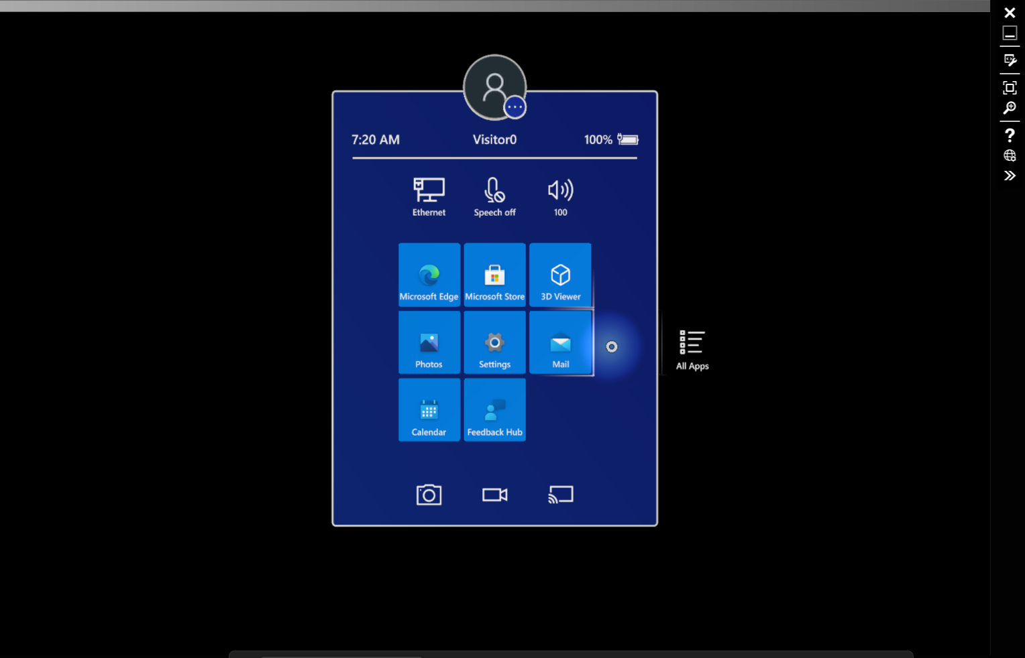

Figure 9.4 HoloLens Emulator Home Page

The HoloLens emulator has plenty of options to explore that simulate the actual HoloLens 2.0. The most convenient part of the emulator is the web-based dashboard. With the web-based dashboard, features can be tweaked, applications can be installed, and more. The application installation process in particular is quite friendly and makes the testing process much easier. The page for the process is demonstrated in Figure 9.5.

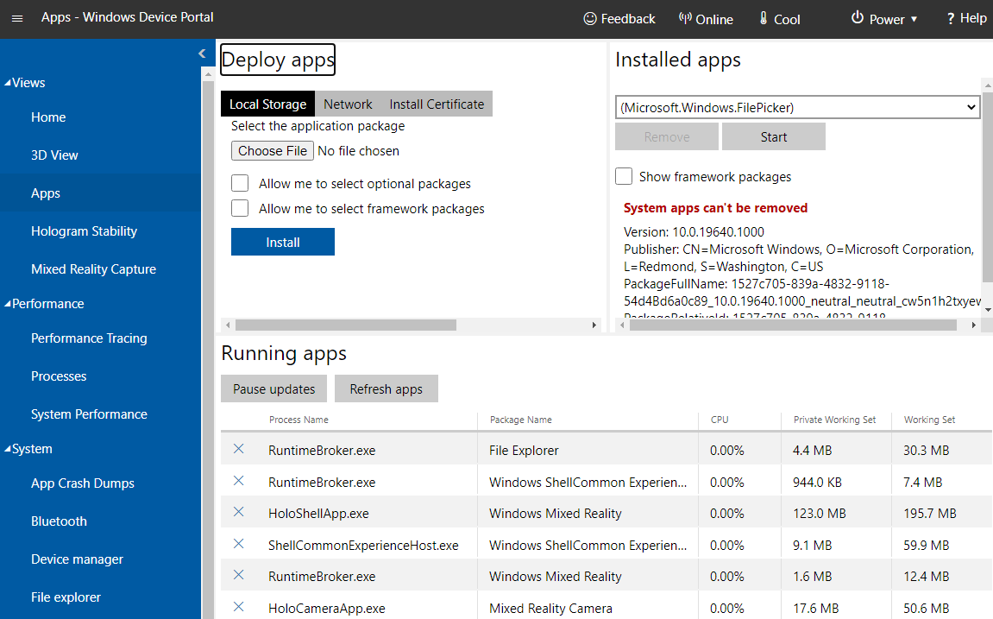

Figure 9.5: HoloLens Emulator Dashboard

A caveat of the HoloLens emulator seems to be an incompatibility issue with ARM Architecture with ARM applications which is a problem since the actual HoloLens 2.0 runs on the ARM architecture and as such needs to be able to properly emulate applications that are supposed to be running on that architecture.

### 9.4..2 HoloLens 2.0

The HoloLens 2.0 is still available to be used for testing more stable versions of cARdiac 2.0. The emulator can only do so much to simulate the HoloLens; However, the HoloLens itself is where the true user experience lies, and thus shall definitely be considered for testing purposes. Specifically, limitations present in the 1.0 version can be tested more rigorously on the 2.0. Potential improvements and features are something to look forward to when considering this testing option. For example, the field of view of the HoloLens has increased between 1.0 and 2.0, thus the user experience can be adjusted to accommodate for the increased screen space. It is also important to test out the HoloLens 2.0 headset in conditions that would be similar to an active classroom. Specifically, a type of classroom where the application would be deployed to ensure that it functions correctly in the determined location. Caveats to this method of testing are that there are only two HoloLens 2.0 headsets available to UCF at this time. Transporting the headsets can also be a delicate time for those that do not have automobiles to transport them outside of campus. However, even with these caveats, it is important that it is still tested as it is the main focus of this application.

### 9.4..3 Unity

Building and running on Unity is not the best for emulating the experience of the user; however, the plus is that trying to run on Unity before building can help iron out errors before waiting for an entire package to build and ultimately failing if there are a few or more errors. Specifically, we want to try and run the application on the latest Long-Term Support version of Unity in order to ensure that the overall project is up to date and running properly. Since this is also the development platform, it will be what the team will be seeing the most in development. Unity will throw errors at the smallest of conflicts to ensure that the project will build smoothly in the end, so it is important to pay attention when testing in Unity. It can also be used in conjunction with Visual Studio in order to The User Interface and the functions of the application will be readily available to get a preview before more proper testing on either the HoloLens emulator or HoloLens 2.0 is done.



Figure 9.6 Preview of cARdiac in Unity

### 3.3.4 Visual Studio

Visual Studio will be the primary way to build on the architecture meant for HoloLens 2.0. Not only that but it can also be used for testing purposes as well. Its usage in the console and API endpoints will be useful for on-the-go coding. It also has its own fair share of built-in testing tools that can be utilized when creating the code. There are plenty of unit test tools built within the program, and if they are not to our liking then there are even more options in the extension store (Visual Studio Marketplace) that is built in. The test explorer framework can also assist with debugging and analyzing code. There are also live unit tests that run in the background and analyze as the code is being written in the case of an immediate modification. User Interface tests can also help as you can implement prints in Unity and have the console print out the output and ensure that the buttons of the application are functioning properly. There’s also ensuring that the code itself is properly formatted so that it will be readable to others who work on cARdiac or are interested in how it works with its functionalities.

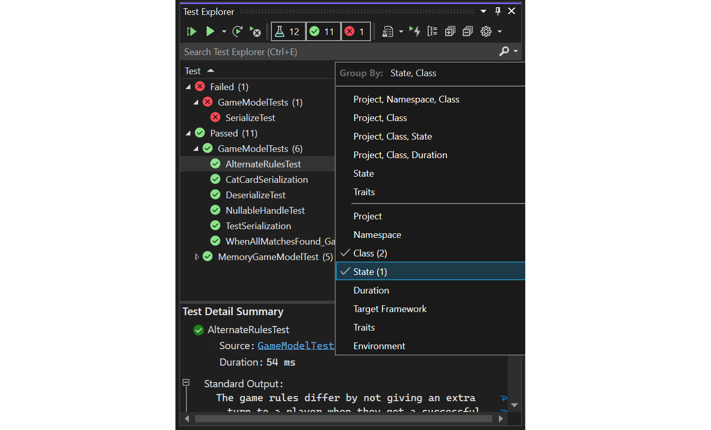

Figure 9.7 Example of test explorer [15]

Visual Studio is one of the biggest software development tools that we’ll be using to upgrade the cARdiac AR application. IDEs make the software development process easier for developers by providing tools to support the process. Visual Studio contributes to making this process easier by offering tools to edit, debug, build and run, and publish applications far superior to most IDEs. It also provides code completion tools, compilers, graphical designers, etc. With a project open it, by default, supports:

* Solution Explorer: Which allows user to manage their code files
* Editor Window: Which displays the content of a file and allows for editing
* Git: Allows user to track their versions control and view changes

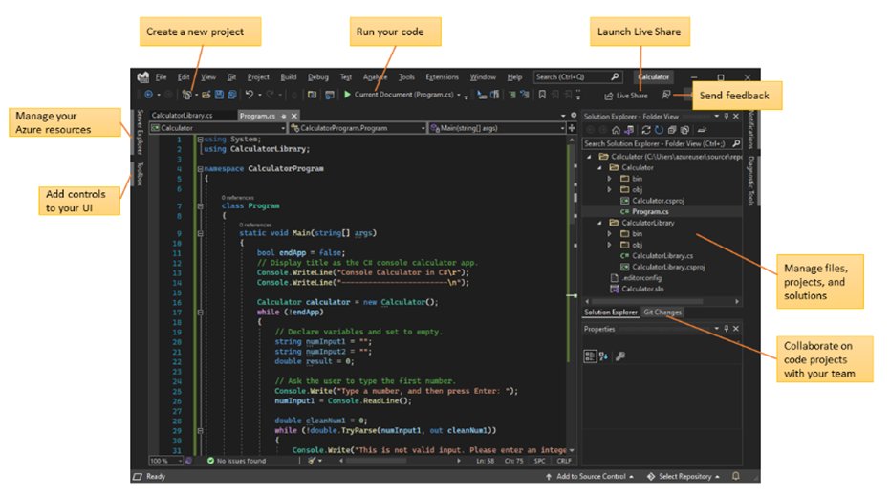

Figure 9.8 Visual Studio Overview

Visual Studio is available on Mac and Windows which share many of the same features and is created to optimize development for cross-platform applications. The following are some of the features that we find would be the most useful in our development [78]:

#### 3.3.4.1 Modular Installation

Visual Studio is a modular installer which allows developers to install which workloads they want. Workloads in Visual Studio are groups of features that languages and platforms need to function. For this project the workloads that we need are .NET desktop development, Universal Windows Platform development, Game development with Unity, and Desktop development with C#.

#### 3.3.4.2 Connect to Database

Visual Studio allows developers to connect to their database in their IDE and view their database through the Server Explorer which allows developers to manage their server instances and their assets remotely or locally. The SQL server explorer allows developers to view their SQL database and do basic work such as editing tables, execute queries, and compare schemas. Visual Studio also offers SQL Server Data Tools which is a development environment for SQL servers. It allows developers to debug, refactor, and build databases.

#### 3.3.4.3 Debugging and Deploying

Debugging and testing is one of the biggest processes during the software development cycle and Visual Studio helps support this process. Visual Studio allows developers to debug their code and test their project locally, on an emulator or on a remote device. This is beneficial for our project because we can test and debug our project using either the HoloLens 2 Emulator or using the physical HoloLens 2 device. Visual Studio also offers built in unit testing, load and performance testing, and Intellitest. Once a developer feels that their application is ready to be released Visual Studio allows developers to deploy their application through the Microsoft Store, SharePoint site, or InstallShield.

#### 3.3.4.4 Squiggles and Quick Actions

Visual Studio will warn you when it detects any errors or potential errors in the user’s code which will appear in the editor as a wavy underline. Hovering over the squiggle will provide the user with more information about the potential error and possibly even offer a quick solution to the issue

#### 3.3.4.5 Refactoring

The IDE can refactor the code by changing the variable names, extracting lines of code into a new method, and even changing the order of a method’s parameters.

#### 3.3.4.6 IntelliSense

IntelliSense is a feature that displays information about the developers code in the editor which is like a small snippet of documentation directly in the editor and sometimes writes a small amount of code as well. These features do vary depending on the language that is being used.

#### 3.3.4.7 Call Hierarchy

The call hierarchy feature allows developers to see which methods call a selected method which is helpful when debugging and can help when deciding to change, remove or add methods. [78]

### 3.3.5 Canvas

We can build our own use of Canvas in order to have an easy-to-access test website before deploying the application onto the actual Canvas that UCF utilizes. We will have to consider the possibility that if this is to be utilized, then the EFI Single Sign-On Service will have to be paid for once again, one for the actual deployment on webcourses, and another for the test environment. As the application progresses, Canvas will become more and more important to test. This is another objective to keep in mind and must work properly if the application is to be considered successful. Otherwise, the alternative option of sending data to an excel sheet will have to be done.

### 9.4.6 Outside Testing

Eventually, we will have to move on from limiting testing to the team to testing with non-team members in order to gather data on what works and what doesn’t. A survey will be created and we will communicate and coordinate with our sponsor to have non-team members test the application through the HoloLens. Testing with the emulator may be easier but is not as beneficial to the study as an actual in-person HoloLens 2.0 testing environment.

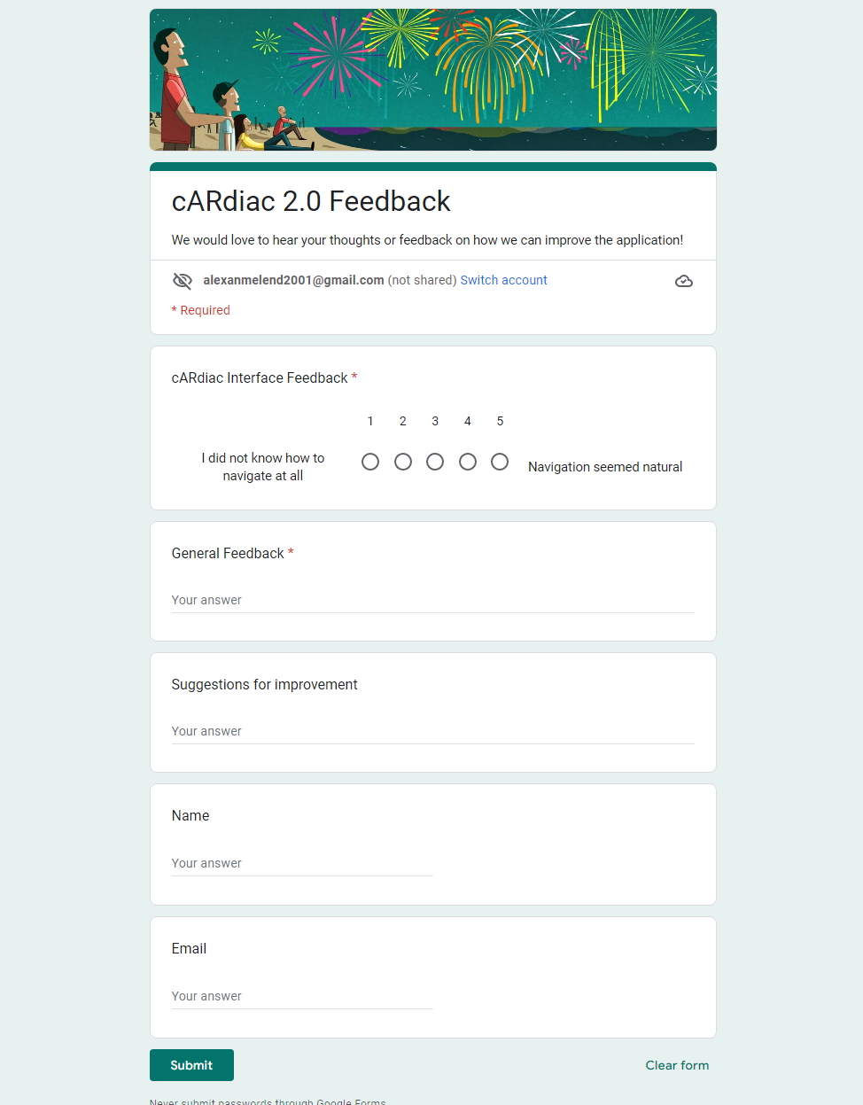

Figure 9.9 Example of a survey for feedback

### 9.4.7 Hyper-V

Hyper-V is a product created by Microsoft that allows users to create multiple operating systems and run on Windows as a virtual machine. Having a virtual machine can help developers organize their virtual workloads and increase security. Virtual machines allow users to do the following:

* Run older version windows or other operating systems
* Test out other operating systems
* Test software on various operating systems

Hyper-V does have some limitations, one being that if a software is dependent on a specific hardware, then it will not operate well on the virtual machine. Another limitation with Hyper-V is that any application that is high precision and latency sensitive may encounter issues when trying to run in the host. Despite having some limitations, Hyper -V does have some advantages as well, which are the following:

* Being able to create a virtual switch, this allows VMs to communicate with each other better
* Uses hardware resources more efficiently and uses less resources such as CPU, memory, storage, systems, etc.
* Both flexible and scalable to where only one Hyper-V server is needed to run multiple servers
* Allows users to install multiple operating systems to help test and develop applications across different OSes [9]

### 9.4.8 .NET Framework

.NET is a platform for developers that consists of tools, libraries, and languages to help developers build applications. There are a few different ways to implement .NET which allows .NET to execute in different operating systems.

* .NET Framework is the original form of .NET which supports websites, desktop applications and other window services.
* .NET is an open source that supports cross platform implementation for websites, desktop applications and other services on different operating systems.
* Xamarin/Mono supports .NET implementation for mobile operating systems such as IOS and Android

#### 9.4.8.1 .NET Architecture

.NET framework consists of two major components which are Common Language Runtime (CLR) and a Class Library.

* CLR is the engine that handles running the applications and provides services such as garbage collection, type safety, threading, exception handling, etc.
* .NET Class Library offers APIs for writing and reading files, connecting to databases, and more.

.NET is written in F#, C# or Visual Basic and the code is compiled and stored into .dll or .exe files. When an application is run, the Common Language Runtime takes the assembly code and uses a Just-in-time compiler to convert it into machine code that can be executed on a specific architecture for the computer that the application is running on. [91]

### 9.4.9 Universal Windows Platform (UWP)

Universal Windows Platform is one of the ways that developers can create client applications on windows. Universal Windows Platform (UWP) applications use WinRT APIs to create UIs and advanced asynchronous features that work well for devices that are connected to the internet. UWP is for creating applications on Windows 10 and 11 but also supports cross-platform applications. UWP applications allows you to do following as well:

* Notifications that display real-time alerts to users
* User activities allows for users to start the application from a checkpoint rather than starting over
* Application can use voice and Bluetooth connection
* Also have Cortana to include voice commands in a UWP app
* Implemented in well-known programming languages such as C++, C#, JavaScript, Visual Basic, etc.
* Monetize your application

#### 9.4.9.1 Secure

UWP applications offer the capability of accessing a user’s device location, microphone, webcam, files, USB devices etc. Because this information is personal, applications created in UWP are created to ask the user for permission to access any of these features before using them.

#### 9.4.9.2 SDK Extensions for Unique Aspects of Specific Devices

UWP has APIs that can be used on any applications that is running Windows 10 or later, but UWP applications also have the ability to take advantage of device specific APIs. SDK extensions allows developers to call APIs for specific devices which allows them to target specific features for that device. It also lets developers to create applications for a specific device and deploy it to Window store solely for that device.

#### 9.4.9.3 Adaptive Inputs and Controls

UI elements respond to the resolutions of the screen that the application is being run on by adjusting the scale. UWP applications work with multiple input devices and allow developers to design layouts that adapt well across different devices. [66]

## 9.5 Testing results

As part of our testing routine, we have asked several students to test the application to help us identify any bugs and report on the general usability of the app. The users selected for testing came from both Computer Science and Medical backgrounds to test various aspects of the application: general usability,presence of bugs, content used for the application and other factors. As a result we were able to gather several responses.

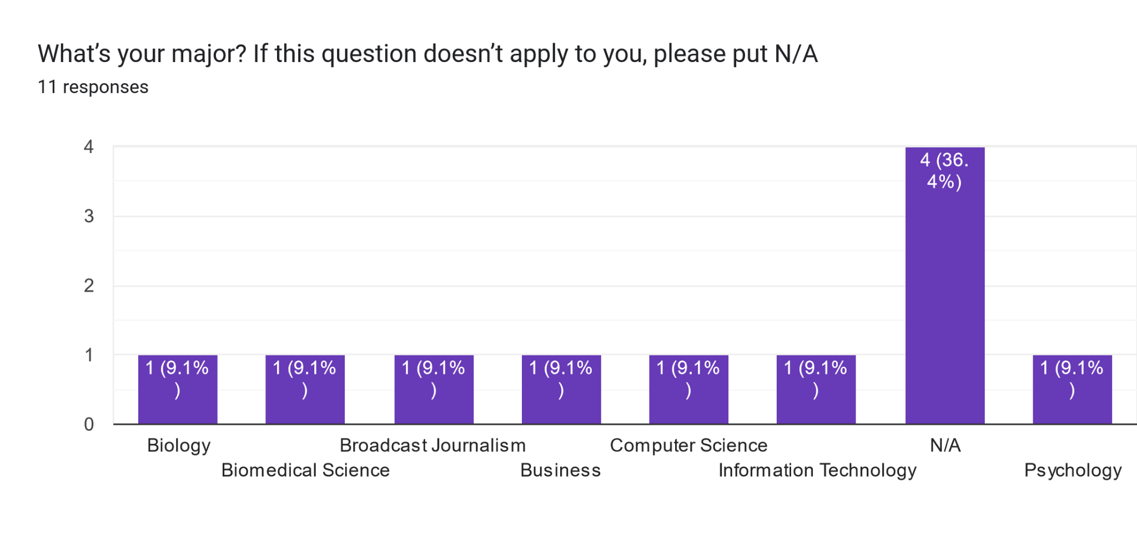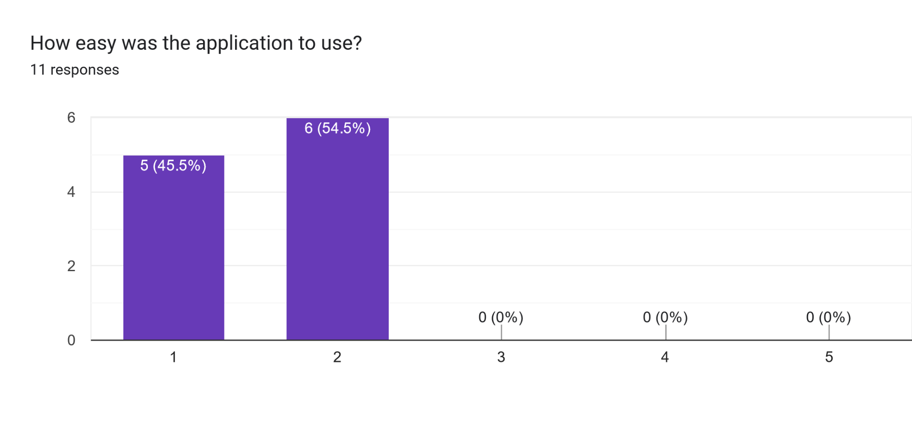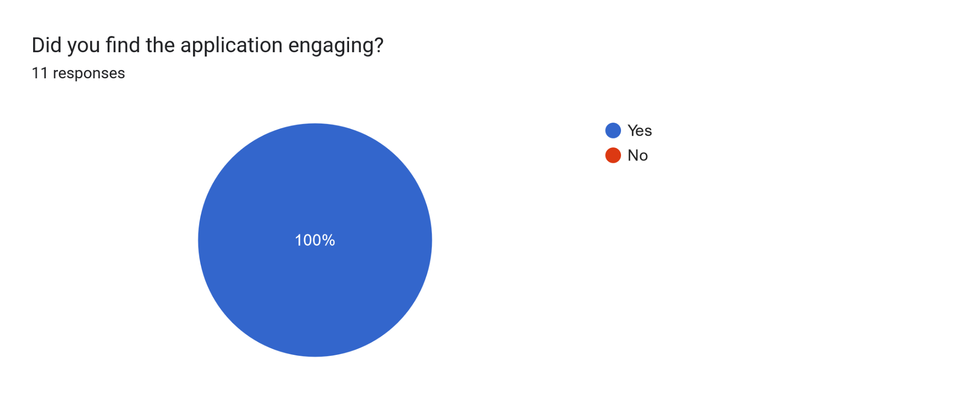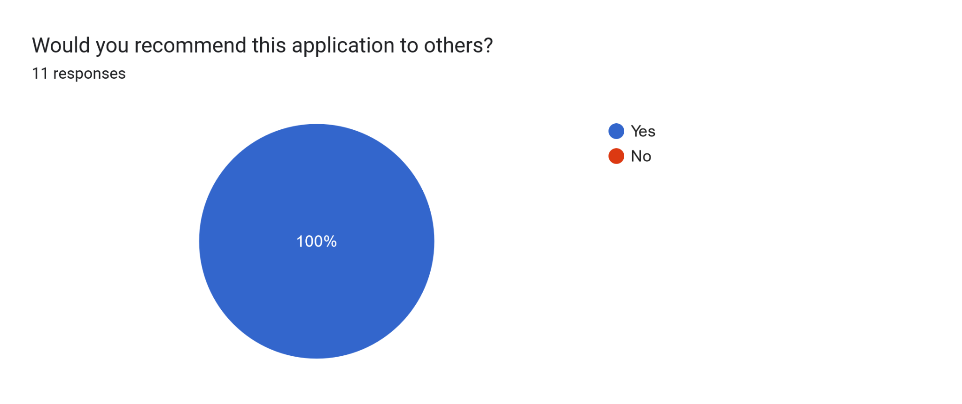

Figure 9.10

Based on the given responses shown in Figure 9.10, on a scale from 1-5, all users stated that the application was either easy or relatively easy to use (1-2). Several test users have stated that the tutorial that we’ve included into the applications has helped a lot before they tested the application to get used to the functionality of HoloLens. Majority of the users tested had 0 experience in AR technology with HoloLens 2 before, so their feedback is similar to the feedback that the first time users might provide after using the application.

Based on the comments provided by the users, we’ve updated the application a little to make the user experience even smoother.

During testing, we also identified several weaknesses of the device and the application. First was the fact that the holograms on the device became very transparent when testing in the room with a lot of natural light. Even though we have made the contrast between the background and the text brighter than the first version, the environment mattered a lot in general visibility of the device. We also encountered tha some buttons were not working as smoothly as needed, so some readjustment was required. We have also verified all of the content with the faculty, because one of the users has noticed an inconsistency in flashcards.

Overall, the feedback has been overwhelmingly positive, all of the testers were particularly interested in the 3D heart model and the interactions with it and expressed how intuitive the interactions with the object has been.

# 10. Conclusions

## 10.1 Characterization of results

During the year, our team has successfully updated the cARdiac-AR application to the second version. The application is now fully usable on the newest HoloLens 2 device with all of the interaction updated to its standard. We were also able to add the user authentication and engagement reporting system, so that faculty can analyze the students progress and tailor their teaching based on the feedback provided by the application. The application has also an updated user interface to better match the Microsoft standards and the user experience has been improved.Users would need to do much less to efficiently interact with the 3D heart model of the heart. We were also able to improve and fix all of the bugs from the 1st version of the application. We also included UCF cARdiac icons to the application, so that on each scene, it is visible that the app is developed by UCF.

For user authentication and engagement reporting, we have created a database and PHP application to handle communication between the database and Unity applications. This allows faculty to easily review and modify some content without redeploying the application.

We have kept the major functionality similar to the 1st version of the application, and made several improvements. Due to the increased screen size, we were able to fit all of the buttons on the screen and could rearrange all of the sections required in the M1 and M2 scenes to be more intuitive for the user. We have also updated the Flashcards, so that the use needs to just click through them without the need to go back to the main menu and select the Flashcards they are interested it. In our app, the user is also able to flip back and forth between the flashcards’ prompt and the question until they are ready to move on to the next flashcard. The cases scene allows the users to test their knowledge. We have updated the UI to make the users more easily read the prompts and visualize whether they ot it correct or not.

Another major update is the anatomy labels that were incorporated to the heart model. The models are now more visually appealing to the user and they don’t cover the heart itself,but rather point to the respective position on the heart that the label refers to. We also made the labels interactable. So when the user clicks on the label on the anatomy, it shows the additional information on the anatomy label selected.

## 10.2 Future improvements

This project also has potential for development beyond the scope of our year. Since we are collaborating with other teams and sharing databases, we can utilize the information gathered to create even more engaging applications for students to utilize in their classes. In the case of not reaching our stretch goals, then that is also another path for future development of the application. Due to the longevity of getting Canvas supported onto an application, this is probably one of the biggest considerations in future development. Having Canvas support would make this project feel a lot more integrated into courses in order to be more intuitive and engaging for both students and professors.

During the development we were able to complete several of our stretch goals, but not all. The stretch heart model is integrated within the app with all of the controls and animations for different speeds are also added. In the future, the blood and electrical flow animations could be added to the sliced model to give the students an even better understanding of the processes happening inside of the heart during various rhythms and diseases. Adding Cases to M1 students as an additional way for them to test the knowledge would also be a nice improvement. There is also a room for improvement for user experience and animations for blood and electrical flow to make them more realistic. There are also several other ideas that the team has come up during the development that might be worth looking into in the future.

Another future improvement for the application is the optimization. There were several times when the application would freeze. We were able to locate that the app might have troubles when all of the animations are playing. Also, the application crashes if the heart model is increased too much. In the future it would be nice to set a boundary on the size of the heart to prevent it from crashing the application.

## 10.3 Summary of the project

As a result of our senior design project, our team has developed a fully functional augmented reality application on cardiac disorders. Studetns are able to login into the application and after following the tutorial, they can view content for various class levels: M1 and M2. Based on the selection they are able to see various content. We have successfully implemented the interactions with the realistic 3D heart model to work with MRTK2, which makes the user interaction much smoother. The user can scale, rotate and move heart using only their hand gestures.Users can also view anatomy labels and get more specific information in regards to a specific part of the heart. Each section also has a module Flashcards, where each section can master the terms thay are learning in class. Students are able to rate their confidence and all their progress is stored for faculty to review. The cases is another module that M2 students can use to test their knowledge. Students are also able to view various heart conditions and see how various animations change based on the cardiac disorder.

## 10.4 Limitations and future updates

## 10.5 UCF Wi-Fi connection to the HoloLens2

There is one limitation that the team faces in regards to connecting the HoloLens2 device to the WPA2 Wi-Fi that is available on campus. There is no network error with other Wi-Fi, but the WPA2 or guest Wi-Fi offered at UCF are throwing network error that prevents the HoloLens from logging into the device. There are several solutions that we are considering.

Since we assume that the error is due to some certificate error, we are currently in the talks with the UCF IT department to see what can be done to fix the error. While identifying and fixing the issue with connecting to Wi-Fi would be ideal, there is a possibility that this will not be achieved based on the replies from the IT and time constraints.

Another solution to this problem is to use personal hotspots from other devices. This bypasses connecting to UCF Wi-Fi, and makes HoloLens 2 usable on campus. Since HoloLens2 devices will not be allowed to take home for students, this poses a limitation to students who are not able to provide hotspots from their devices.

### 10.5.1 Connecting to Corporate Wi-Fi

The University of Central Florida uses WPA2 Wi-Fi. This Wi-Fi requires one to sign in using their NID and password. To have the best experience when using the headset with the cARdiac app, it is recommended that the headset be connected to Wi-Fi. The HoloLens 2 headset has specific steps that need to be done in order for one to connect the headset to a corporate Wi-Fi. These steps can be broken down to several key sections which are the following: enrollment validation, Wi-Fi certificate validation, and validate install of the line-of-business app.

#### 10.5.1.1 Enrollment Validation

This step requires a properly configured Azure Active Directory (Azure AD) user account and mobile device management (MDM) enrollment. The device, in this case the HoloLens 2 headset, should be in a state of factory settings. Once it is in a factory setting state you follow the prompts as they appear. When it gets to connecting to a Wi-Fi network you will first have to connect to a Wi-Fi that does not require certificates to join. This is needed to download the certificate for the corporate Wi-Fi that you will later connect to. When you see the prompt that asks “Who owns this HoloLens?” you must click “My work or school owns it.” This will then prompt you to enter the Azure AD user account information. Then you proceed to complete the start up guide.

Once the start up guide is complete you will have to open the start menu and go to settings to find the device name, which follows the format of “HOLOLENS-” followed by six characters.

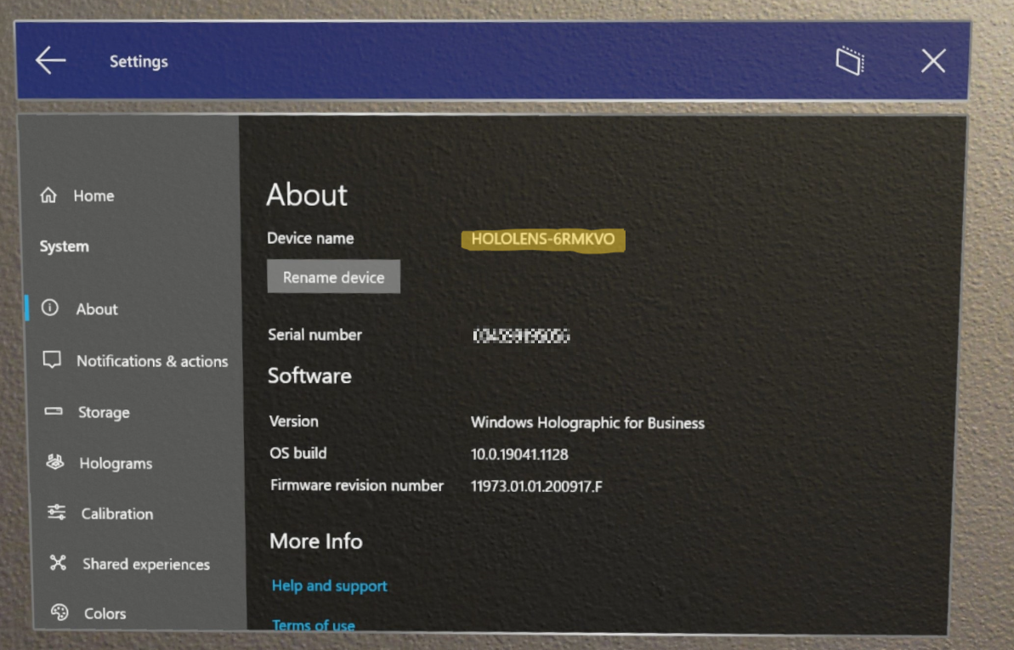

*Figure 10.1 Device name screen with name example [44]*

Using this device name, you should then ensure that your device is properly connected to the Azure AD account and has been enrolled with MDM.

#### 10.5.1.2 Wi-Fi Certificate Validation

As long as you set up the device properly and it is connected to the appropriate accounts then your device should have already received the Wi-Fi certificate. This can be tested by attempting to connect to the Wi-Fi that your device has downloaded the certificate to and try opening a webpage to ensure you are connected to the internet. If you still are unable to connect to the Wi-Fi then go to settings -> update & security -> certificates, here you will see if your device has properly downloaded the certificate.

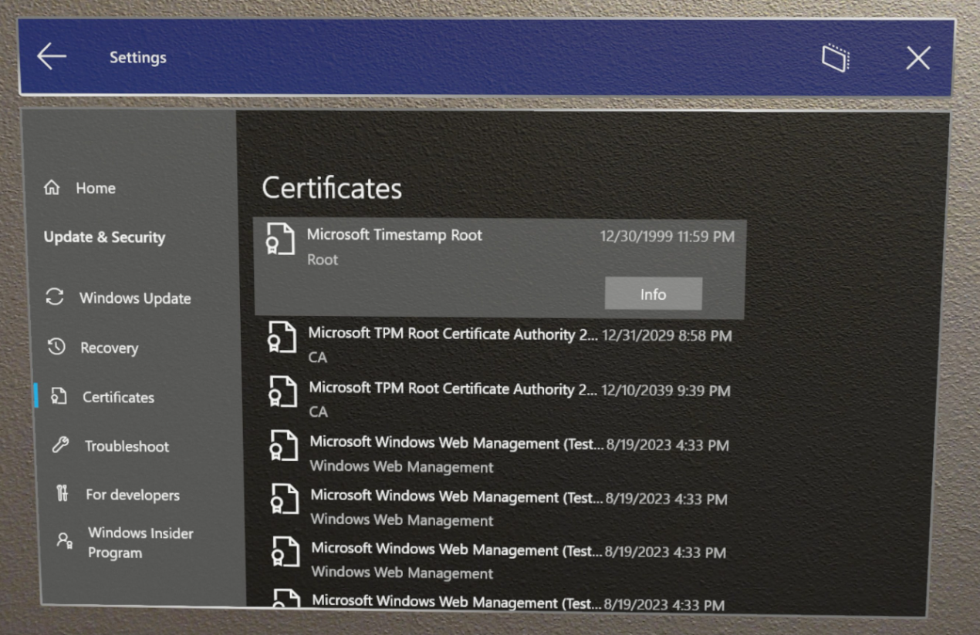

*Figure 10.2 Certificate screen [30]*

If it did not then you will have to follow other steps to download the certificate needed for the Wi-Fi.

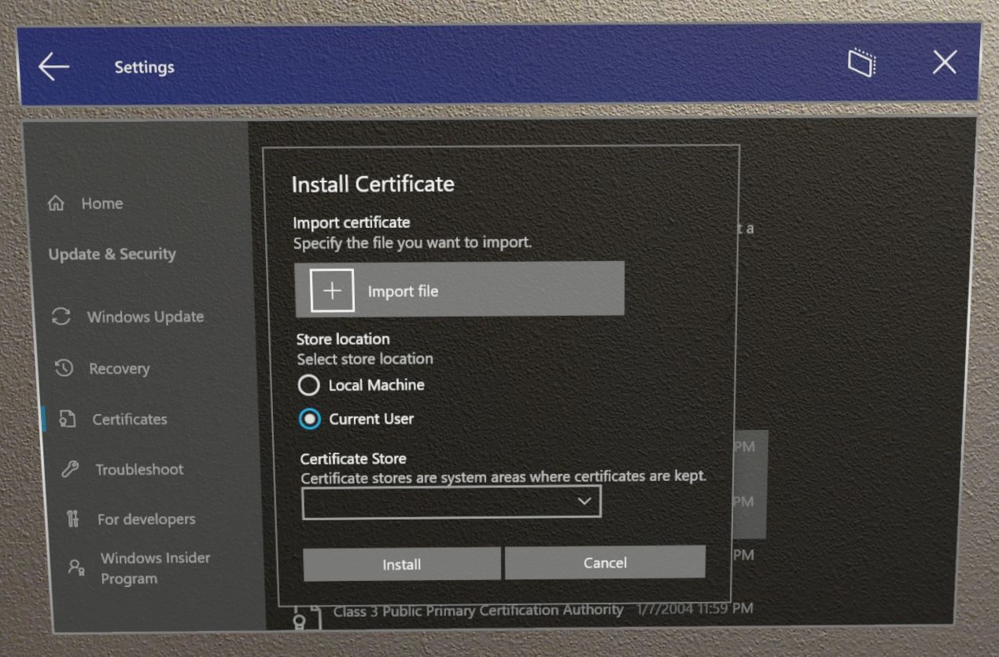

*Figure 10.3 Add certificate screen [30]*

#### 10.5.1.3 Validate Line-of-business App Install

To see if the app is installed or view its install progress the user can go to settings -> accounts -> access work or school then by clicking info. The app can be configured to be a required installation that will happen automatically once the HoloLens is enrolled with a user, but this is an optional step.

### 10.5.2 Solution

During the development, we haven’t found out what exactly was causing the error, none of our proposed solutions helped us. However, after factory resetting the device and using the same credentials as given to the sponsor,the Wi-Fi issue on main campus has been resolved. Any student, faculty can login with their credentials similarly to any Windows computer. We think the best way would be for faculty to login with their credentials to UCF_WPA2 so that students wouldn’t have to do it themselves.

## 10.6 PHP app limitations

Our team uses the first tier of the Azure App services and it comes with various constraints. Since the team is using the Free tier for the App services for Azure, there is a lot of monitoring functionality that is locked due to the free tier. Security is another limitation for the Free Tier. The app is set to allow public access, which is acceptable for the purpose of the app, but it would still be nice to have only authorized devices be able to run the PHP script. The only free solution we found is setting up the firewall rules So only authorized devices and faculty IP addresses could get access to the DB. However, this means that each faculty and device needs to be registered in Azure Access Restrictions. There are several issues with this. One of them, faculty and students are “tied” to certain places and devices. In case they access the app from another device it will have to be registered first. Second issue is the amount of devices. Since the PHP app is used for AR and VR teams the amount of headsets is much bigger than just 2 HoloLens 2. Manually inputting all devices is not feasible. Additionally, having too many firewall rules will slow the application’s response.

## 10.7 Usage Constraints

There are some constraints on the usage of the cARdiac app on the HoloLens 2. The biggest constraint at this time would be that there are only two HoloLens 2 headsets that are available at UCF’s College of Medicine. This would not be much of an issue if the class size was small, but having over 100 students does cause some issues just because there are fifty times more students than headsets. Luckily the UCF’s College of Medicine does have some VR headsets that the students will be able to use and run the VR version of cARdiac app on as well. Having VR headsets does alleviate some of the sharing issues but if a number of students have a preference towards HoloLens 2 then it could take away from the sharing benefits.

In addition to the limited number of headset available for students to use, students can only use them at a certain place and time. This is another constraint because if the student wants to use the headset to get some extra studying done they would have to go to UCF’s College of Medicine. This restricts the ease of access a little bit, especially if the student is relying on some sort of transportation outside of their own means. Students will most likely have a majority of their usage time happen during standard class or work hours, further limiting the ease of access.

Another possible constraint would be any health related issues when wearing and or utilizing the headset. Some people get motion sickness when using headsets and the HoloLens 2 is no different. Studies have shown that most consumers that use the HoloLens will not feel any motion sickness symptoms but few do, those being who are more prone to motion sickness. Even those who do experience it experience only slight symptoms of motion sickness. Microsoft does have information on what should be done to help your body get used to the headset. They recommend that when using the headset you are in a safe location where you will not hurt yourself and to be aware of your surroundings. Microsoft also suggests that your first couple of sessions be short and to take breaks as needed. They say if you feel any discomfort stop and take a break until you feel better. During our testing however, very few expressed any discomfort when using the device. That was due to the fact that the headset was giving headaches after prolonged use, possibly due to its heating up.

One constraint that we faced is Miracast with UCF WPA2 WiFi.While Miracast works with regular PCs, once on UCF campus we were unable to run and make the mirroring work. Also, when streaming the view from the HoloLens 2 to the PC using the Windows device portal, there is a delay of about 2-3 seconds. Any streaming of the screen from HoloLens to PC didn’t work on UCf campus Wifi unless the device and PC were connected to the hotspot.

The final constraint applies to a limited degree. Use and control of the HoloLens 2 headset can be seen as a constraint, at least for the first couple times the student uses the headset. Now that our entire team got to try out the headset we noticed it was a little difficult to control and use, even after going through the tutorial. This can play against the student when they are still relatively new to the device because it would take away time from studying and use of the app. The student could be more focused on trying to maneuver through the app and get used to the controls instead of the actual continent of the app. We hope that our incorporated tutorial and user guide would help the new users, but during testing any first time user needed help even turning the device on and figuring out the basic functionality even before launching the app.

# 11. Administration

## 11.1 Budget and financing

The budget for this project is an open ended question.The ultimate goal of the team is to create an application that would require as little paid resources as possible. Before the development the budget decided for this project was set to be $50 annually. The applications itself would cost us $0, as well as the database. However, the team has decided to incorporate the SSO login for students and faculty to increase the security of the app and reduce the amount of sensitive information stored in the app. Adding UCF SSO through an EFI service would cost $50 yearly for a server. As of now, the team doesn’t plan for any additional costs for developing the project. But if any arise in the further development process, there is a possibility to increase the budget if the reason for an increased budget is well explained and beneficial to the project, such as increasing security of the sensitive information.

HoloLens 2 device and HoloLens 1 device had been given to the team during the development and that is the biggest expense in this project. All of the educational sources we used throughout the development has been free, as well as all the 3D models for the Unity application. The expenses for this has been $0

Another cost that might be introduced is the database hosting through Azure service. As a UCF student there are credits available for us that would cover the cost of hosting the database. However, later on once the credits are used, we expect that the database hosting would cost around $2-4 per month. In case any additional arise in the further development process, there is a possibility to increase the budget if the reason for an increased budget is well explained and beneficial to the project, such as increasing security of the sensitive information. It is also important to note that the expense for the database would be shared between the apps of the two other teams (cARdiac-VR and Dr. Hemo Escape Room).

## 11.2 Project management

### 11.2.1 Agile

Throughout the project the team used Agile to stay organized and on track. Agile project management is an iterative approach to delivering a project throughout its development.[92] Our team had iterative steps, called sprints to allow flexibility of the project development. This iterative process allows the developers to adjust the workflow as you go along. This way the team can deliver updates to the application and upgrade the functionality of the application. This is particularly useful for this type of project, so that the sponsor can constantly review the progress and provide feedback to the team on the progress completed after each sprint. As part of the agile development, the team created a set of requirements for the applications, as well as some nice-to-haves, and prioritized them in order to have the best efficiency and deliver the product with useful functionality. In order to efficiently apply Agile principles, the team used Jira as a management Software.

#### 11.2.1.1 Agile Principles

There are many variations of the Agile workflow, however they all apply the principles of

* Ensure customer satisfaction in delivery of software
* Welcome changes in development
* Ensure consistent developments of software
* Developers and Sponsors must work together throughout the project
* Create an environment that allows individuals to be motivated and supported
* Utilize face-to-face conversation for efficient and effective communication
* Software that works is a main measure of progress
* Sponsors, developers, and users should be able to ensure a consistent pace.
* Attention to excellence and design increases thinking and understanding
* It is essential to maximize the amount of work that is not done; effectively, ensuring that too much work is not being done.
* Self-organizing teams form the best designs
* Within regular times, the team must reflect on how to optimize their work more and adjust accordingly.

#### 11.2.1.2 Agile Scrum

Scrum is a framework that is derived from Agile that is founded on experiential knowledge and focuses on essentials. The aim of this framework is to guide the interactions between team members, rather than following a more strict way of doing things. Due to the nature of this aim, Scrum is typically reserved for groups of a smaller variety, those of a size of 10 team members or lower. Scrum has roles for team members to help guide these interactions which typically consists of the following:

* Scrum Master: The one accountable for the establishment of the Scrum Team and its effectiveness. Typically the Project Manager, they ensure goals are met and ensure the team is working efficiently.
* Product Owner: The one accountable for ensuring the product from the Scrum Team is maximized. They ensure that the product backlog is being effectively managed and understood.
* Developers: The ones accountable for creating aspects of increments during each sprint. They ensure that they hold each other accountable by working towards their sprint goal and definition of done.

What is appealing is that it is also rather flexible in its execution of roles. In order to minimize problems along the way of work, it follows an iterative, incremental approach for those who have the skills and motivation to do work and share knowledge while also acquiring skills when lacking. Specifically, there are artifacts that aim to ensure transparency of goals: the Product Goal, the Sprint Goal, and the Definition of Done. The Definition of Done is simply when an increment meets the proposed quality of the product. In order to achieve the Definition of Done, Scrum uses sprints. Scrum sprints specifically utilize these three aspects:

* Transparency: The process of work must be transparent and perceivable to those doing the work as well as those receiving the work. As mentioned before, it is important artifacts have a sense of transparency. Transparency enables inspection.
* Inspection: The progress towards goals must be checked upon and inspected frequently and thoroughly in order to minimize issues. Inspection enables adaptation
* Adaptation: If any progress is being hindered by inefficient processes, then said processes must be adjusted in order to minimize any further hindrances. Adaptation is expected at any moment something pops up during a moment of inspection.

As mentioned, these three aspects flow into each other linearly and allow efficiency within a team. There are also five particular values that Scrum follows:

* Commitment: Committed to supporting each other and achieving goals
* Focus: Focused during sprints to ensure progress
* Openness: Open and transparent on work and challenges
* Respect: Respectful towards one another in work
* Courage: Courage towards difficult problems and asking others for help.

### 11.2.2 Jira

Jira is one of the most popular management tools for Agile. According to Atlassian [7], Jira is a great tool to create a customizable workflow for the software development team. Jira provides scrum boards, to monitor the progress for each sprint. Our progress board included several sections: To do, In progress, Done, Merged. This helps the team members track the progress for the overall team, set up the priorities for the task, and hosts a great environment to keep track of the requirements and progress for this project.

### 11.2.3 Sprints

Sprints are used in Agile development to divide the backlog into manageable chunks. Our team chose the sprint to be 2 weeks long. Every two weeks, the team would discuss what needs to be done during this time frame. Once the print was created, and all the tasks were assigned, the sprint would begin, and each team member would start working on their assigned tasks. After the spring is finished, we would discuss as a team what was done, difficulties encountered, and start developing the new sprint based on uncompleted tasks from the backlog.

### 11.2.4 Backlog

In order to identify, prioritize and assign tasks to the team, we used Jira software. To make sure that we have our tasks and requirements correct and achievable, we created a backlog of all the tasks we plan on completing during the development of the application. All the tasks have been divided into epics. Epics are considered to be large chunks of work that should be broken down into smaller and more manageable chunks. As a result, the team created 6 main epics: Fixing UI bugs, Updating flashcard functionality, Creating cases for M1 students and updating their functionality, implementing login for students, connecting the app to the database, and Wifi connection to the device. Each of those epics contain a subset of tasks that is going to be divided among the team during the development process. One of the advantages of the epics is that the tasks that belong to them can be implemented during different sprints, so there is no pressure to finish the epic till the end of the sprint. Additionally it shows overall progress on the epic based on how many tasks had been completed which is an additional way to track the progress.

Each task selected for the sprint is assigned to one teammate, however, collaboration with other members of the team is also possible. Jira uses a board for each sprint to track the progress of the team.

The backlog that the team setup for this project is presented in Figure 11.1

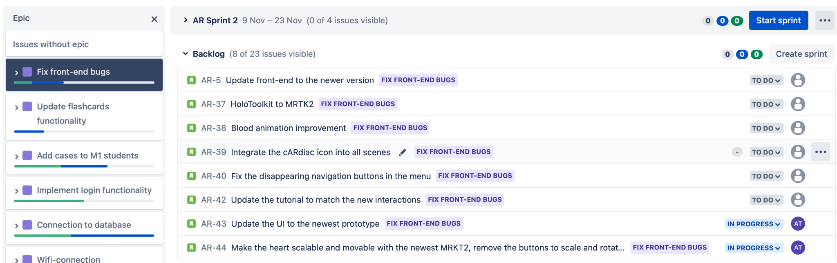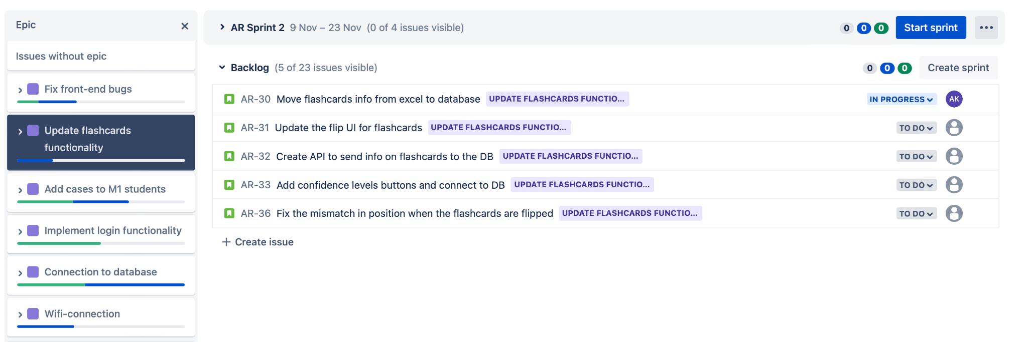

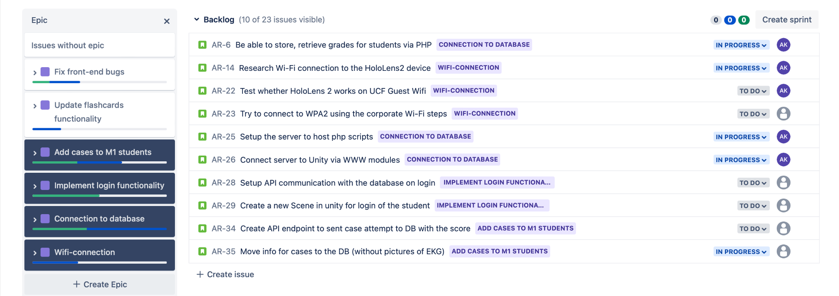Figure 11.1 Backlog for the project in Jira for different epics

## 11.3 Communication

The communication among the team mostly consisted of discord and in person weekly meetings. Throughout the week the team keeps each other updated on all important progress. During the weekly meeting in person on Wednesdays, we discussed the next steps for the week, any difficulties, ideas the team had, and questions for the sponsor if there were any. Additionally, the team has weekly meetings with the sponsor to show the progress and ask any additional questions about the project. As a part of our development phase the team additionally communicated with two other Senior Design teams: cARdiac-VR and Dr. Hemo’s Escape Room. The communication with the teams was done once a week through Discord or Zoom, and was necessary to identify the steps required to set up the shared database, as per request of the sponsor. Lastly, there has been excessive communication with the UCF IT due to potential SSO, WebCourses integration, and device connection.

### 11.3.1 Group Meetings

Our team decided to have two weekly meetings. The first type of meeting was just for our group to make sure that everyone is doing their fair share of work, is not falling behind, and update the group on what we have been working on and or plan to work on. This meeting acted as our standup for the group, which was part of our agile development plan. The second type of meeting was with our sponsor. In this meeting we would ask any questions that we had for her and or inform her of any ideas that we had to get her feedback. The sponsor meetings were optional, if we had no new or question to report to the sponsor we would let her know in advance and we would cancel the meeting.

The very first meeting we had was a sponsor meeting in which she went over what the project is and what the deliverables look like for a successful project completion. The deliverables are to update the app from HoloLens 1 to HoloLens 2 along with being able to collect data from the students participation when using the app. In this meeting we were able to ask any clarifying questions to make sure we knew what needed to be done. In this meeting we were provided resources to familiarize ourselves with the tools that we would be using along with a OneDrive folder of the project. The OneDrive included the code, the models, screenshots of the app, and a demo.

In our first group meeting, which will be referred to as the sprint meeting, we mainly discussed what roles we each would prefer and or feel most comfortable with. We also shared what experience we have if any that would be relevant to the project , along with any ideas that we thought of, and resources we found. In this meeting we also discussed what tools and technologies would be needed for the project. By the end of the meeting we knew that we would need a database to store the students information, a portal for the teachers to view the students’ completion and progress, and knew our roles going forward.

Our next major sprint meeting is where we came up with the idea of using single sign on (SSO), similar to what webcourses and myUCF offers, to identify students when using the headset. We also came up with other possible ways that can be used to identify students in case we would not be able to incorporate the SSO. Some examples of the ideas we came up with are using the student’s ID, a QR code, and a list of students that one can select their own name. We also decided what database to use between Firebase, MongoDB, and SQL after discussing the advantages and disadvantages of each.

The next major sprint meeting is one of the more important sprint meetings we had. This meeting really changed what our goals were and what our stretch goals were. We discussed various issues that we were facing with getting the project working, the HoloLens 2 emulator working, and updating the project. We realized that the project was using HoloToolkit, which stopped receiving support in 2018, instead of Mixed Reality Toolkit (MRTK), which still receives support. There are two ways that this issue can be resolved. The first option being we continue to use HoloToolkit but can only upgrade the project to Unity 2018; the other option is we swap over to MRTK and upgrade the project to the newest long term support version of Unity which is Unity 2021. In order to do the second option we would have to first update the project to use MRTK v2 and then upgrade it to the newest long term support version of Unity moving from one year to the next, 2017 to 2018 to 2019 and so on. To do this we could either start from scratch and use the code from previous teams to update it all to the newest long term support version of Unity and MRTK v2, straight to 2021, or upgrade version by version until we get the latest versions working. Getting the emulator working was also a bit of an issue, first we had to install Windows Education in order to get the emulator. Once we had the emulator installed, we were having trouble successfully opening any project in it. All of these points and some smaller ones would have to be discussed in our next sponsor meeting.

In the sponsor meeting, following the sprint meeting that caused us to re-evaluate our goals and stretch goals, we discussed our issues, finding, and provided our current plans. During this meeting we decided to put creating a teacher portal as a stretch goal, opting for a .csv file that the teacher can download. We also decided that upgrading version by version would most likely be best for our team because we are all unfamiliar with MRTK and this would just require some smaller changes than starting from scratch. Our group was also advised to try the HoloLens 2 headset, either go to the UCF College of Medicine or see if the sponsor can bring the headset to the main campus. Finally our group was instructed to meet with the other teams working on this project to discuss parts of the project that we will all be using, like data storage and what data to collect. It would be easier if all the teams used a shared database and collected the same data. Having this team collaboration would make the instructor's job much easier, since she would be able to get all the data she wants from one place instead of jumping between databases and looking at different data that was collected.

Following the sponsor meeting, that was just talked about, our team met with the sponsor and was able to check out the HoloLens 2 headset. Having the HoloLens 2 headset readily available whenever we need it would make testing changes and functionality much easier since we would only need to update the app on the headset and not plan a day to meet to go to UCF College of Medicine just to test the changes. We also decided to not work towards setting up the HoloLens emulator for two reasons; one we now had the headset and can just try any changes made directly on that and two setting up the emulator was giving us too many issues that were not easily resolvable.

We also met with the other cARdiac teams to discuss what database would be best for all of us to use, since we will all be using one shared database among all the teams as requested by the sponsor. In this meeting we decided that all the groups are going to collect the same data. We started talking about the different data we each thought of collecting and tried to narrow it down to a select few ideas. In this meeting we also set up a means of communication with the other teams, we would use discord, and set up a recurring meeting for once every three weeks. These meetings would serve to update the other teams on our progress, any issues we are encountering, and new ideas that we might have had.

In one of our last meetings that we had we had talked about what the new database that is going to be used. One of the other teams mentioned that a relational database would be better for their needs so we decided to switch over to a SQL server. Progress was being made to setting up the database locally but would still have to be done to work with a server, Azure server. Azure does not work well with Unity so we will have to see what can be done to minimize the issues between the two. Ideally we would want the app, from Unity, to communicate with Azure, the server, which has access to the database, Azure would be acting as the middle man between the two. The last thing we talked about in this meeting was talking about things we should have people in our group write about, because it is relevant information. Between this meeting and the meeting with the other teams, one of our group members started making progress towards making the new project and having it open without issues. Now we could all start to work on it collectively and start adding to it.

The last group meeting we decided to have for this semester will serve to format the final design document. Throughout the semester we have each individually been writing each of our own pages in a separate google doc within a shared folder. Writing our own pages in separate google docs allows us to see what each of our page contributions are and to make sure that everyone was keeping up with the workload and that it was being split evenly among us all. Throughout the semester we would slowly add our pages into one single google doc that would serve as our final design document. In this meeting we will make any finishing touches to the design document before submission and go through it with our team to make sure it is meeting all the required criteria and formatting specifications. We would also make sure that everyone’s pages are included into the final document and placed in the correct sections.

For our second semester, the team has decided to have weekly team meetings and a weekly meeting with the sponsor as well as keeping the team updated with the progress constantly. For the few first week, we were also have been communicating heavily with the rest of the team to finalize and setup the database and the PHP application. Weekly sponsor meeting were used primarily to share the progress weekly with the sponsor and identify any changes that were need to be made based ont he sponsor’s feedback. During our weekly meetings, the updates were shared and the tasks for the week has been identified.

## 11.4 Documentation and Source Code

We have created documentation for the application and put all of the necessary files in the cARdiac-AR Google Drive Folder called Documentation shared with our sponsor.

### 11.4.1 Source Code

We have also included the Github repositories with the code in the same folder. We have created two separate repositories: one is only for the Unity application cARdiac-AR and another one is the PHP application repository which is needed for student response gathering from 3 applications: cARdiac-AR, cARdiac-VR and Dr.Hemo Escape Room. In the future, the PHP application will have to be replaced to .NET application and connected to all three applications to work properly and for a possibility to migrate it to the UCF IT services.

### 11.4.2 Documentation

In the same Documentation Folder we have created two separate documentations of the app. One is for the PHP application, describing all of the scripts. Anther one is for the Unity applications which describes all of the classes used in the application and its description

Deployment: is a document which has a detailed description of the steps required to deploy the application to the device. There are several other ways, but we’ve described what we’ve used and what definitely worked for us

Unity Scene Guide: This document is meant to help locate where the scripts are within each scene to identify which game objects are attached to which scripts.

User Guide: This document is designed for the users. It includes the basic introductory information that might be useful for them, like basic gestures on the HoloLens and basic interaction with the objects. Additionally we’ve included the description of all the scenes so the first time users know what to expect and how to navigate the app better.

Database and PHP app documentation: Contains detailed instructions on PHP app and database connection and detailed setup.

## 11.5 Milestones

On Figure 11.2 a description of our schedule along with a description of the schedule and setbacks is present. We have tried to make sure that the application was completed by the end of March at the latest, to give us some time to test the application and identify and fix some bugs and complete the documentation in time.

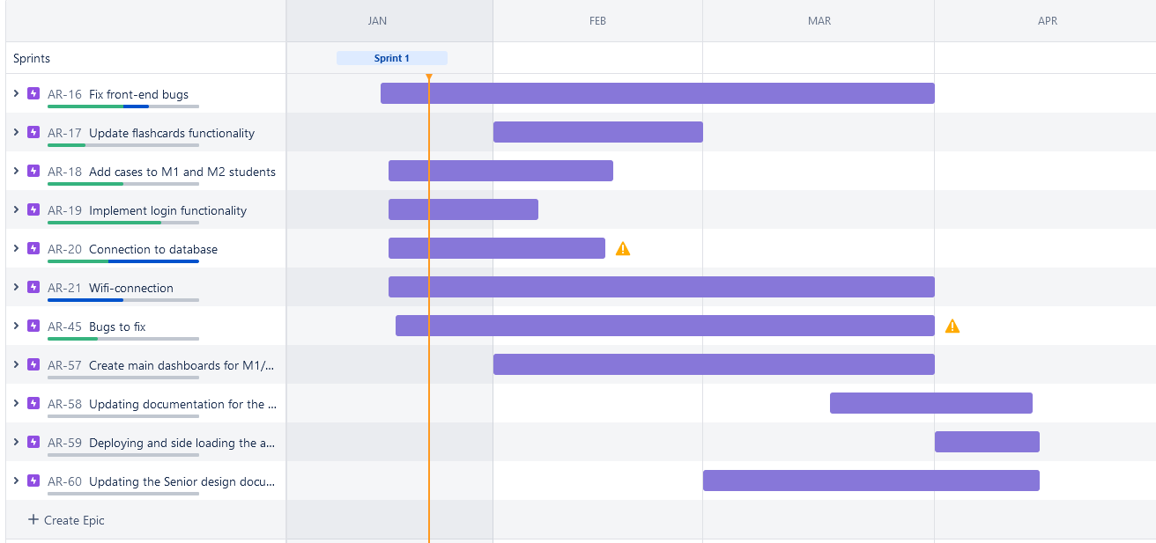

Figure 11.2

| Date | Milestone |
| --- | --- |
| 09/19/22 | Startup: Meet up with the team and coordinate weekly meetings and dynamic |
| 09/23/22 | 1st Sponsor Meeting: Meet with the sponsor for project requirements |
| 09/26/22 | Second Group Meeting: Assign project roles |
| 10/02/22 | Initial Design Proposal document due (15 pages as a group) |
| 10/03/22 | Third Group Meeting: Discuss necessary resources |
| 10/07/22 | First TA Check-in |
| 10/10/22 | Speak with UCF I.T for access to Web Courses API |
| 10/20/22 | Figma wireframe of updated design of the application |
| 10/21/22 | Second Sponsor Meeting: Present our initial design to our sponsor |
| 10/23/22 | Start learning Unity from Unity modules from Unity.Learn |
| 10/25/22 | Fully understand previous Senior Design team’s project schema |
| 10/27/22 | Port previous Senior Design team’s project to HoloLens 2 |
| 10/28/22 | Third Sponsor Meeting: Ask our sponsor any clarifying questions etc. |
| 11/06/22 | 15 Individual Pages due |
| 11/10/22 | Begin working on SSO login |
| 11/11/22 | Second TA Check-In |
| 11/16 | Get firsthand use on HoloLens 2.0 and previous version of the app. |
| 12/06/22 | Finish Unity. Learn Modules |
| 12/07/22 | Final Design Document (30 Individual Pages) |
|  | Winter break |
| 12/11/22 | Finish Login |
| 01/09/23 | First team meeting of Senior Design 2 semester |
| 01/13/23 | First sponsor meeting of Senior Design 2 semester |
| 01/16/23 | Begin updating the UI/UX design of the application for Tutorial |
| 01/18/23 | Setting up the PHP application and database |
| 01/19/23 | Kickoff Meeting the Gerber |
| 01/19/23 | Meeting with the cardiac-VR, Dr.Hemo to finalize the database structure |
| 01/20/23 | Second Sponsor Meeting: Present any updates on project |
| 01/20/23 | Team meeting on CDR presentation |
| 01/23/23 | PHP scripts for connecting Unity with database completed |
| 01/23/23 | Rehearsal of the CDR presentation |
| 01/30/23 | Working on M1 and M2 scenes |
| 02/01/23 | Critical design review |
| 02/02/23 | Finish updating the UI/UX design for main student’s’ scenes and tutorial |
| 02/03/23 | Third Sponsor Meeting: Present updated UI/UX design to sponsor for feedback |
| 02/06/23 | Review and update application based on sponsor’s feedback |
| 02/10/23 | Login functionality completed |
| 02/17/23 | Flashcards scene completed |
| 02/20/23 | Finish incorporating student’s progress to the application for flashcards |
| 02/24/23 | Fourth Sponsor Meeting: General updates |
| 02/27/23 | Review and update application based on sponsor’s feedback, implementing Guest Login |
| 03/06/23 | Completing Case scene, adding the animations and syncing them to heart model |
| 03/13/23 | Finalizing the animations for Blood and electrical flow, adding new heart model |
| 03/17/23 | Finalized the Cases scene and added student progress functionality |
| 03/21/23 | First Demo with Dr. Gerber |
| 04/03/23 | Fifth Sponsor Meeting: Final project reviews |
| 04/04/23 | Minor updates from the feedback from the sponsor and faculty |
| 04/06/23 | Application testing |
| 04/07/23 | Updating minor issues detecting during student testing |
| 04/08/23 | Recording showcase video, updating Senior design document |
| 04/14/23 | Testing the application on the UCF COM location, final review by sponsor |
| 04/17/23 | Final presentation, senior design document due |

## 11.6 Division of labor

### 11.6.1 Alexandra Krivonos

* Project Manager
* Creating and connecting database
* Creating a PHP application and communicating with the teams
* Setting up Github repository for PHP applications
* Migrate Case and Flashcard information to the database
* Allow professors a way to change Case and Flashcard material
* Deployment and sideloading of the application on the HoloLens 2
* Team management in Jira
  + Creating sprints
  + Creating tasks
* Showcase video editing and upload

### 11.6.2 Alexander Melendez

* Connecting PHP app to Unity, Unity WebRequest
* Unity Version Assistance
* HoloLens Emulator setup
* Adding the Guest Login functionality
* Adding a CSV to the Unity application for cases and flashcards to access with no internet
* HoloLens 2 streaming to PC

### 11.6.3 Andrew Rodriguez

* Cardiac App Use Diagram
* Permissions Diagram
* Project Budget
* Group Meetings
* Connection of the Hololens to UCF-WPA2
* Flashcards Scene

### 11.6.4 Anthony Tran

* Created the wireframe for the app
* Heart model interactions
* Updating the UI and UX
* Updating the app to use MRTK2
* Looking into the problem between the HoloLens 2 and WPA 2 Connections
* Set up Github Repo for version control
* cARdiac AR Application Prototype
* Updating the animations
* Implementing Slice model
* Updating the animations

### 11.6.5 Chris Mathew

* Project Function
* Cases Scene
* Cases connection to Unity
* Project Requirements and Specifications
* Canvas API
* OAuth2

### 11.6.6 Emmanuel Pineda

* Created the wireframe for the app
* Updating the UI and UX
* Blood flow and electrical Flow animations
* Updating the app to use MRTK2
* Breakthrough to update the application properly

# 12. Acknowledgments

We would like to express our special thanks to the wonderful faculty team for their support during the development of this project. We would like to thank Michael Callahan for the help with the backend part of the project, for proposing us the best practices in programming, and guiding us whenever we had technical difficulties and Dr. Plochocki for helping us with the medical content of the application to make sure that all our work is correct and will not harm the students when learning. We would also like to express our gratitude to our sponsor, Mellisa Cowan, and to our faculty advisor, Dr. Gerber, for helping us out with any questions we had.

UCF CS Senior Design Fall 22 – Spring 23:

Alexandra Krivonos

Chris Mathew

Alexander Melendez

Emmanuel Pineda

Andrew Rodriguez

Anthony Tran

UCF COM Faculty:

Jeffrey Plochocki, Ph.D.

UCF COM Educational Technology Staff:

Melissa Cowan

Ryan Dickerson

Jonathan Bohinsky

Mariana Lobeto

# **13. References**

[1] A universal git connector. Plastic SCM. (n.d.). Retrieved November 18, 2022, from https://www.plasticscm.com/gitserver

[2] Agile Principles. Principles behind the Agile Manifesto. (n.d.). Retrieved December 3, 2022, from http://agilemanifesto.org/principles.html

[3] An open LTI™ app collection (2022) Edu App Center. Retrieved November 6, 2022, from https://www.eduappcenter.com/

[4] Angular vs React: A Detailed Side-by-Side Comparison. Kinsta®, 7 Oct. 2022, https://kinsta.com/blog/angular-vs-react/#angular-vs-react-an-indepth-comparison

[5] Angular vs React: Difference between Angular and React. InterviewBit, 2 June 2022, https://www.interviewbit.com/blog/angular-vs-react/#

[6] Angular vs React: Which One to Choose for Your App - Freecodecamp.org. https://www.freecodecamp.org/news/angular-vs-react-what-to-choose-for-your-app-2

[7] Atlassian. (n.d.). Jira competitors and alternatives. Atlassian. Retrieved November 6, 2022, from https://www.atlassian.com/software/jira/comparison?&aceid=&adposition=&adgroup=136973859330&campaign=18440774103&creative=624486809659&device=m&keyword=jira+software&matchtype=e&network=g&placement=&ds_kids=p73335831615&ds_e=GOOGLE&ds_eid=700000001558501&ds_e1=GOOGLE&gclid=EAIaIQobChMIxqCIraL0-gIVVMeGCh24Pwy4EAAYASABEgKIlfD_BwE&gclsrc=aw.ds

[8] Baker, Kristen. “User Testing: The Ultimate Guide.” HubSpot Blog, HubSpot, 6 Oct. 2022, https://blog.hubspot.com/service/user-testing#what-is-user-testing.

[9] BenjaminArmstrong. “Hyper-V Technology Overview.” Microsoft Learn, https://learn.microsoft.com/en-us/windows-server/virtualization/hyper-v/hyper-v-technology-overview.

[10] Better Code, Faster: 8 Reasons Why You Should Use Unit Testing. Forte Group, 1 Dec. 2021, https://fortegrp.com/the-importance-of-unit-testing/.

[11] BluEntByte. “Lamp Tech Stack: Pros and Cons for Your Business.” BluEnt Technology, 28 Sept. 2022, https://www.bluent.net/blog/lamp-tech-stack-pros-and-cons/.

[12] Bruce, D. (2022, September 15). Ultimate Guide Mongodb: Definition, Advantages & Disadvantages. knowledgenile. Retrieved November 6, 2022, from https://www.knowledgenile.com/blogs/pros-and-cons-of-mongodb/

[13] Canvas LMS - REST API and extensions documentation (2022). Instructure Inc. Retrieved November 6, 2022, from https://canvas.instructure.com/doc/api/index.html

[14] Clark, J. (2022) How to set up API developer keys in canvas, Edlink Community. Edlink Community. Retrieved November 6, 2022, from https://ed.link/community/how-to-set-up-developer-keys-in-canvas/#:~:text=Developer%20keys%20are%20powerful%20tools%20that%20allow%20external,3%20Modifying%20grades%2C%20and%3B%204%20Reading%20course%20rosters.

[15] Code testing tools & services: Visual Studio (2021) Visual Studio. Retrieved November 6, 2022, from https://visualstudio.microsoft.com/vs/features/testing-tools/

[16] CodeClouds. (2022, July 8). The Pros and cons of using github for repository management. CodeClouds. Retrieved November 12, 2022, from https://www.codeclouds.com/blog/advantages-disadvantages-using-github/

[17] Cordenne Brewster • 7 min read, and Cordenne Brewster. “What Is Vue.js? the Pros and Cons of Vue.js in 2022.” Trio Developers, https://www.trio.dev/blog/why-use-vue-js.

[18] Corporate, A.A. (2022) Improve quality of code with Visual Studio Testing Tools, AnAr Solutions Pvt. Ltd. Retrieved November 6, 2022, from https://anarsolutions.com/visual-studio-testing-tools/#:~:text=Primary%20Testing%20Tools%20of%20Visual%20Studio%201%20Unit,Coded%20UI%20Test%20...%205%20Remote%20Testing%20

[19] Davidkline-Ms. “Boundary System Overview - MRTK 2.” Boundary System Overview - MRTK 2 | Microsoft Learn, https://learn.microsoft.com/en-us/windows/mixed-reality/mrtk-unity/mrtk2/features/boundary/boundary-system-getting-started?view=mrtkunity-2022-05.

[20] Davidkline-Ms. “Spatial Awareness Getting Started - MRTK 2.” Spatial Awareness Getting Started - MRTK 2 | Microsoft Learn, https://learn.microsoft.com/en-us/windows/mixed-reality/mrtk-unity/mrtk2/features/spatial-awareness/spatial-awareness-getting-started?view=mrtkunity-2022-05.

[21] Davidkline-Ms. (n.d.). MRTK modularization - MRTK 2. MRTK modularization - MRTK 2 | Microsoft Learn. Retrieved December 5, 2022, from https://learn.microsoft.com/en-us/windows/mixed-reality/mrtk-unity/mrtk2/packages/mrtk-modularization?view=mrtkunity-2022-05

[22] Davidkline-Ms. (n.d.). MRTK packages - MRTK 2. MRTK packages - MRTK 2 | Microsoft Learn. Retrieved December 5, 2022, from https://learn.microsoft.com/en-us/windows/mixed-reality/mrtk-unity/mrtk2/packages/mrtk-packages?view=mrtkunity-2022-05

[23] Davidkline-Ms. (n.d.). Systems, extension services, and Data Providers - MRTK 2. Systems, extension services, and data providers - MRTK 2 | Microsoft Learn. Retrieved December 5, 2022, from https://learn.microsoft.com/en-us/windows/mixed-reality/mrtk-unity/mrtk2/architecture/systems-extensions-providers?view=mrtkunity-2022-05

[24] Deshpande, C. (2022, November 25). What is angular?: Architecture, features, and advantages [2022 edition]. Simplilearn.com. Retrieved December 5, 2022, from https://www.simplilearn.com/tutorials/angular-tutorial/what-is-angular

[25] Dotnet-Bot. “Follow Class (Microsoft.mixedreality.toolkit.experimental.utilities).” (Microsoft.MixedReality.Toolkit.Experimental.Utilities) | Microsoft Learn, https://learn.microsoft.com/en-us/dotnet/api/microsoft.mixedreality.toolkit.experimental.utilities.follow?view=mixed-reality-toolkit-unity-2020-dotnet-2.5.4.

[26] React vs. Angular Compared: Which One Suits Your Project Better? AltexSoft, AltexSoft, 28 Feb. 2020, https://www.altexsoft.com/blog/engineering/react-vs-angular-compared-which-one-suits-your-project-better/.

[27] Eira, Astrid. “20 Current Augmented Reality Trends & Predictions for 2022/2023 and Beyond.” Financesonline.com, FinancesOnline.com, 6 Nov. 2022, https://financesonline.com/augmented-reality-trends/.

[28] Electronic Federated Identity (EFI) sign-on service (2019) UCF IT. Retrieved November 6, 2022, from https://it.ucf.edu/electronic-federated-identity-efi-sign-on-service/

[29] Estela, L. (2021, March 2). From unity to hololens, Lucy's tech dev blog. Lucy's Tech Dev Blog. Retrieved December 2, 2022, from http://lucyestela.com/dev/unity/from-unity-to-hololens/

[30] Evmill. (n.d.). Certificate manager. Microsoft Learn. Retrieved November 25, 2022, from https://learn.microsoft.com/en-us/hololens/certificate-manager

[31] Git vs. perforce: How to choose (and when to use both). Perforce Software. (2019, April 11). Retrieved November 12, 2022, from https://www.perforce.com/blog/vcs/git-vs-perforce-how-choose-and-when-use-both

[32] Goralski, Cezary. “Pros and Cons of React.” The Codest, 26 May 2022, https://thecodest.co/blog/pros-and-cons-of-react.

[33] Guriev, B. (2021, March 26). Firebase Pros and Cons: When you should and shouldn't use Firebase. OSDB. Retrieved November 6, 2022, from https://osdb.io/firebase-pros-and-cons-when-you-should-and-shouldnt-use-firebase-osdb/#:~:text=Pros%20and%20cons%20of%20Google%20Firebase%20%20,%20Android%20centered%20%201%20more%20rows%20

[34] Hamalawi. “Using the HoloLens Emulator - Mixed Reality.” Mixed Reality | Microsoft Learn, https://learn.microsoft.com/en-us/windows/mixed-reality/develop/advanced-concepts/using-the-hololens-emulator.

[35] Hickeys. “Color in Windows Apps - Windows Apps.” In Windows Apps - Windows Apps | Microsoft Learn, https://learn.microsoft.com/en-us/windows/apps/design/style/color.

[36] Hololens 2 basics & setup · enklu documentation (no date) Enklu Documentation. Retrieved November 6, 2022, from https://docs.enklu.com/docs/HoloLens/HoloLens2Basics&amp;Setup

[37] Hololens 2-Overview, Features, and Specs: Microsoft Hololens. -Overview, Features, and Specs | Microsoft HoloLens, https://www.microsoft.com/en-us/hololens/hardware.

[38] Hololens 2. Wikipedia, Wikimedia Foundation, 22 Sept. 2022, https://en.wikipedia.org/wiki/HoloLens_2

[39] Hololens device quick start. Hololens Device Quick Start in Unreal Engine | Unreal Engine 5.1 Documentation. (n.d.). Retrieved December 2, 2022, from https://docs.unrealengine.com/5.1/en-US/hololens-device-quick-start-in-unreal-engine/

[40] How do I manage API access tokens as a student? community.canvaslms.com. (2020). Retrieved November 6, 2022, from https://community.canvaslms.com/t5/Student-Guide/How-do-I-manage-API-access-tokens-as-a-student/ta-p/273

[41] IBM Cloud Education. “Lamp Stack Explained: Master the Basics and Get Started Quickly.” IBM, https://www.ibm.com/cloud/learn/lamp-stack-explained#toc-how-the-el-bTbrnFrN

[42] Introduction to Unity Unit Testing. Kodeco.com, https://www.kodeco.com/9454-introduction-to-unity-unit-testing

[43] JonMLyons. “Testing Your App on Hololens - Mixed Reality.” Mixed Reality | Microsoft Learn, https://learn.microsoft.com/en-us/windows/mixed-reality/develop/advanced-concepts/testing-your-app-on-hololens

[44] Joyjaz. (n.d.). Deployment Guide – Corporate Connected hololens 2 with dynamics 365 guides - deploy. Deployment Guide – Corporate connected HoloLens 2 with Dynamics 365 Guides - Deploy | Microsoft Learn. Retrieved November 24, 2022, from https://learn.microsoft.com/en-us/hololens/hololens2-corp-connected-deploy

[45] Kościesza, J. (2020, January 15). Hololens 2 vs hololens 1: What's new?: 4Experience's AR/VR Blog. 4Experience. Retrieved October 27, 2022, from https://4experience.co/hololens-2-vs-hololens-1-whats-new/#:~:text=HoloLens%202%20includes%20a%20newer,2GB%20in%20HoloLens%201)

[46] Mamaylya. (n.d.). Use hololens (first gen) devices with Dynamics 365 guides - dynamics 365 mixed reality. Use HoloLens (first gen) devices with Dynamics 365 Guides - Dynamics 365 Mixed Reality | Microsoft Learn. Retrieved October 27, 2022, from https://learn.microsoft.com/en-us/dynamics365/mixed-reality/guides/hl1

[47] Marijan, Bosko. “Lamp vs. Mean: Whats the Difference between Two Stacks.” Knowledge Base by PhoenixNAP, 27 June 2022, https://phoenixnap.com/kb/mean-vs-lamp#:~:text=LAMP%20was%20introduced%20in%201998,scenarios%20and%20utilize%20different%20components.

[48] Mattzmsft. (n.d.). Build and deploy to the hololens - mixed reality. Mixed Reality | Microsoft Learn. Retrieved December 2, 2022, from https://learn.microsoft.com/en-us/windows/mixed-reality/develop/unity/build-and-deploy-to-hololens

[49] Mavitazk. “Color, Light, and Materials - Mixed Reality.” Mixed Reality | Microsoft Learn, https://learn.microsoft.com/en-us/windows/mixed-reality/design/color-light-and-materials

[50] mDevelopers - IT Outsourcing x Software House. (2022, January 20). What is angular, and why should you use it? What is Angular, and Why Should You Use It? Retrieved December 5, 2022, from https://mdevelopers.com/blog/what-is-the-angular-framework

[51] Mern Stack. GeeksforGeeks, 7 Oct. 2021, https://www.geeksforgeeks.org/mern-stack/.

[52] Microsoft hololens. Microsoft Hololens - NExT Lab. (n.d.). Retrieved October 27, 2022, from https://msd-makerspaces.gitbook.io/next-lab/augmented-reality/resources/platforms-hardware/microsoft-hololens

[53] Microsoft mixed reality - healthcare. Microsoft Mixed Reality - Healthcare. (n.d.). Retrieved December 1, 2022, from https://www.microsoft.com/en-us/hololens/industry-healthcare#:~:text=HoloLens%202%20x%20Healthcare,at%20the%20point%20of%20care

[54] MongoDB C#. MongoDB C#/.NET Driver - MongoDB Drivers. (n.d.). Retrieved December 5, 2022, from https://www.mongodb.com/docs/drivers/csharp/

[55] MSHoloLens. “MSHoloLens/Holotoolkit-Unity: This Is Effectively Part of the Existing HoloToolkit, but Is the Repo That Will Contain All Unity Specific Components.” GitHub, https://github.com/MSHoloLens/HoloToolkit-Unity.

[56] MySQL 8.0 Reference Manual. MySQL. (n.d.). Retrieved November 5, 2022, from https://dev.mysql.com/doc/refman/8.0/en/

[57] MySQL Advantages and disadvantages. W3schools. (2022, June 25). Retrieved November 6, 2022, from https://www.w3schools.blog/mysql-advantages-disadvantages

[58] Pbarnettms. “Perception Simulation - Mixed Reality.” Mixed Reality | Microsoft Learn, https://learn.microsoft.com/en-us/windows/mixed-reality/develop/advanced-concepts/perception-simulation-overview

[59] Performance, scalability and network optimizations. Plastic SCM. (n.d.). Retrieved November 15, 2022, from https://www.plasticscm.com/games/performance/performance-results-of-plastic-scm

[60] Plastic SCM vs. perforce helix core: Which is best for your team? Perforce Software. (2021, June 14). Retrieved November 12, 2022, from https://www.perforce.com/blog/vcs/plastic-scm-vs-perforce

[61] Polar-Kev. (n.d.). MRTK2-Unity Developer Documentation - MRTK 2. MRTK2-Unity Developer Documentation - MRTK 2 | Microsoft Learn. Retrieved December 5, 2022, from https://learn.microsoft.com/en-us/windows/mixed-reality/mrtk-unity/mrtk2/?view=mrtkunity-2022-05

[62] Porting Hololens (1st gen) apps to hololens 2 - mixed reality. Mixed Reality | Microsoft Learn. (2022, August 4). Retrieved October 13, 2022, from https://learn.microsoft.com/en-us/windows/mixed-reality/develop/porting-apps/porting-hl1-hl2

[63] Pros and Cons of Reactjs Web App Development. DDI Development, https://ddi-dev.com/blog/programming/pros-and-cons-reactjs-web-app-development/.

[64] qianw211. “What Is a Hologram? - Mixed Reality.” Mixed Reality | Microsoft Learn, https://learn.microsoft.com/en-us/windows/mixed-reality/discover/hologram.

[65] qianw211. “What Is Mixed Reality? - Mixed Reality.” Mixed Reality | Microsoft Learn, https://learn.microsoft.com/en-us/windows/mixed-reality/discover/mixed-reality.

[66] QuinnRadich. “What's A Universal Windows Platform (UWP) App? - UWP Applications.” UWP Applications | Microsoft Learn, https://learn.microsoft.com/en-us/windows/uwp/get-started/universal-application-platform-guide.

[67] Savjani. (n.d.). Connect to azure app service - azure database for mysql. Connect to Azure App Service - Azure Database for MySQL | Microsoft Learn. Retrieved December 2, 2022, from https://learn.microsoft.com/en-us/azure/mysql/single-server/how-to-connect-webapp

[68] Savjani. (n.d.). Quickstart: Connect - mysql workbench - azure database for MySQL - Flexible Server. Quickstart: Connect - MySQL Workbench - Azure Database for MySQL - Flexible Server | Microsoft Learn. Retrieved December 2, 2022, from https://learn.microsoft.com/en-us/azure/mysql/flexible-server/connect-workbench

[69] Schaik, J.van (2021) Positioning QR codes in space with hololens 2 - building a 'poor man's vuforia', DotNetByExample - The Next Generation. Retrieved November 6,2022,fromhttps://localjoost.github.io/Positioning-QR-codes-in-space-with-HoloLens-2-building-a-%27poor-man%27s-Vuforia%27/

[70] Scooley. (n.d.). Prepare a new hololens 2. Prepare a new HoloLens 2 | Microsoft Learn. Retrieved November 25, 2022, from https://learn.microsoft.com/en-us/hololens/hololens2-setup

[71] Sean-Kerawala. (n.d.). Integrate Azure Cloud Services to your unity project on hololens 2 - training. Training | Microsoft Learn. Retrieved December 2, 2022, from https://learn.microsoft.com/en-us/training/modules/azure-cloud-services-tutorials/

[72] Sean-Kerawala. (n.d.). Introduction to the mixed reality toolkit--set up your project and use hand interaction - training. Training | Microsoft Learn. Retrieved December 3, 2022, fromhttps://learn.microsoft.com/en-us/training/modules/learn-mrtk-tutorials/1-1-introduction

[73] Seesharprun. (n.d.). Introduction to azure cosmos DB. Introduction to Azure Cosmos DB | Microsoft Learn. Retrieved November 6, 2022, from https://learn.microsoft.com/en-us/azure/cosmos-db/introduction

[74] Seesharprun. (n.d.). Use azure cosmos DB change feed to visualize real-time data analytics. Microsoft Learn. Retrieved November 6, 2022, from https://learn.microsoft.com/en-us/azure/cosmos-db/nosql/changefeed-ecommerce-solution?source=recommendations#next-steps

[75] Shibboleth service provider (SP) 3.4 installation guide. SWITCH. (n.d.). Retrieved November 6, 2022, from https://www.switch.ch/aai/guides/sp/installation/

[76] Shibboleth, Setting up a Service Provider (2021) SWITCH. Retrieved November 6, 2022, from https://answers.uillinois.edu/illinois/page.php?id=48459#:~:text=When%20you%20set%20up%20Shibboleth%20access%20to%20your,provide%20to%20people%20who%20match%20the%20requested%20credentials.

[77] Surur. (2019, February 26). Controversy around hololens 2 field of view continues. MSPoweruser. Retrieved October 27, 2022, from https://mspoweruser.com/controversy-around-hololens-2-field-of-view-continues/

[78] TerryGLee. “Overview of Visual Studio.” Overview of Visual Studio | Microsoft Learn, https://learn.microsoft.com/en-us/visualstudio/get-started/visual-studio-ide?view=vs-2022.

[79] Thalbern. “Object Manipulator - MRTK 2.” Object Manipulator - MRTK 2 | Microsoft Learn, https://learn.microsoft.com/en-us/windows/mixed-reality/mrtk-unity/mrtk2/features/ux-building-blocks/object-manipulator?view=mrtkunity-2022-05.

[80] The 2020 scrum GUIDE TM. Scrum Guide | Scrum Guides. (n.d.). Retrieved December 3, 2022, from https://scrumguides.org/scrum-guide.html

[81] The difference between Microsoft hololens vs hololens 2. Program. (2022, June 13). Retrieved October 18, 2022, from <https://program-ace.com/blog/microsoft-hololens-vs-hololens-2-comparison/>

[82] The Good and the Bad of Angular Development.” AltexSoft, AltexSoft, 27 Feb. 2020, https://www.altexsoft.com/blog/engineering/the-good-and-the-bad-of-angular-development/.

[83] The Good and the Bad of Vue.js Framework Programming. AltexSoft, AltexSoft, 27 Feb. 2020, https://www.altexsoft.com/blog/engineering/pros-and-cons-of-vue-js/.

[84] The Pros and cons of power apps development. The Pros and Cons of Power Apps Development. (2022, October 27). Retrieved October 27, 2022, from https://www.damcogroup.com/blogs/unlock-the-potential-of-power-apps-for-your-business-advantage

[85] Thetuvix. “Spatial Anchors - Mixed Reality.” Mixed Reality | Microsoft Learn, https://learn.microsoft.com/en-us/windows/mixed-reality/design/spatial-anchors

[86] Unity Technologies. (2022, November 4). Version control integrations. Unity. Retrieved November 12, 2022, from https://docs.unity3d.com/Manual/Versioncontrolintegration.html

[87] Unity3dAzure. (n.d.). Unity3dazure/AppServices: Azure App Services for unity. GitHub. Retrieved December 2, 2022, from https://github.com/Unity3dAzure/AppServices

[88] Vovk, A., Wild, F., Guest, W., & Kuula, T. (2018, April 1). Simulator sickness in augmented reality training using the Microsoft hololens: Proceedings of the 2018 CHI Conference on Human Factors in Computing Systems. ACM Conferences. Retrieved November 25, 2022, from https://dl.acm.org/doi/10.1145/3173574.3173783#:~:text=Our%20findings%20suggest%20that%20the,environments%20we%20tested%20it%20in

[89] Web Content Accessibility Guidelines. Wikipedia, Wikimedia Foundation, 6 Sept. 2022, https://en.wikipedia.org/wiki/Web_Content_Accessibility_Guidelines.

[90] What is a Lamp Stack? Amazon. Retrieved December 5, 2022, from https://aws.amazon.com/what-is/lamp-stack/

[91] What Is .NET Framework? A Software Development Framework. Microsoft, https://dotnet.microsoft.com/en-us/learn/dotnet/what-is-dotnet-framework.

[92] What is Agile Project Management? APM. (n.d.). Retrieved December 2, 2022, from https://www.apm.org.uk/resources/find-a-resource/agile-project-management/

[93] What Is The Mern Stack? Introduction & Examples. MongoDB, https://www.mongodb.com/mern-stack.

[94] What Is Unit Testing vs. Testing? FlashMob Computing, https://www.flashmobcomputing.org/what-is-unit-testing-vs-testing/.

[95] X DevAPI User Guide. MySQL. (n.d.). Retrieved November 6, 2022, from https://dev.mysql.com/doc/x-devapi-userguide/en/